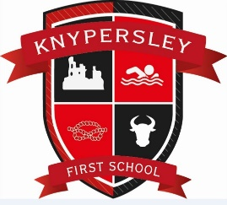
Dear Parents
I hope that you have had a lovely half term break and enjoyed time with friends and family. As you will be aware, the law and guidance regarding Covid has been updated. Here is the link to the most recent guidance for parents. What parents and carers need to know about early years providers, schools and colleges - GOV.UK (www.gov.uk)
In line with the latest guidance for schools Schools COVID-19 operational guidance (publishing.service.gov.uk) we are asking that if a pupil has the key symptoms of COVID-19 they should not attend school whilst infectious, given the potential risk to others. They should isolate and then take an LFD test from 5 days after their symptoms started followed by another one the next day. If both of these tests results are negative, they should return to school, as long as they feel well enough to do so and do not have a temperature (see diagram below).
If your child displays any of the Covid symptoms, please take them for a PCR test. The main symptoms of coronavirus (COVID-19) are:
- a high temperature – this means you feel hot to touch on your chest or back (you do not need to measure your temperature)
- a new, continuous cough – this means coughing a lot for more than an hour, or 3 or more coughing episodes in 24 hours (if you usually have a cough, it may be worse than usual)
- a loss or change to your sense of smell or taste – this means you've noticed you cannot smell or taste anything, or things smell or taste different to normal

Other symptoms linked with COVID-19 include shortness of breath, fatigue, loss of appetite, muscle ache, sore throat, headache, stuffy or runny nose, diarrhoea, nausea and vomiting.
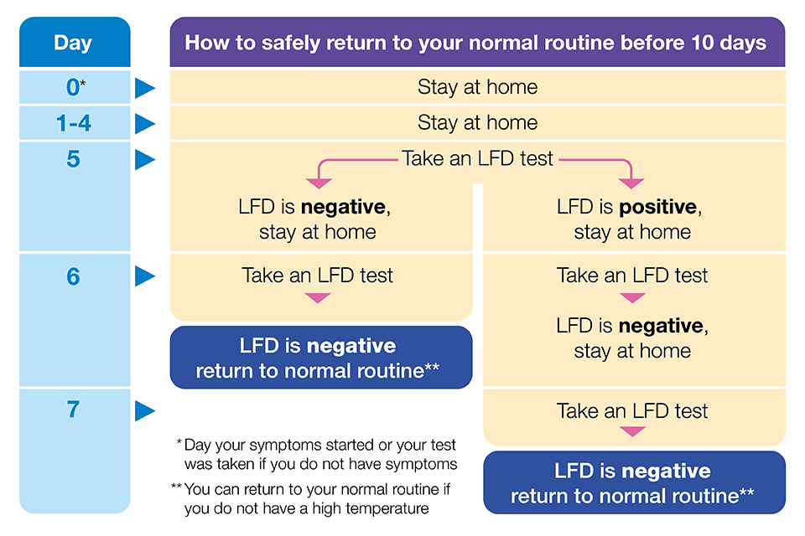

In light of the updated guidance, in school we will:
- Update our outbreak management plan and risk assessment. We will use these as well as advice from the local outbreak team to effectively manage any future outbreaks in school. (Both are now available on our covid area which can be found here: http://knypersley.staffs.sch.uk/covid-19-information/
- Ensure good hygiene for everyone including continuing with additional cleaning routines
- Keep occupied spaces well ventilated and monitor ventilation via the use of carbon dioxide monitors
- Keep up to date with and follow public health advice on testing, self-isolation and managing confirmed cases of COVID-19
- Ensure the identification and management of symptomatic staff, pupils and visitors to our school are managed effectively
- Remove, at an appropriate pace, all bubble restrictions and monitor the impact of this closely
- Provide clubs, extra-curricular activities, trips, parental engagement events in line with our risk assessment
- Promote the ‘catch it, bin it, kill it’ personal hygiene approach
- Continue to promote handwashing and the use of hand sanitiser in all classrooms
- Strongly recommend that our staff are both fully vaccinated including a booster
- Encourage the optional wearing of masks in communal areas especially for those staff deemed be at greater risk.
- Encourage temperature checks on arrival for all adults on our school site
Pupils health and well-being
Children previously considered clinically extremely vulnerable should attend school and should follow the same COVID-19 guidance as the rest of the population. In some circumstances, a child or young person may have received personal advice from their specialist or clinician on additional precautions to take and they should continue to follow that advice. If this is the case for your child, please contact the school office so that a personal risk assessment and additional measures can be put in to place.
Some pupils may be experiencing a variety of emotions in response to the COVID-19 pandemic, such as anxiety, stress or low mood. If you have concerns about your child, please speak to your child’s class teacher so that we can support.
PPE and Cleaning Arrangements
The school has provided the staff with access to aprons, gloves, masks and face shields. Staff will be asked to wear all PPE when dealing with a child who has had an accident, is poorly or is showing any symptoms of COVID19. Beyond this staff can wear whatever PPE they feel safe and comfortable in. Additional cleaning during the school day is in place both by staff in the classrooms and by our cleaning teams to ensure frequently used areas and touch points are regularly wiped down.
If you have any additional questions please contact us via the school office- 01782 973810 or admin@knypersley.staffs.sch.uk
Thank you for your continuing support as we learn to live with Covid. We aim to keep everyone in school as safe as we possibly can whilst carefully resuming all of the great activities and events that make school life so fun and memorable.
Best wishes,

Mrs A. Rourke (Executive Headteacher)

