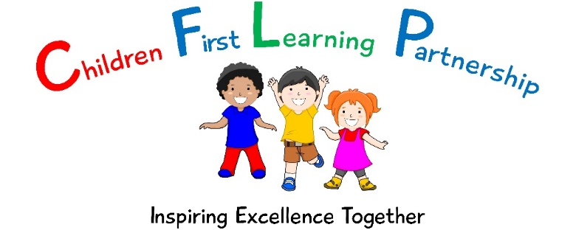

Administering Medication Policy
June 2021

June 2023
To be reviewed:
June 2021
Agreed and ratified by the Directors Board on:
Headteacher – Mrs E. Goodyear
Responsible Officer:
Mr C. Clulow
Chair of Local Advisory Board:
The Administering Medication Policy has been discussed and adopted by the Local Advisory Board

Code of Practice for Administration of Medicines in School.
Also refer to the school Asthma Policy and Managing Medical Conditions in school Policy

Administration of medication is always best done by the parent of the child and parents are welcome to come in at the appropriate time to do so. However, we know this is not always possible.

Children may need medication in the following circumstances:
- During a short term illness or condition, such as the requirement to take a course of antibiotics
- For treatment of a long term medical condition which may require regular medicines to keep them well.
- Medication in particular circumstances, such as children with severe allergies who may need an emergency treatment such as adrenaline injection.
- Daily medication for a condition such as asthma, where children may have the need for daily inhalers (and, potentially additional assistance during an asthma attack).
We recognise that most children with medical needs can attend school or a setting regularly and take part in normal activities, sometimes with support.

There are other pupils who will have medical conditions that, if not properly managed could limit their access to education. Such pupils are regarded as having medical needs. Most children with medical needs are able to attend school regularly and we will ensure a care plan is put in place following consultation with parents and professional services.

There is no legal duty, which requires school to administer medication; this is a voluntary role. Staff who provide support for pupils with medical needs or who volunteer to administer medication only do this with the support of the Executive Head, Head of School and parents.

When a parent requests that medicine be administered to their child at school the circumstances will be considered by the Headteacher & Assistant Headteacher and the decision will have regard to the best interests of the child and implications for the staff.

Generally prescribed and non-prescribed medication will be administered by staff.

Self Management of Medication:

We believe it is good practice to support and encourage children, who are able, to take responsibility for managing their own medicines from a relatively early age and schools and other settings should encourage this.
Older children with a long-term illness should, whenever possible, assume complete responsibility under the supervision of their parent or our staff.
The age at which children are ready to take care of, and be responsible for, their own medicines, varies. There is no set age when this transition will be made, and there may be circumstances where it is not appropriate for a child of any age to self-manage. Where this is agreed it will be added to the Parental Consent Form. In these circumstances, Health professionals need to assess, with parents and children, the appropriate time to make this transition.
If a child can take their medicines themselves, staff will still be required to supervise and ensure suitable storage arrangements are provided.

Procedure for Administering Medication

If you need us to administer medication to your child please contact the Headteacher to agree the support to be provided by the school. Written permission must be given before medication can be administered.
If medicines are to be administered by staff in school we must bear in mind the county’s guidelines on such matters which are:-

- The medicines must be kept safely and the containers clearly labelled.
  - Name of pupil
  - Date of dispensing
  - Dose and frequency
  - Cautionary advice/special storage instructions
  - Name of medicine
  - Expiry date
- There are written instructions
- A form of consent “Administration of Medicines/Treatment has been filled in and signed.
- The Parent has brought in the medicine and signed on receipt and collection of medicine.

Medicines will not be administered by staff if:

- Some technical or medical knowledge or experience is required and training has not been given

Storage
All medication will be stored in the school office with the exception of inhalers which will be stored in the class first aid boxes. The school has emergency inhalers stored in the school office – indicated on the first aid box. (Please refer to the Asthma policy for further guidance.)
If children fall ill during the school day parents will naturally be expected to make arrangements to take the child home. It is therefore vitally important that the school is kept advised of up to date contact numbers.

A school nurse can be contacted to provide a consultation for anyone who might wish to talk about their child’s health.

Developing an Individual Healthcare Plan

Not all children who have medical needs will require an individual plan. The main purpose of an individual health care plan for a child with medical needs is to identify the level of support that is needed, who will carry out that support and how the setting with deal with any problems or emergencies.

The individual healthcare plan may also include individual risk assessments which have taken place as decisions have been made about the child’s medication or care. An individual health care plan clarifies for staff, parents and the child the help that can be provided. It is important for staff to be guided by the child’s GP or pediatrician as well as parents and carers.

Staff should agree with parents how often they should review the healthcare plan. This must happen at least annually, but much depends on the nature of the child’s particular needs; some would need reviewing more frequently.

Developing a health care plan should not be onerous, although each plan will contain different levels of detail according to the need of the individual child. In addition to input from the child’s GP/Pediatrician or other health care professionals (depending on the level of support the child needs).

Those who may need to contribute to a health care plan include:
- The head teacher or head of setting
- The parent or carer
- Healthcare professional e.g. Health Visitor/School nurse/Looked After Children’s Nurse/Community Pediatric Nurse as appropriate.
- The child (if appropriate)
- Early Years practitioner/class teacher (primary schools)/form tutor/head of year
- Care assistant or support staff (if applicable)
- Staff who are trained to administer medicines
- Staff who are trained in emergency procedures

The content and format of individual healthcare plans will vary depending on what is most effective for the needs of each individual. Within school settings attention should be paid to the statutory guidance regarding supporting pupils at school with medical conditions.

Medicines for a staff members own use

An employee may need to bring medicine into school /setting for their own use. All staff have a responsibility to ensure that these medicines are kept securely and that young people will not have access to them, e.g. locked desk drawer or staff room.

Adequate safeguards must be taken by employees, who are responsible for their own personal supplies, to ensure that such medicines are not issued to any other employee, individual or young person.

