Year 2
Please find todays learning tasks below.
The table below explains the tasks and you will find the resources underneath. Your child will know which challenge they usually access in each subject and which task will be appropriate for them.
Year group: 2 Date: 10.06.2020
English | The Bear who came to babysit is the story that we will focus on in our English work this week.  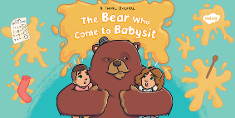
 | Bronze | Silver | Gold
Today you are going to use super sentences to write a menu for the meals a bear might make. First talk about your favourite meals and how they might be described on a menu. E.g. delicious pasta strings wrapped in a juice tomatoes and beef sauce, topped with a sprinkle of grated cheese and served with crusty garlic bread. (This will help you when you try to describe the bear’s meals.)

You can use the outline below if you like or write your it into your book.
Maths | Warm Up – follow this link to complete your maths warm up.  https://www.ictgames.com/mobilePage/mostlyPostie/index.html  This is a game about reading scales.
 | Bronze | Silver | Gold
 | Today you will be continuing to learn about mass. Today you will be reading scales in kg and g. Look at the powerpoint on the home learning website and then complete the activities below. | Today you will be continuing to learn about mass.Today you will be reading scales in kg and g. Look at the powerpoint on the home learning website and then complete the activities below. | Today you will be continuing to learn about mass. Today you will be reading scales in kg and g. Look at the powerpoint on the home learning website and then complete the activities below.
Reading  Phonics/SPAG | Log in to Oxford Owls and choose a book that you would like to read.  https://www.oxfordowl.co.uk/please-log-in?open_loginbox  Complete the activity handwriting activity

Unless otherwise specified, please complete the tasks in either your home learning book or print out the document below.

Bronze, Silver, Gold

Bronze- Maths

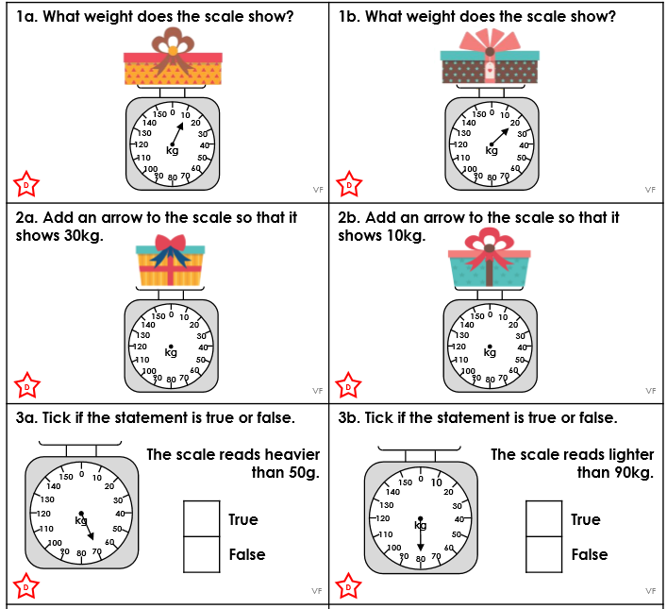

Silver- Maths

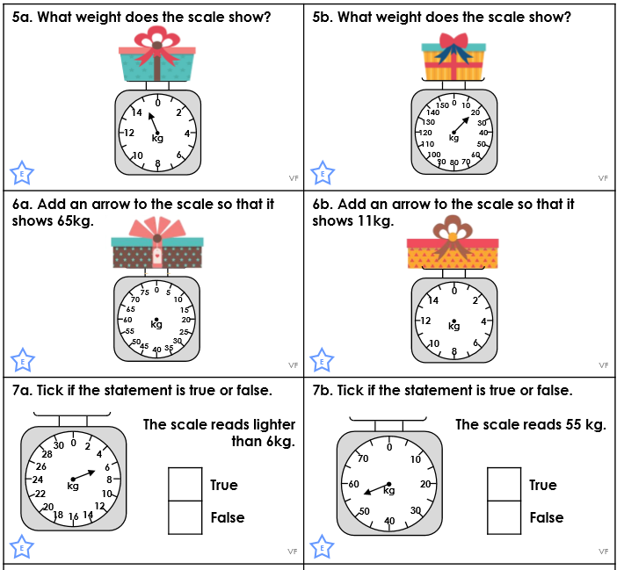

Gold- Maths

