Year 3 Topic Menu!
Pick and choose from the subjects and activities below to complete over the next two weeks. Can you challenge yourself to complete 3 a week?

Science | PE | D and T
Types of nutrition  This week in Science we would like you to look at the packet labels of the different food you eat and write the different nutrients included. Please complete the table attached which includes carbohydrates, protein, saturated and unsaturated fats, minerals, vitamins, water and fibre. | For PE this week we would like you try the Physical Activity Connect 4 game. We would like you to play this game as a family.  Please see the connect 4 game below. | For D and T this week we would like you to design and make a prairie schooner. Remember to label the materials you would like to use.  Here is a prairie schooner:  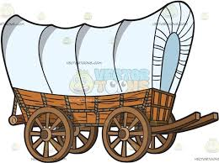
Computing | French | Well Being
Using operations for programming  Follow the instructions to make an adding algorithm on scratch. This will require you to use variables and operations.  Then, use your knowledge to change the algorithm to subtract, multiply and divide. | Look at the body parts and match the French words for each part. The internet might help you for some of the trickier words. | I am amazing  This week we would like the children to complete the ‘I am amazing’ activity sheet. Please complete the sentence starters. The activity sheet is attached below.

PE resources
Physical Activity Connect 4
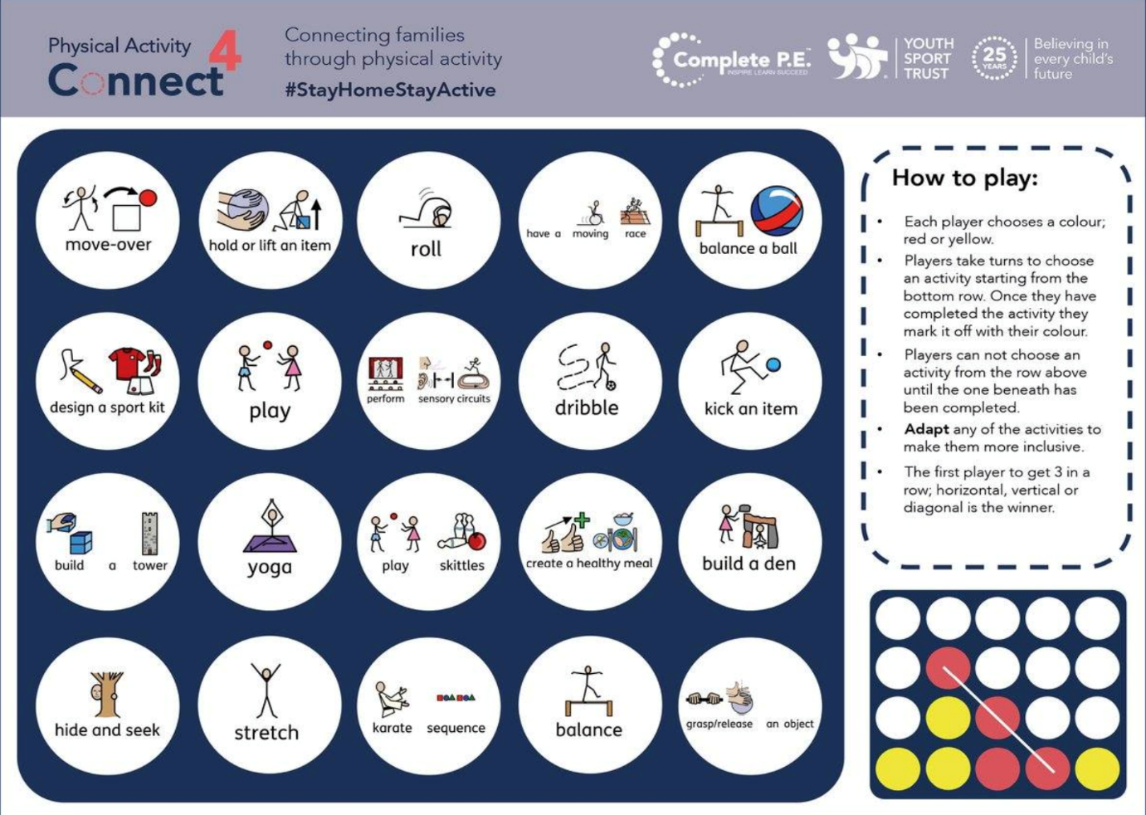

Well-Being

Computing
Go to https://www.scratch.mit.edu and click create.
- Using the variable menu click “Make a variable” and make 2 variables called “number 1” and “number 2”.
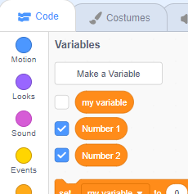
- Make the code as shown below… (The colour of each block should help you to find it. Remember that the drop downs will have to be changed.)
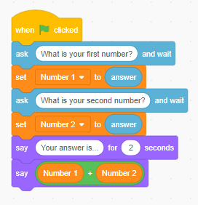
- This will add 2 numbers together… Test it by clicking the green flag.
- Can you edit this code to subtract, multiply and divide numbers?

Science
Complete the table using food packets you can find in your kitchen or online.
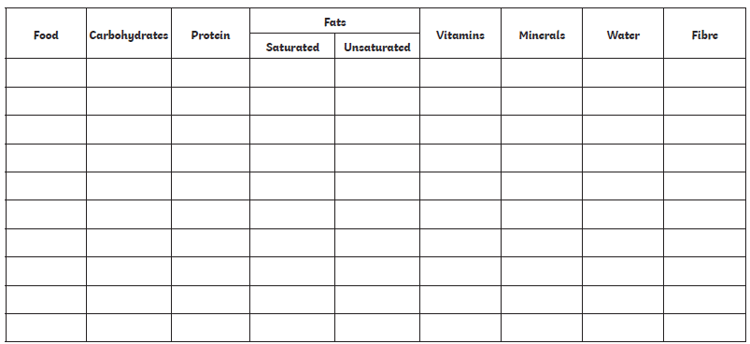

French
