Year 2
Please find todays learning tasks below.
The table below explains the tasks and you will find the resources underneath. Your child will know which challenge they usually access in each subject and which task will be appropriate for them.
Year group: 2 Date: 11.06.2020
English | 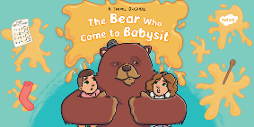  The Bear who came to babysit is the story that we will focus on in our English work this week.
 | Bronze | Silver | Gold
 | Today watch a powerpoint about newspaper reports – then you are going to try to write a front page of a report yourself. Our Gorilla report is at the bottom to show you what a good one looks like. Then you can use the outline below if you like or write it into your book. | Today watch a powerpoint about newspaper reports – then you are going to try to write a report yourself. Our Gorilla report is at the bottom to show you what a good one looks like. Then you can use the outline below if you like or write it into your book.
Maths | Warm Up – Can you discuss this reasoning problem with a grown up?  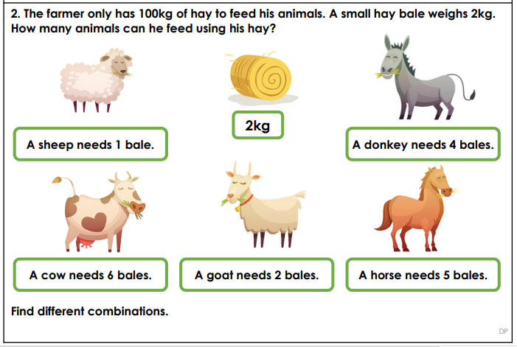
 | Bronze | Silver | Gold
 | Today you will be learning about temperature. Look at the powerpoint about temperature on the website and then answer the questions below. | Today you will be learning about temperature. Look at the powerpoint about temperature on the website and then answer the questions below. | Today you will be learning about temperature. Look at the powerpoint about temperature on the website and then answer the questions below.
Reading  Phonics | Go to https://www.educationquizzes.com/ks1/english/comprehension-aliens-stole-my-homework-summer-of-year-2/  Read the piece and answer the questions  Play this game and add the correct punctuation  https://www.turtlediary.com/game/identify-correct-punctuation.html

Unless otherwise specified, please complete the tasks in either your home learning book or print out the document below.

Bronze, Silver, Gold

#

Bronze,

Silver and Gold

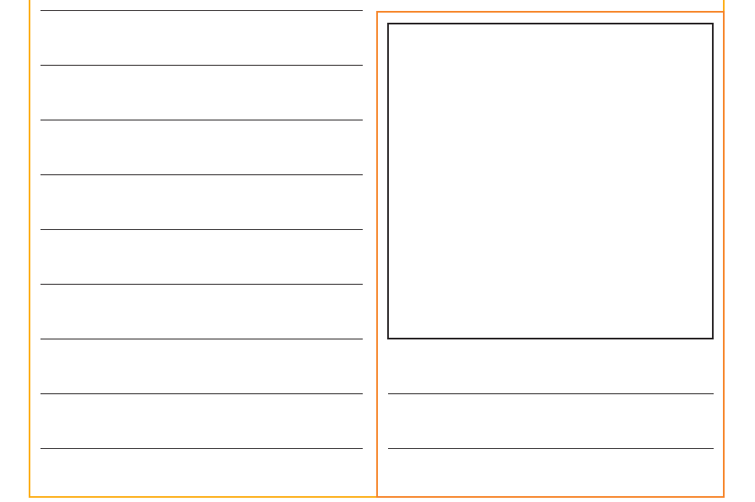

Bronze-Maths
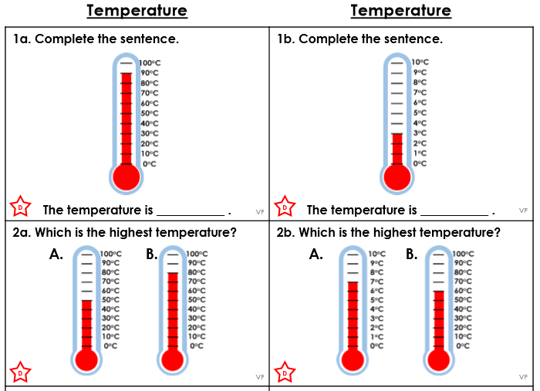
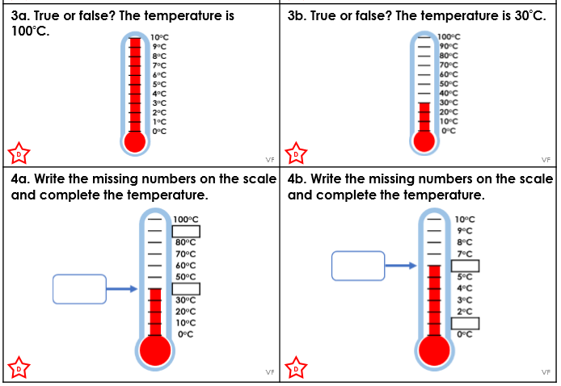

Silver-Maths

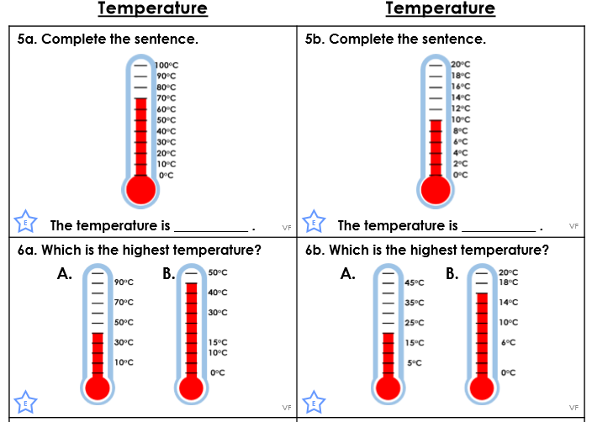
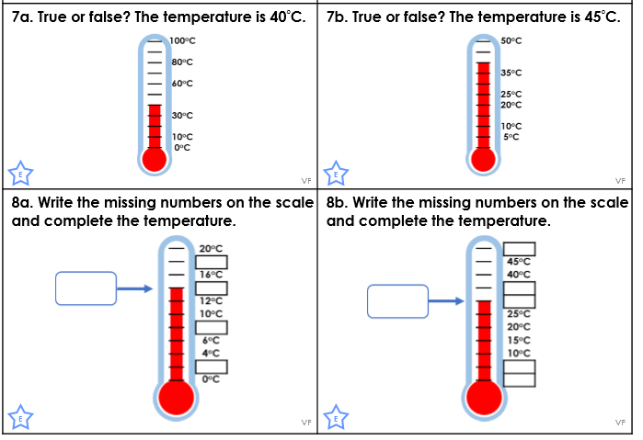

Gold-Maths
