Year 2
Please find todays learning tasks below.
The table below explains the tasks and you will find the resources underneath. Your child will know which challenge they usually access in each subject and which task will be appropriate for them.
Year group: 2 Date: 08.06.20
English | The Bear who came to babysit is the story that we will focus on in our English work this week.  Please read the story together at least once – maybe you could even try out your own voices for the characters or act it out with your family!!The story is in the link.  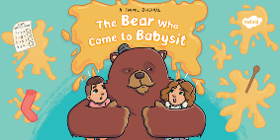
 | Bronze | Silver | Gold
 | Today you are going to write a character description of the bear.  Can use some of the words from the word bank and then describe him in sentences?  You can use the outline below if you like or write it into your book. | Today you are going to write a character description of the bear.  Can use some of the words and phrases from the word bank and then describe him in sentences?  You can use the outline below if you like or write it into your book. | Today you are going to write a character description of the bear.  Can write your word bank then use the words or phrases words to describe him in sentences?  You can use the outline below if you like or write it into your book.
Maths | Warm Up – follow this link to complete your maths warm up.  http://www.ictgames.com/mobilePage/capacity/index.html  This is a game linked to capacity and our learning last week.
 | Bronze | Silver | Gold
 | Today you will be learning about mass. Look at the Powerpoint about mass on the website.  Then, complete the reasoning problems below about comparing mass. | Today you will be learning about mass. Look at the Powerpoint about mass on the website.  Then, complete the reasoning problems below about comparing mass. | Today you will be learning about mass. Look at the Powerpoint about mass on the website.  Then, complete the reasoning problems below about comparing mass.
Reading  Phonics | Go to our website and read or share the e book of The bear who came to babysit, then sequence the story cards.  Complete the activities from the SPAG mat for today, choose bronze silver or gold.

Unless otherwise specified, please complete the tasks in either your home learning book or print out the document below.

Bronze

Silver
Gold

Bronze SPAG
Silver SPAG

Gold SPAG

Bronze Maths

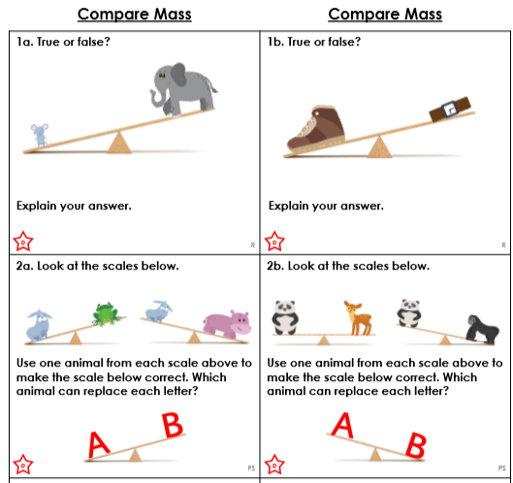

Silver Maths
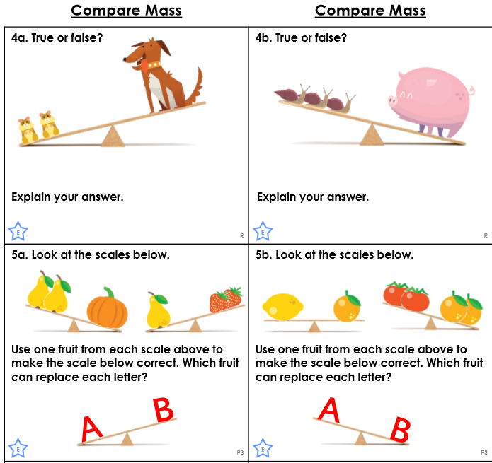

Gold Maths

