Year 2
Please find todays learning tasks below.
The table below explains the tasks and you will find the resources underneath. Your child will know which challenge they usually access in each subject and which task will be appropriate for them.
Year group: 2 Date: 12.06.2020
English | The Bear who came to babysit is the story that we will focus on in our English work this week.  Today we are developing inference – what you think might happen.
 | Bronze | Silver | Gold
 | Complete at least one of the activity sheets at the bottom – Write in what the bear is thinking. You can either print the sheet or write it into your book once you’ve looked at the picture. | Complete at least two (more if you like) of the activity sheets at the bottom – Write in what the bear is thinking. You can either print the sheet or write it into your book once you’ve looked at the picture. | Complete at least three (more if you like) of the activity sheets at the bottom – Write in what the bear is thinking. You can either print the sheet or write it into your book once you’ve looked at the picture.
Maths | Today log into Times Tables Rockstars and practise your times tables.
 | Bronze | Silver | Gold
 | Today you will be continuing to learn about temperature. Complete the sheets below. | Today you will be continuing to learn about temperature. Complete the sheets below. | Today you will be continuing to learn about temperature. Complete the sheets below.
Reading  Phonics | Go to https://www.booktrust.org.uk/books-and-reading/our-recommendations/best-new-books/ Choose a level for you and a book you like there’s lots to choose from.  Complete the activity ‘Little Bird Spelling’ Choose Year Group 1,2 or 3 and a coloured bird box to practise your spellings http://www.ictgames.com/littleBirdSpelling/

Unless otherwise specified, please complete the tasks in either your home learning book or print out the document below.

Bronze, Silver, Gold

Bronze-Maths
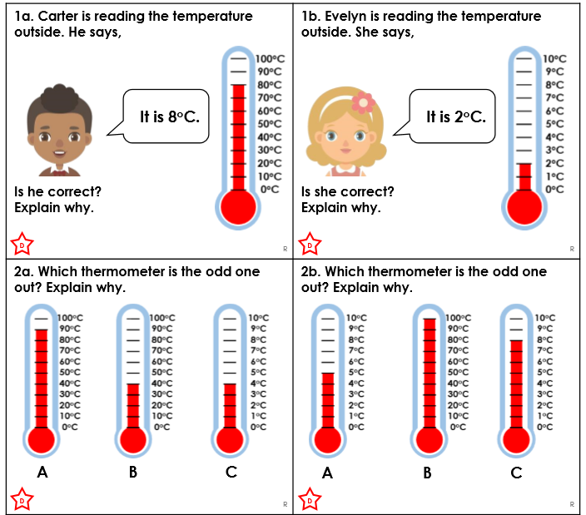
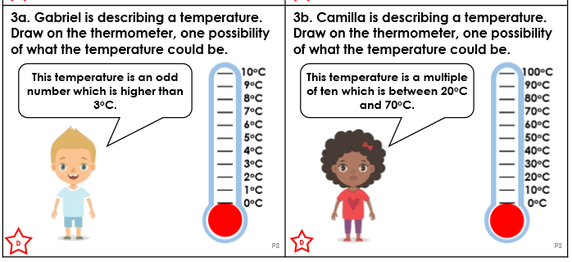

Silver-Maths
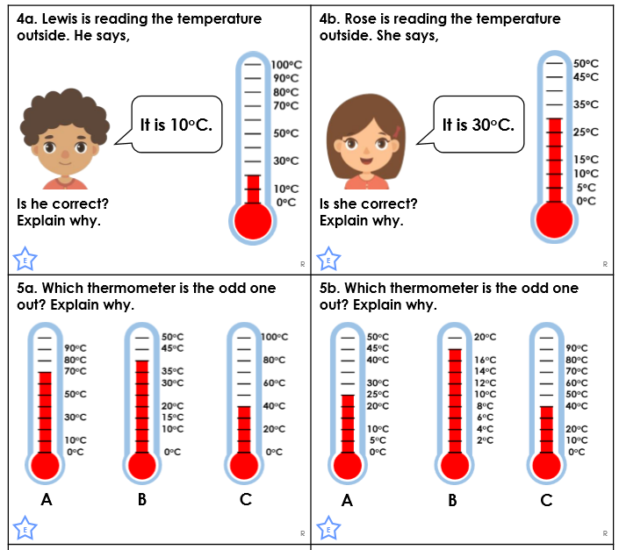
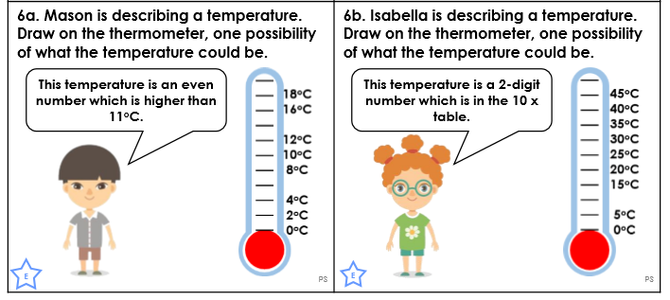

Gold-Maths
