Please find todays learning tasks below.
The table below explains the tasks and you will find the resources underneath. Your child will know which challenge they usually access in each subject and which task will be appropriate for them.
Year group: 3 Date: 29th June
 | Bronze | Silver | Gold
English | Handwriting and suffixes- Today we would like you to practise your curly caterpillar letters. Please use this link to watch the videos. https://www.bbc.co.uk/bitesize/articles/zkt7xyc Then complete the activities on the website. | Conjunctions- Today we would like you to watch the video on Education City which explains what a conjunction is. Then complete the activity sheet below.
Maths | Work out the scale intervals and then use it to read the masses from the scale. | Work out the scale intervals and then use it to read the masses from the scale. | Work out the scale intervals and then use it to read the masses from the scale.  Don’t forget to write a sentence explaining your learning.
Reading/Spelling | Please follow the link below to access online reading books. Please see the list of books for your child’s reading band in their red book. https://www.oxfordowl.co.uk/  Please read at least 2 pages of a book and record it in the red school links book. Can you write the common exception word 3 times? Please see the tables on the next pages. These are the words for this week. You could even test yourself on Friday. (new words will be given next Monday)
Unless otherwise specified , please complete the tasks in either your homework book or on a word document
Bronze- Spellings
Spelling | Write | Write | Write
climb
most
only
both
pretty

Silver/Gold- Spellings

Spelling | Write | Write | Write
guide

heard

heart

height

history

increase

knowledge

English- Bronze
Please follow this link and watch the videos to demonstrate how to write the curly caterpillar letters. Then complete the handwriting and suffix activities on the website.
https://www.bbc.co.uk/bitesize/articles/zkt7xyc

English- Silver/Gold
Please watch the video on Education City which explains what conjunctions are. Then complete this activity.

English-Silver/Gold Task 2

Maths- Bronze
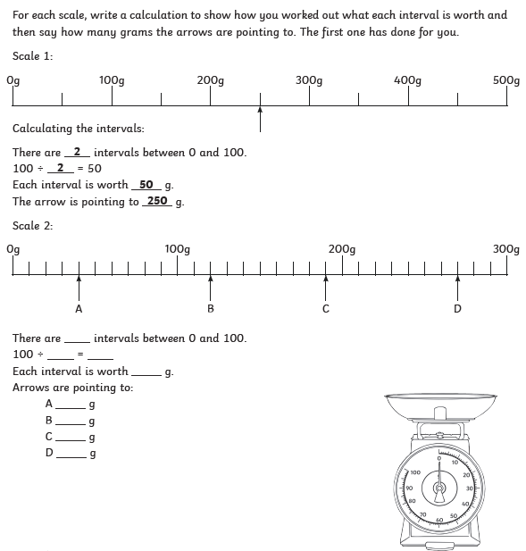

Maths- Silver
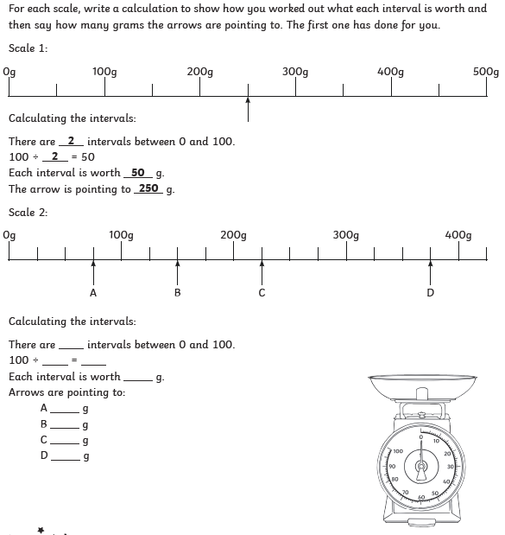

Maths- Gold
