Year Group: Year 4 Date 02.07.2020
 | Bronze | Silver | Gold
English | Sound Poems  We are looking at sound poems today. One of the most important words in this lesson is onomatopoeia, these are words that sound like the action they are trying to describe.  Follow the revision guide, visit the given webpage and then follow the given activities to write your own sound poem. We hope you have fun! | Sound Poems  We are looking at sound poems today. One of the most important words in this lesson is onomatopoeia, these are words that sound like the action they are trying to describe.  Follow the revision guide, visit the given webpage and then follow the given activities to write your own sound poem. We hope you have fun! | Sound Poems  We are looking at sound poems today. One of the most important words in this lesson is onomatopoeia, these are words that sound like the action they are trying to describe.  Follow the revision guide, visit the given webpage and then follow the given activities to write your own sound poem. We hope you have fun!
Maths | Area – Problem Solving  Can you use the knowledge you have acquired this week to solve the various problems about area. We are looking for you to do at least 4 problems out of the 6 available.  Remember to use RUCSAC when looking to solve the question. Underline the important information and keep checking your method and answer.  GOOD LUCK!! | Area – Problem Solving  Can you use the knowledge you have acquired this week to solve the various problems about area. We are looking for you to do at least 4 problems out of the 6 available.  Remember to use RUCSAC when looking to solve the question. Underline the important information and keep checking your method and answer.  GOOD LUCK!! | Area – Problem Solving  Can you use the knowledge you have acquired this week to solve the various problems about area. We are looking for you to do at least 4 problems out of the 6 available.  Remember to use RUCSAC when looking to solve the question. Underline the important information and keep checking your method and answer.  GOOD LUCK!!
Phonics/  Reading | GET EPIC! Class Code uam9686  Choose a book and get reading! It can be from any genre.  Write a little book review when you are finished?  We want to know what you liked about the book.  Was it the characters? The plot? The ending? Or was it a whole mixture of things. Tell us in a few short sentences. We can’t wait to read them

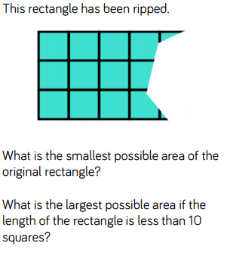
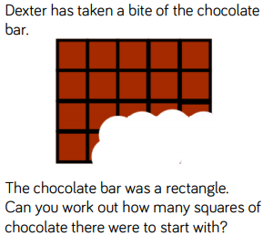
Bronze, Silver Gold Maths

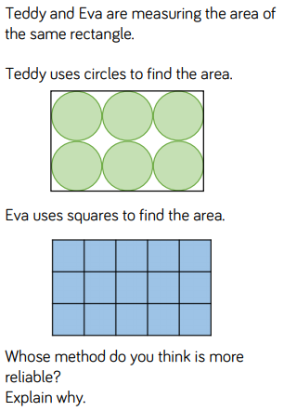

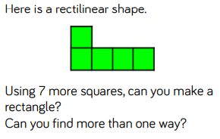
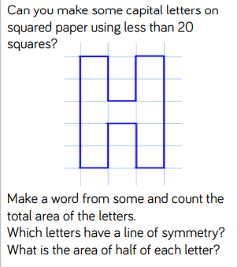

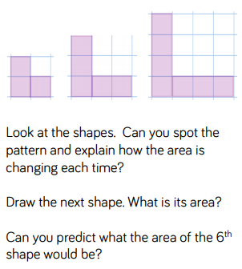

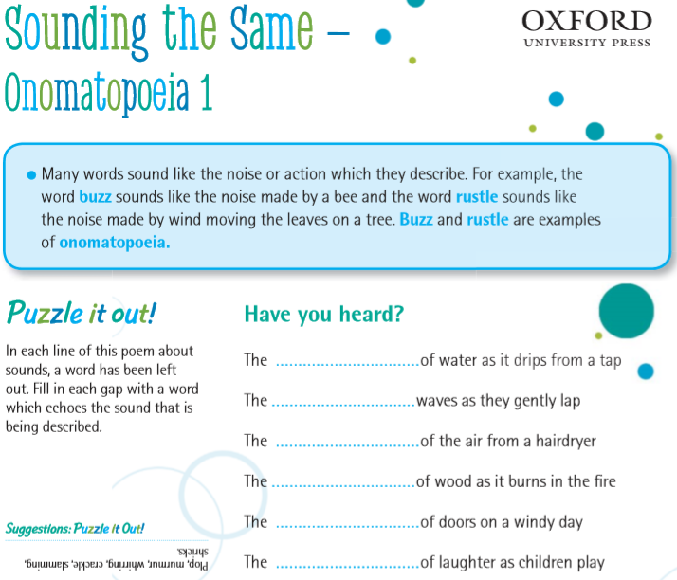
Bronze Silver Gold English

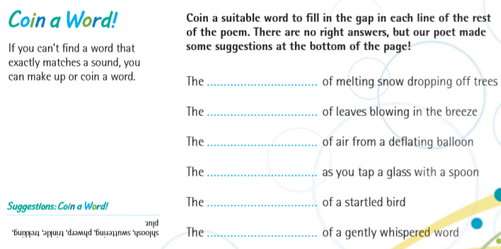

Follow the link below to watch videos and learning more about sound poetry

https://www.bbc.co.uk/bitesize/articles/zkvyxbk

Activity 1
Imagine you are visiting a zoo, like Joseph Coelho was in the video on the webpage.
Write down a list of all the onomatopoeia words you might hear in a zoo and what is making those noises.
Aim to write at least eight noises in your list.
For example:
- Roar = an angry tiger
- Plop = a penguin jumping into the water
- Rustle = branches in the insect house

Activity 2

Now write your own onomatopoeia poem.
You could use Joseph Coelho’s onomatopoeia poem from the video as inspiration.
For your poem you need to:
- Write in sentences.
- Write at least five lines.
- Use a different onomatopoeia word in each line.
You could also:
- Use rhyme (words that end with a similar sound)
- Use alliteration (words that start with the same first sounds)
Add some illustrations to your poem showing pictures of the things that are making the sounds in the zoo.

