Please find todays learning tasks below.
Year group: 3 Date: 1st July
 | Bronze | Silver | Gold
English | Sentence types- Today we would like you to understand the four types of sentences. Please use this link to watch the videos and complete the activities. https://www.bbc.co.uk/bitesize/articles/z7b3trd | Synonyms and antonyms- Today we would like you to understand what synonyms and antonyms are. Please follow the link and watch the videos. https://www.bbc.co.uk/bitesize/articles/zhwqmfr  Then complete the 3 activities on the BBC Bitesize website.
Maths | Please read the scales using Kg and g to write the amounts shown by the arrows.  Remember to work out you intervals to help you.  Don’t forget that 1Kg is 1000g.
Reading/Spelling | Please follow the link below to access online reading books. Please see the list of books for your child’s reading band in their red book. https://www.oxfordowl.co.uk/  Please read at least 2 pages of a book and record it in the red school links book. Can you write the common exception word 3 times? Please see the tables on the next pages. These are the words for this week. You could even test yourself on Friday. (new words will be given next Monday)  We have attached some wordsearches for you to complete.
The table below explains the tasks and you will find the resources underneath. Your child will know which challenge they usually access in each subject and which task will be appropriate for them.
Unless otherwise specified , please complete the tasks in either your homework book or on a word document
Bronze- Spellings

Spelling | Write | Write | Write
climb
most
only
both
pretty

Bronze- Spellings

Silver/Gold- Spellings

Spelling | Write | Write | Write
guide

heard

heart

height

history

increase

knowledge

Silver/Gold- Spellings

English- Bronze

Sentence types

We would like you to watch the videos on the following link about the 4 types of sentences.
https://www.bbc.co.uk/bitesize/articles/z7b3trd
Then complete the activities on the website.

English- Silver/Gold
Synonyms and antonyms.
We would like you to understand synonyms and antonyms are. Please follow the link and watch the videos. https://www.bbc.co.uk/bitesize/articles/zhwqmfr
Then complete the 3 activities on the BBC Bitesize website.

Maths- Bronze
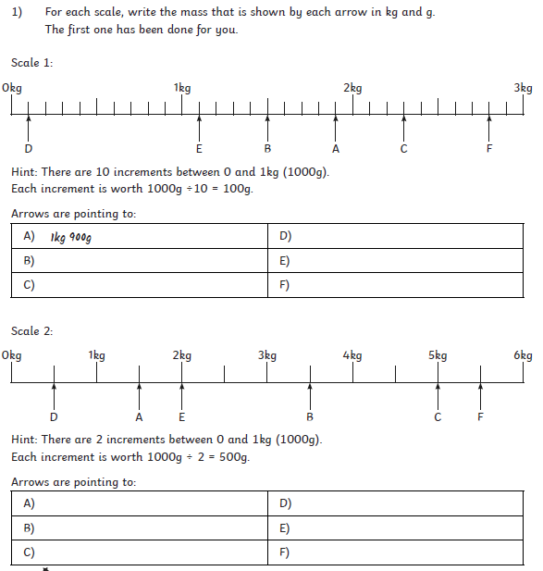

Maths- Silver
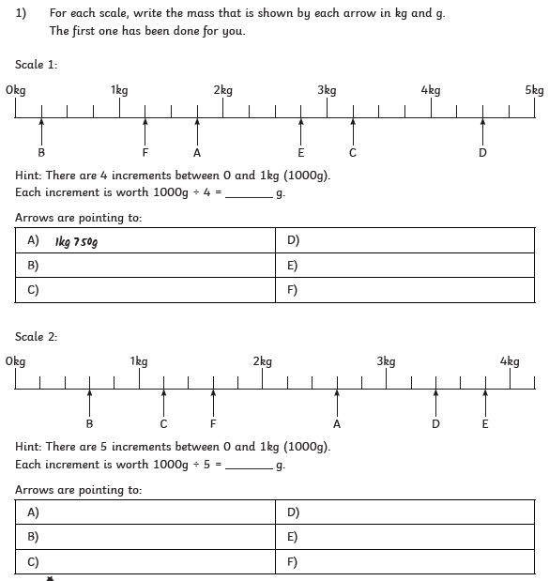

Maths- Gold
