Year Group: Year 4 Date 01.07.2020
 | Bronze | Silver | Gold
English | Rhyming Poems  Can you read the revision guide to rhyme in poem and answer the questions?  Next, use the knowledge you have acquired to create your own rhyming poem. Make sure you follow the rules! | Rhyming Poems  Can you read the revision guide to rhyme in poem and answer the questions?  Next, use the knowledge you have acquired to create your own rhyming poem. Make sure you follow the rules! | Rhyming Poems  Can you read the revision guide to rhyme in poem and answer the questions?  Next, use the knowledge you have acquired to create your own rhyming poem. Make sure you follow the rules!
Maths | Area – Comparing Area  Can you compare different shapes and work out with shapes have biggest are and which have the smallest? Can you then go on to solve different problems about comparing area? | Area – Comparing Area  Can you compare different shapes and work out with shapes have biggest are and which have the smallest? Can you then go on to solve different problems about comparing area? | Area – Comparing Area  Can you compare different shapes and work out with shapes have biggest are and which have the smallest? Can you then go on to solve different problems about comparing area?
Phonics/  Reading | GET EPIC! Class Code uam9686  Choose a book and get reading! It can be from any genre.  Write a little book review when you are finished?  We want to know what you liked about the book.  Was it the characters? The plot? The ending? Or was it a whole mixture of things. Tell us in a few short sentences. We can’t wait to read them

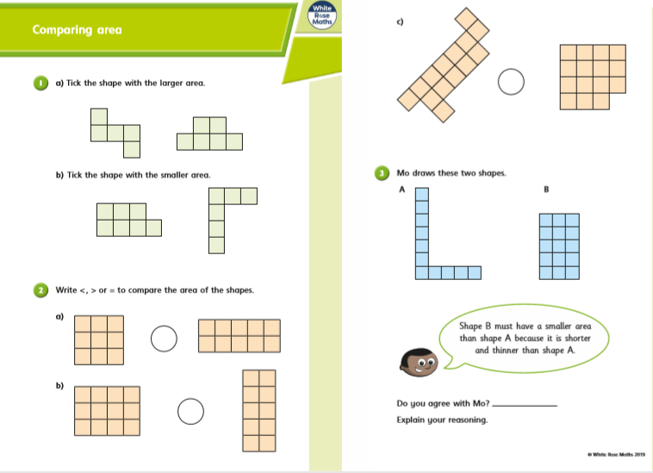
Bronze, Silver Gold Maths

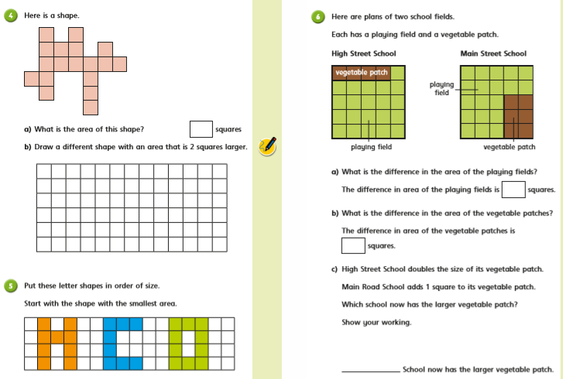

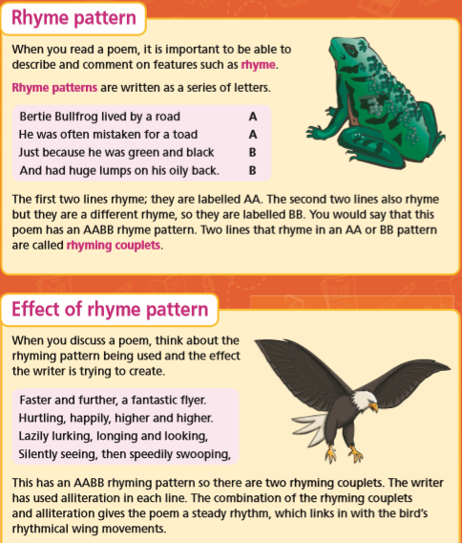
Bronze Silver Gold English
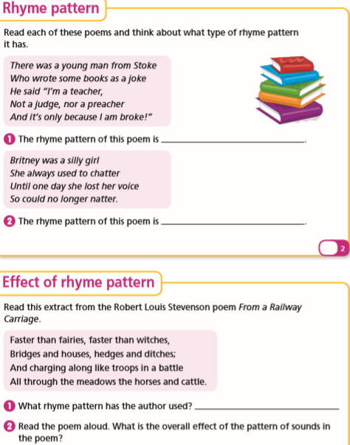

Activity

Follow the link below to watch videos and learning more about rhyming in poetry

https://www.bbc.co.uk/bitesize/articles/z3tx8hv
You’re going to have a go at writing your own poem using an A A B B rhyme scheme.
It will be based on an animal.
First choose your animal and think about what they are like.
- What colour is your animal?
- What do they eat?
- How do they act?
- What noises do they make?
Then, write your poem. It should be four lines long and follow the A A B B rhyme scheme.
Challenge yourself: If you’re really enjoying it, you could carry on and write another four lines using the same rhyme scheme.
Top tip!
If you’re struggling to think of an animal, choose one from the images below.

