Year 2
Please find todays learning tasks below.
The table below explains the tasks and you will find the resources underneath.
Your child will know which challenge they usually access in each subject and which task will be appropriate for them.
Year group: 2 Date: 3.06.20
English | Read the poem called The Magic London Bus. (Found below) Practice reading it a few times. Can you read it with expression? Can you take it in turns with your grown up to read a line each? Can you discuss any tricky words and what they might mean?
 | Bronze | Silver | Gold
 | After reading the poem, answer the questions about the poem on the sheet below. | After reading the poem, answer the questions about the poem on the sheet below. | After reading the poem, answer the questions about the poem on the sheet below.
Maths | Warm up- https://www.topmarks.co.uk/maths-games/hit-the-button  Click on the link and play the hit the button game- numbers bonds to 100.
 | Bronze | Silver | Gold
Today’s maths session is reasoning about capacity and volume.
Look at the challenge cards below. Can you reason about the questions and then practically solve them?
Reading  Phonics | Go to https://www.oxfordowl.co.uk/ log in again and continue reading the story started yesterday.  The Crystal Planet and read chapter 3 and 4.  Can you solve the muddled words? (see below)

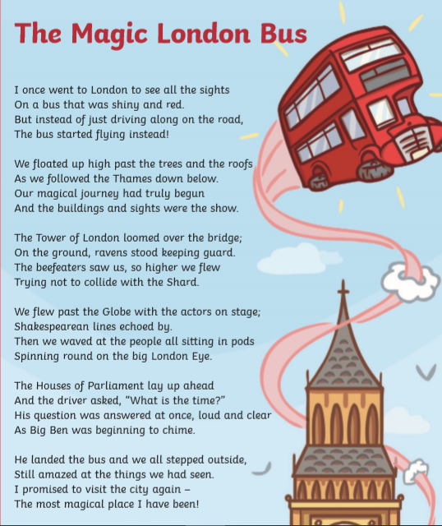

Bronze English
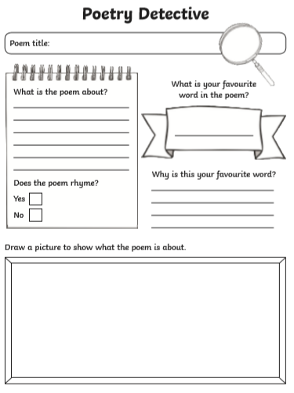

Silver English
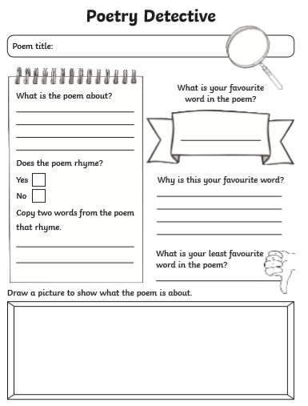

Gold English
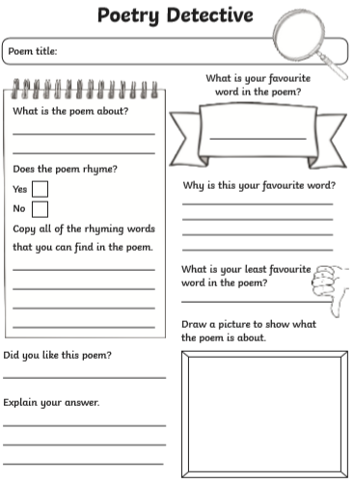

Phonics / Spelling
Can you spell these muddled words?

tehfar = ________
idlw = ____________
lwohe = _____________
flha = ____________
giana = ____________
opro = ______________
ndki = ______________
dlcuo = _______________
tbha = _______________
ecuasbe = _____________

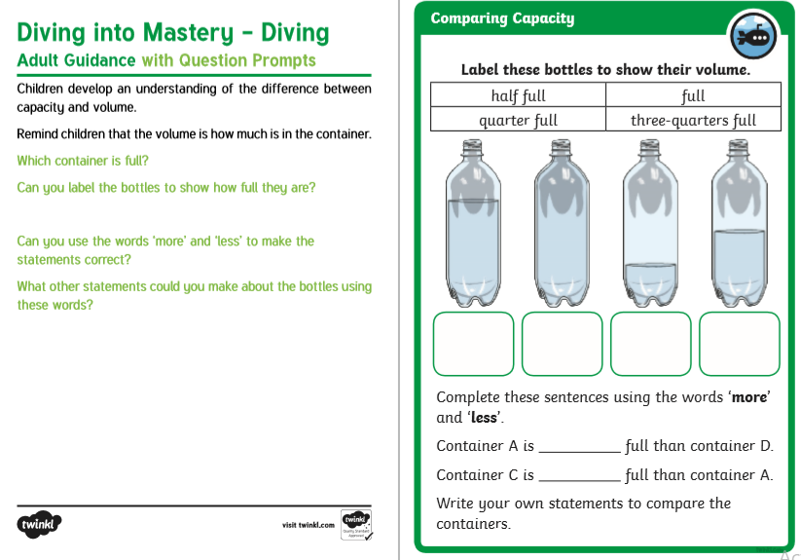
Bronze-Maths

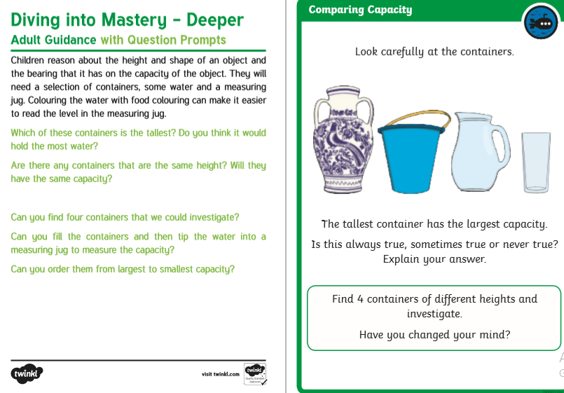

Silver-Maths
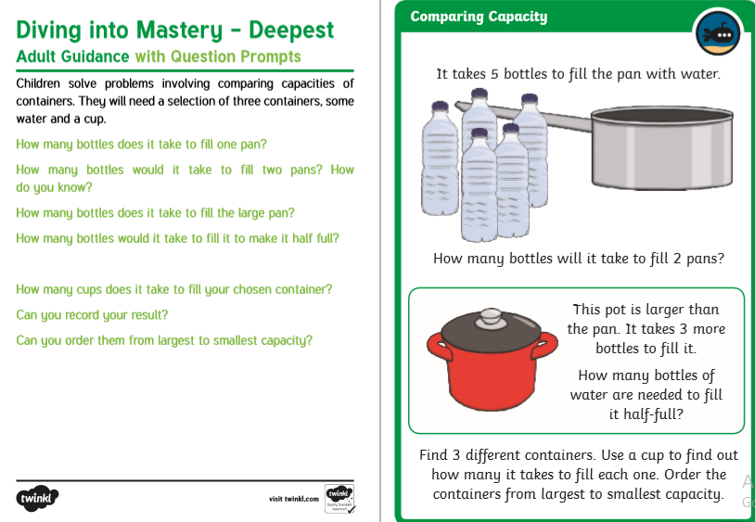
Gold-Maths

