Year 2
Please find todays learning tasks below.
The table below explains the tasks and you will find the resources underneath.
Your child will know which challenge they usually access in each subject and which task will be appropriate for them.
Year group: 2 Date: 2.06.20
English | Can you remember the story about Paddington that we watched yesterday?  You might like to have another look.  https://www.youtube.com/watch?v=mClA14WQFu8
 | Bronze | Silver | Gold
Today we are writing a list of things that you think that Paddington might want to pack in his suitcase.
Use the sheet below or write it in your home learning book.
What will be the first thing on your list?
Remember he may be away for a long time so don’t forget anything important and he can only take 10 things!
Try and include 2A in your list.

Maths | 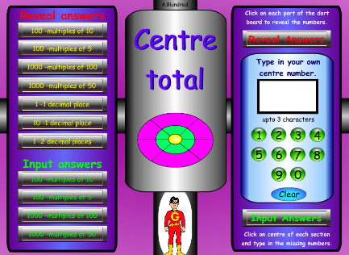  Warm Up – follow this link to complete your maths warm up.  http://www.wldps.com/gordons/Dart_Board_-_centre_total.swf  Choose the multiples of 10 and 5 from the top of the left hand column.
 | Bronze | Silver | Gold
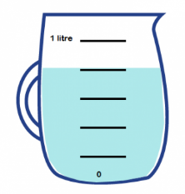
Today’s maths session is a practical activity.
Can you choose some different containers from around your kitchen and home and measure how much water they can hold in ml? Then can you put them into order. Can you take a photograph of them afterwards and share it with us?

Reading  Phonics | Go to https://www.oxfordowl.co.uk/ log in.  Search for book – The Crystal Planet and read chapters 1 and 2.  Play spelling activity on Topmarks http://www.missmaggie.org/scholastic/fishemup2_eng_launcher.html  Practise spelling words including ing / ed rules.

Unless otherwise specified, please complete the tasks in either your home learning book or print out the document below.

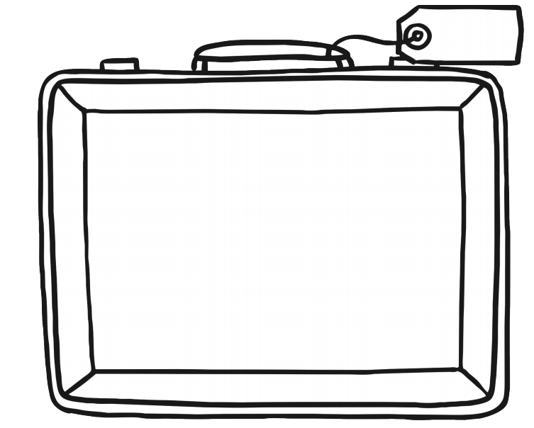
EEnjkjhkjhhjjgE
English-All Groups

