Year 2
Please find todays learning tasks below.
The table below explains the tasks and you will find the resources underneath. Your child will know which challenge they usually access in each subject and which task will be appropriate for them.
Year group: 2 Date: 01.06.20
English | 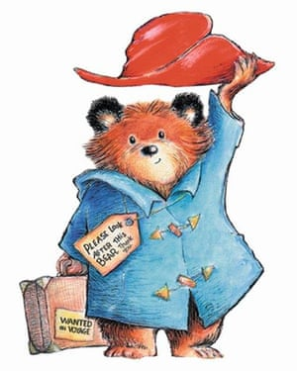  Before the holiday you will have listened and watched some of the Paddington stories. We are going to use these stories in some of our English work this week.  Watch https://www.youtube.com/watch?v=mClA14WQFu8  Paddington Bear- Please Look After This Bear
 | Bronze | Silver | Gold
 | Today you are going to write a character description of Paddington.  Can you draw a picture of him and then describe him in sentences? What does he look like? What is he wearing? What does he like doing?  You can use the outline below if you like or write it into your book. | Today you are going to write a character description of Paddington.  Can you draw a picture of him and then describe him in sentences? What does he look like? What is he wearing? What does he like doing?  Can you include some 2A (2 adjective) sentences to describe him? Paddington has a soft, blue coat on.  You can use the outline below if you like or write it into your book. | Today you are going to write a character description of Paddington.  Can you draw a picture of him and then describe him in sentences? What does he look like? What is he wearing? What does he like doing? Can you include some 2A (2 adjective) sentences to describe him? Paddington has a soft, blue coat on. Can you use also use adventurous adjectives?  You can use the outline below if you like or write it into your book.
Maths | 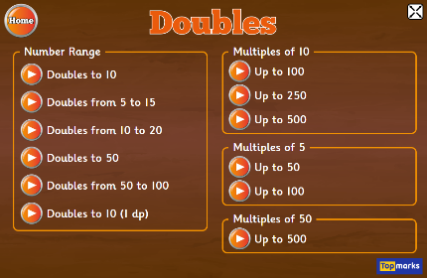  Warm Up – follow this link to complete your maths warm up.  https://www.topmarks.co.uk/maths-games/hit-the-button  Complete the Doubles Activity – start with doubles to 10 and see how far you can go!
 | Bronze | Silver | Gold
 | Today you will be learning about capacity,  Can you practise measuring out different amounts of water in a measuring jug and reading the scales in ml? Then complete the sheet below. | Today you will be learning about capacity,  Can you practise measuring out different amounts of water in a measuring jug and reading the scales in ml? Then complete the sheet below. | Today you will be learning about capacity,  . Can you practise measuring out different amounts of water in a measuring jug and reading the scales in ml? Then complete the sheet below.
Reading  Phonics | Go to https://www.booktrust.org.uk/books-and-reading/have-some-fun/storybooks-and-games/the-dragon-machine/  and read along to ‘The Dragon Machine’ by Helen Ward.  Complete the activity ‘Little Bird Spelling’ Choose Year Group 1 or 2 and a coloured bird box to practise your spellings http://www.ictgames.com/littleBirdSpelling/

Unless otherwise specified, please complete the tasks in either your home learning book or print out the document below.

English ALL groups
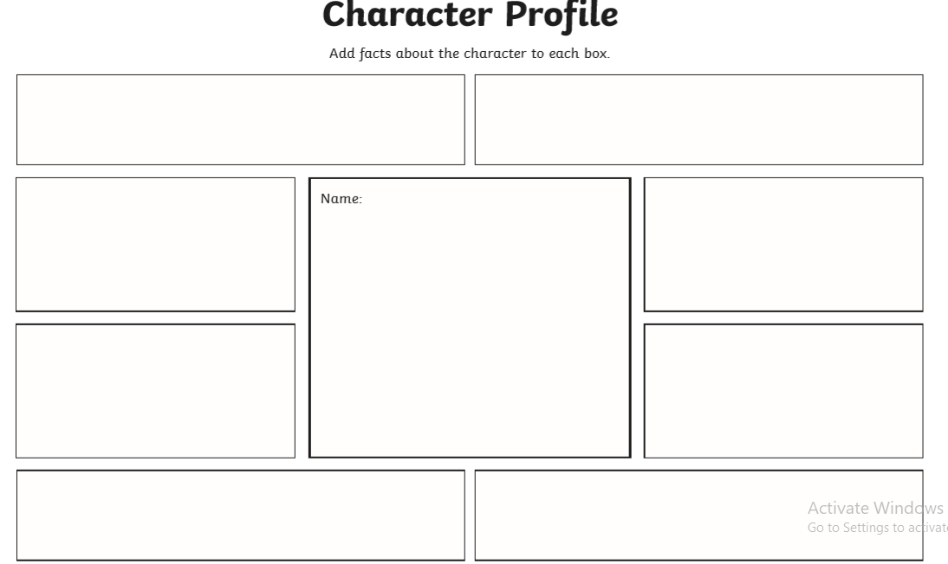

Maths Bronze
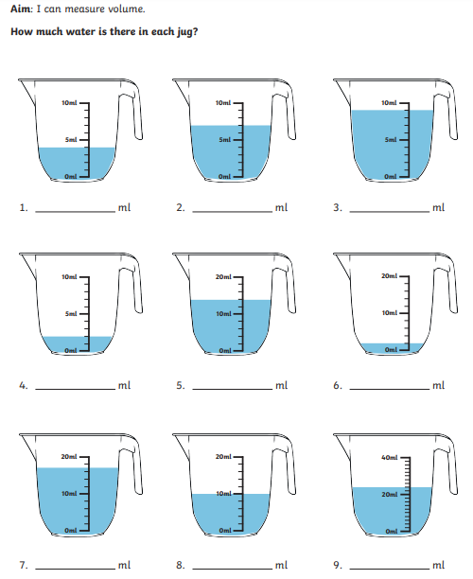

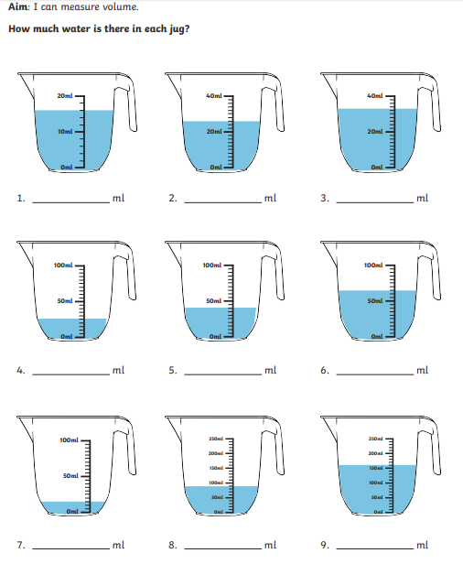Maths Silver
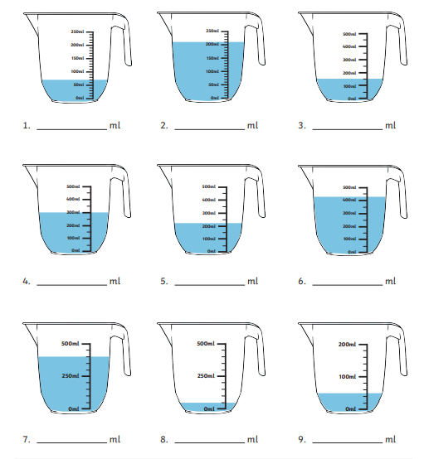Maths Gold

