Year 2
Please find todays learning tasks below.
The table below explains the tasks and you will find the resources underneath. Your child will know which challenge they usually access in each subject and which task will be appropriate for them.
Year group: 2 Date: 5.06.20
English | Today you will be answering questions about a fictional story based at the time of The Great Fire of London.
 | Bronze | Silver | Gold
 | Read the text below about Sid the Swan and answer the questions. | Read the text below about Sid the Swan and answer the questions. | Read the text below about Sid the Swan and answer the questions.
Maths | Log onto Times Tables Rockstars and play some games.
 | Bronze | Silver | Gold
 | Follow the warm up by completing the activity sheet below about multiplication and division. Remember, you can jot down any workings.  . | Follow the warm up by completing the activity sheet below about multiplication and division. Remember, you can jot down any workings. | Follow the warm up by completing the activity sheet below about multiplication and division. Remember, you can jot down any workings.  .
Reading  Phonics | Log onto Oxford Owl and choose a book to read.  Log into Spelling Shed and practise the words that have been set for you.

Uness otherwise specified, please complete the tasks in either your home learning book or print out the document below.

English Bronze
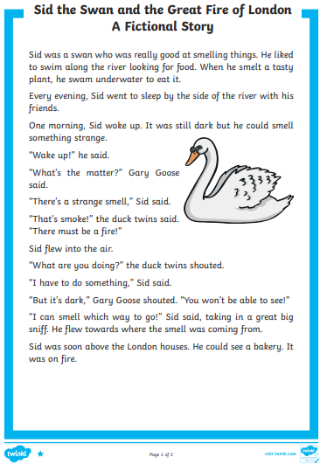

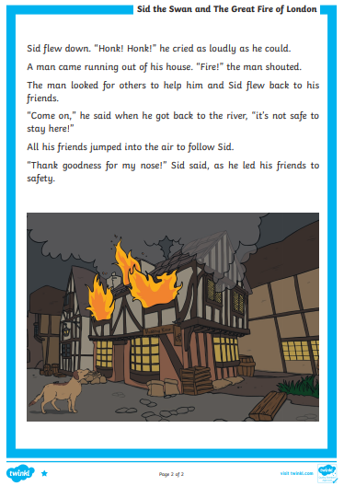

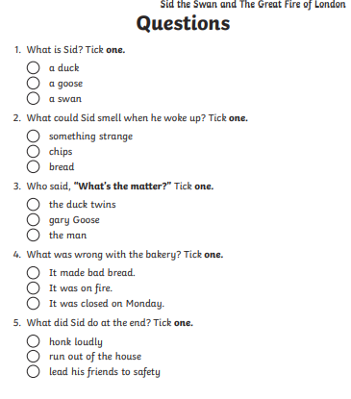
Bronze Questions

Silver English
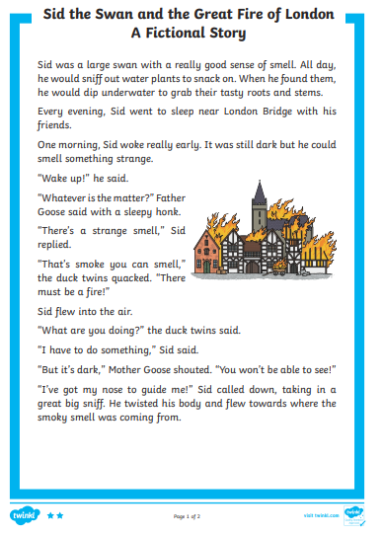
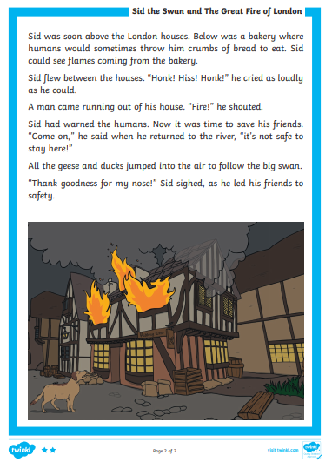
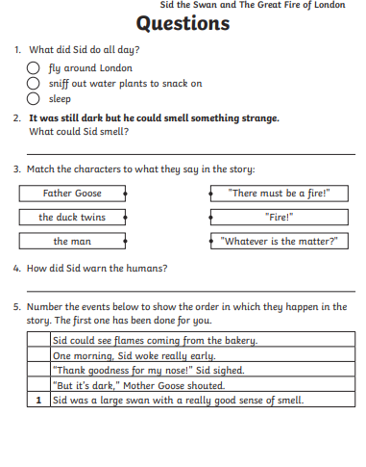
Silver Questions

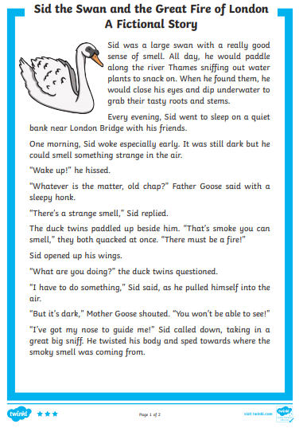
Gold- English

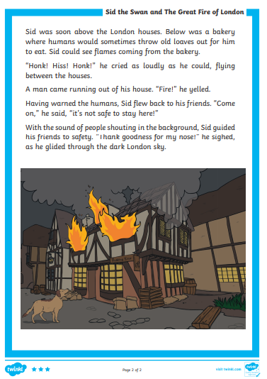

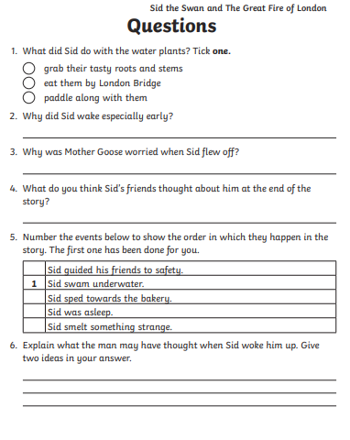
Gold Questions
Bronze -Maths
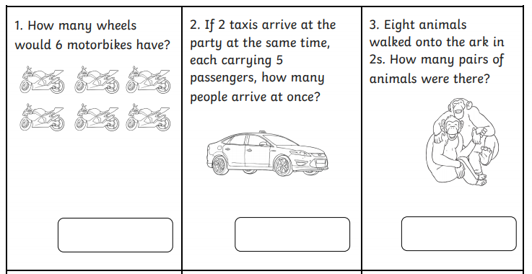
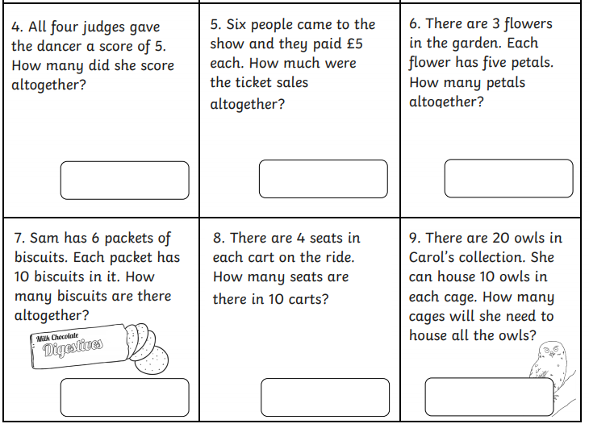

Silver- Maths
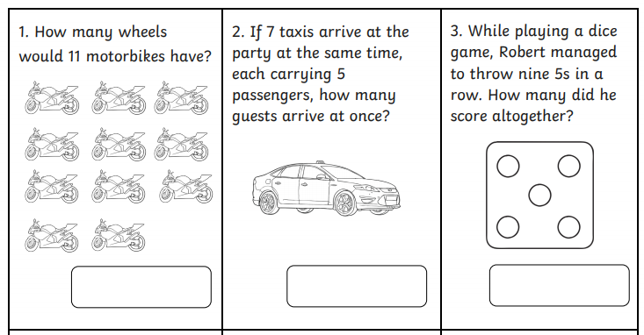
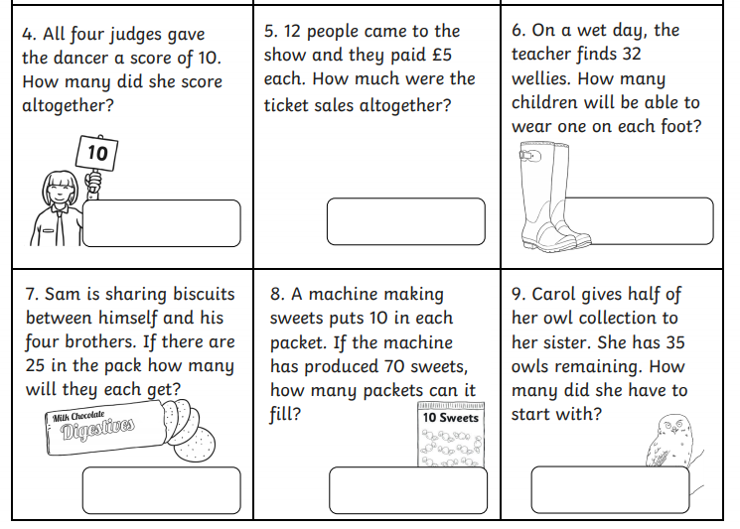

Gold-Maths
