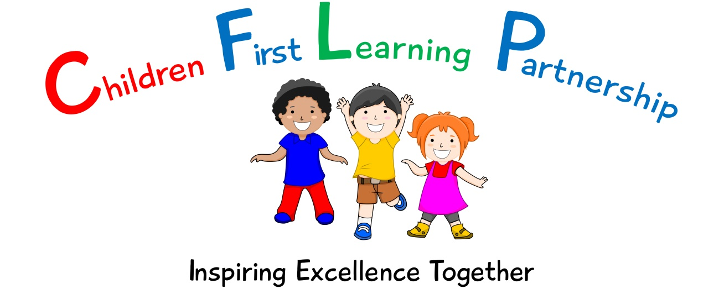

Anti-Bullying Policy 2021

March 2022 or earlier if required
To be reviewed:
March 2021
Agreed and ratified by the Local Advisory Board on:
Knypersley Headteacher- Mrs E Goodyear

Responsible Officer:
Mr. C Clulow
Chair of Local Advisory Board:
The Anti Bulling Policy in respect of Knypersley First School has been discussed and adopted by the Local Advisory Board in Spring 2021

Knypersley First School
ANTI-BULLYING POLICY 2021

This policy is available on the school website, the shared staff area on the school network and on request from the Headteacher in hard copy. It should be read in conjunction with the following policies:
- Child Protection and Safeguarding Policy
- E-safety Policy
- Equal Opportunities Policy
- Behaviour Policy
- SEN Policy and Information Report
- PSHRE Policy

PRINCIPLE OF POLICY

To meet the requirements set out in the:
- The Children’s Act 1989
- The Education and Inspection Act 2006
- The Equality Act

Knypersley First School seeks to provide a safe, secure and positive environment in which children can develop and grow making full use of the range of facilities available to them. In order to ensure a safe, secure and positive environment exists children, young people and the adults involved with them are entitled to be treated with respect and understanding and to participate in any activity free from intimidation.

THE NATURE OF BULLYING
Bullying may be defined as the intentional abuse of power by an individual or group with the intent and motivation to cause distress to another individual or group. It may be physical, sexual, verbal or psychological in nature. It may occur frequently or infrequently, regularly or irregularly, but it should be taken seriously even if it has only occurred on one occasion. Bullying is not a phenomenon which occurs solely between children. The above definition can also be seen to characterise some adult/adult, adult/child and child/adult relationships.

In more serious instances where adults abuse their power over a child or a child does over another child, bullying may be viewed as child abuse and should be seen within this context.

Different types of bullying include:

Physical hitting, kicking, spitting, tripping someone up, stealing/damaging someone’s belongings, etc.
Verbal name-calling, insulting a person’s family, threats of physical violence, spreading rumours, constantly putting a person down.
Emotional excluding someone from a group, humiliation.
Racist insulting language/gestures based on a person’s actual or perceived ethnic origin or faith, name-calling, graffiti, racially motivated violence.
Sexual sexually insulting language/gestures, name-calling, graffiti, unwanted physical contact.
Homophobic insulting language/gestures based on a person’s actual or perceived sexuality, name-calling, graffiti, homophobic violence.
Cyber All areas of internet, such as email & internet chat room misuse. Mobile threats by text messaging & calls. Misuse of associated technology , eg. cameras

Bullying can take place between pupils, between pupils and staff, or between staff. It can involve individuals or groups and be face-to-face-, indirect or use a range of cyber-bullying methods.

We are committed to creating a stimulating, motivated and happy
learning environment.

Not all aggressive behaviour is bullying. Behaviour which appears to be bullying may be exhibited by some children, especially very young children, without the intention or awareness that it causes distress.

Some individuals may feel they are being bullied, even when there is no intention from others to cause them distress. Such incidents of this behaviour should be taken seriously.

BULLYING BEHAVIOUR
Bullying behaviour is not a natural part of growing up and should not be seen as such.
Children and young people who bully are likely to experience difficult and unhappy
relationships with both peers and adults and frequently need help to overcome these difficulties. Children and young people who bully are unlikely to stop if they are not challenged.

OTHERS INVOLVED
Bullying behaviour does not just affect the victim and the perpetrator. Those who witness or know of bullying may live in fear that it will be their turn next.

Bullying promotes poor models of behaviour and may encourage others to imitate these models. Children and young people who have been bullied in one setting may well become bullies in another.

For children transferring from First to Middle school the fear of bullying is
widespread and therefore this need must be addressed by the primary school to ensure that this fear is eradicated.

Evidence has shown that bullying is a major concern for parents and children of all ages. Bullying is unacceptable behaviour and will not be tolerated at Knypersley First School.

Everyone in our school has a responsibility for the safety of others. All staff, children and young people are alerted to the fact that bullying can happen. We aim to provide and encourage a safe, listening 'no secrets' environment in which adults, children and young people feel free to discuss their concerns regarding bullying behaviour in an open fashion, on a regular basis whenever necessary.

AN OVERVIEW OF ACTION TO BE TAKEN IF BULLYING OCCURS
- Make anyone who alleges they have been bullied immediately feel safe
- Any incident will be investigated and appropriate action taken as part of the
investigation
- Incidents will be recorded and subsequent action taken where needed
- Due consideration will be given to confidential issues
- Parents will be informed
- Action will be monitored and evaluated
- Victims of bullying will be supported by staff and guided as to further action needed
- Appropriate action will be taken when necessary to prevent further bullying taking place
To ensure the above actions take place swiftly and effectively, specific roles and responsibilities are as follows:

PREVENTION:
At Knypersley First School we aim to ensure that we promote an inclusive and supported ethos by:
- a general culture of positive behaviour/ positive whole school ethos/ respect focus;
- celebrating positive role models and behavior through the behavior ladder rewards
- supporting children to develop social qualities through additional intervention - Forest School, Nurture
- regular awareness raising opportunities to communicate anti-bullying messages, policy and practice and to celebrate the success of anti-bullying work;
- the role of the class anti-bully ambassador (Knypersley Knights) lead by Mr Gillespie and strategies offered by the Trailblazers/Visyon Teams
- opportunities to promote equality and to acknowledge and celebrate diversity; eg through the special person award
- curriculum/other activities that raise awareness, cultivate a sense of responsibility and develop skills to respond to bullying, either as a bystander or as a target;
- curriculum/other activities that develop social and emotional skills;
- Classroom resources to support communication such as the emotion boards and worry monsters
- opportunities to engage children and young people in planning anti-bullying activities and in supporting their peers; eg through the leadership roles of the Playground Leaders
- appropriate levels of adult supervision so that children and young people feel safe around the site and can be confident that bullying behaviour will be seen and acted upon at all times;
- transparent systems for reporting incidents of bullying so that children and young people and parents/carers know who to turn to and confident that their concerns will be taken seriously and acted upon.

PARTNERSHIPS
The school works in partnerships with other schools, Staffordshire County Council Services (including the Police and Health Services) to reduce bullying and promote safe communities.

The role of the Teacher

Teachers in our school take all forms of bullying seriously and will intervene to prevent incidents from taking place. They keep their own records of all incidents that happen in their class and that they are aware of in the school.

If teachers witness an act of bullying, they do all they can to support the child who is being bullied.

Bullying behaviour would be recorded on the class behaviour ladder system and logged on SIMS and on My Concern if appropriate.

A logbook in the head teacher’s room records all incidents of bullying and actions taken. This may include incidents that occur outside lesson time, either near the school or on the children’s way home or to school. If any adult witnesses an act of bullying, they should request access to the school bullying log to record the event.

If, as teachers, we become aware of any bullying taking place between members of a class, we will deal with the issue immediately. We spend time talking to the child who has bullied: we explain why the action of the child was wrong, and we endeavour to help the child change their behaviour in future. If a child is repeatedly involved in bullying other children, we inform the head teacher and the special needs co-ordinator. Support is provided for both the bully and the victim through intervention (Nurture or Forest School behaviour group) or specialist partners (Trailblazers or Visyon). We invite the child’s parents into the school to discuss the situation. In more extreme cases, for example where these initial discussions have proven ineffective, the head teacher may contact external support agencies such as the social services.

Training is available to all staff which will enable them to become equipped to deal with incidents of bullying and behaviour management. Personal training requirements will be reviewed as part of the staff performance management annual cycle.

Teachers will attempt to support all children in their class and to establish a climate of trust and respect for all. By praising, rewarding and celebrating the success of all children, we aim to prevent incidents of bullying.

The role of the Pupil

Without the support of our pupils we will not be able to prevent bullying. That is why our pupils will be consulted and will participate in the development, monitoring and review of anti-bullying policy and strategies. We want our pupils to feel confident that everything is being done to make school a safe and secure environment for them to achieve and learn.
We want our pupils to feel that they are supported in reporting incidents of bullying and reassured that action regarding bullying will take place.
We expect that pupils:
- will support the Headteacher and staff in the implementation of the policy
- will not bully anyone else, or encourage and support bullying by others
- will tell an adult if they are being bullied, usually either a member of staff or parent (could suggest alternatives)
- will act to prevent and stop bullying, usually this is through telling an adult if they know or suspect that someone else is being bullied
Pupils must recognise that being a “bystander” is not acceptable and understand how their silence supports bullying and makes them in part responsible for what happens to the victim of bullying.

The role of the Head Teacher
It is the responsibility of the Headteacher to implement the school anti bullying strategy and to ensure that all staff (both teaching and non-teaching) are aware of the school policy and know how to deal with incidents of bullying. The head teacher reports to the governing body about the effectiveness of the anti-bullying policy on an annual basis.
The head teacher will ensure that all children know that bullying is wrong, and that
it is unacceptable behaviour in this school. The Head teacher will draw the attention of children to this fact at suitable moments. For example, if an incident occurs, the head teacher may decide to use assembly as a forum in which to discuss with other children why this behaviour was wrong, and why a pupil is being punished.
The Head teacher will ensure that all staff receives sufficient training to be equipped to deal with all incidents of bullying.
The Head teacher sets the school climate of mutual support and praise for success, so making bullying less likely. When children feel they are important and belong to a friendly and welcoming school, bullying is far less likely to be part of their behaviour.

The role of Parents
Parents who are concerned that their child might be being bullied, or who suspect that their child may be the perpetrator of bullying, should contact their child’s class teacher immediately.
Parents have a responsibility to support the school’s anti-bullying policy and to actively encourage their child to be a positive member of the school.

The role of Local Advisory Board
The Local Advisory Board supports the head teacher in all attempts to eliminate bullying from our school. This policy statement makes it very clear that the board members do not allow bullying to take place in our school, and that any incidents of bullying that do occur are taken very seriously and dealt with appropriately.

The Local Advisory Board will monitor the incidents of bullying that occur, and reviews the effectiveness of the school policy regularly. The governors require the Headteacher to keep accurate records of all incidents of bullying and to report to the governors annually about the effectiveness of school anti-bullying strategies.

The Local Advisory Board will respond within ten days to any request from a parent to investigate incidents of bullying. In all cases, the board members will notify the headteacher and asks him/her to conduct an investigation into the case and to report back to a representative of the board.

Monitoring and review
Owing to the sensitive nature of this policy the monitoring of its effectiveness takes place on a day-to-day basis by the head teacher, who reports to governors about the effectiveness of the policy on an annual basis, this will include the number of bullying incidents recorded and the schools response and actions.

Governors will analyse the information provided with regard to gender, age and ethnic background of all children involved in bullying incidents, referring to other related policies such as Behaviour and SEND Policy.

The school will review this policy annually and assess its implementation and effectiveness. The policy will be promoted and implemented throughout the school.

