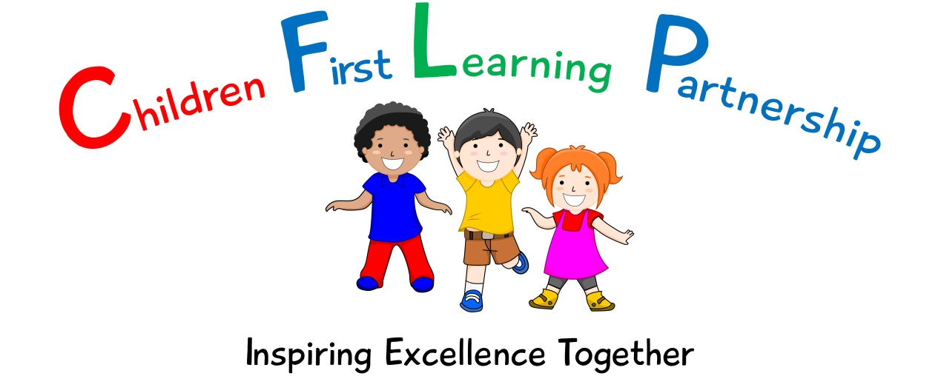

SOCIAL MEDIA POLICY ( Version 2)

May 2022
To be reviewed:
26.05.2021
Agreed and ratified by the Directors Board on:
CEO – Mrs A Rourke
Responsible Officer:
Mrs N Chell
Chair of Board:
The Social Media Policy in respect of the Children First Learning Partnership has been discussed and adopted by the Directors Board

Contents

Clause

1. About this policy 4
2. Scope 4
3. Personnel responsible for implementing the policy 4
4. Compliance with related policies and agreements 5
5. Data protection 5
6. Personal use of social media 6
7. Prohibited use 7
8. Use of social media on behalf of the Children First Learning Partnership 8
9. Guidelines for responsible use of social media 8
10. Monitoring 9
11. Recruitment 10
12. Breach of this policy 10

About this policy

This policy is in place to minimise the risks to the Children First Learning Partnership through use of social media and to provide guidance for staff to ensure that social media is used responsibly.

This policy deals with the use of all forms of social media, including but not limited to Facebook, MySpace, LinkedIn, Twitter, Google+, Wikipedia, Whisper, Instagram, Vine, flickr, YouTube, Tumblr and all other social networking sites, internet postings and blogs. It applies to the use of social media for Children First Learning Partnership business as well as personal use that may affect the Children First Learning Partnership in any way.

This policy does not form part of any employee's contract of employment and the Children First Learning Partnership may amend it at any time.

Scope

This policy applies to the Children First Learning Partnerships Governing Body, all teaching and non-teaching staff, trainee teachers, other trainees, volunteers and individuals or external contractors who provide services to the Children First Learning Partnership]. These individuals are collectively referred to as staff in this policy.

This policy applies to the personal use of social media and the use of social media for official Children First Learning Partnership purposes. This includes any social media sites hosted or maintained on behalf of the Children First Learning Partnership

Personnel responsible for implementing the policy

The Directors of the Children First Learning Partnership has overall responsibility for the effective operation of this policy, but has delegated day-to-day responsibility for its operation to the Headteacher/Head of School.

Responsibility for monitoring and reviewing the operation of this policy and making recommendations for change to minimise risks lies with the Headteacher/Executive Head and the members of the Local Advisory Board who will review this policy regularly to ensure that it meets legal requirements and reflects best practice.

Headteachers/ Heads of School have a specific responsibility for operating within the boundaries of this policy, ensuring that all staff understand the standards of behaviour expected of them and taking action when behaviour falls below its requirements.

All staff are responsible for the success of this policy and should ensure that they take the time to read and understand it. Any misuse of social media should be reported to the Headteacher. Questions regarding the content or application of this policy should be directed to the Headteacher.

Compliance with related policies and agreements

Social media should never be used in a way that breaches any of the Children First Learning Partnership’s other policies. If an internet post would breach any of the Children First Learning Partnership’s policies in another forum, it will also breach them in an online forum. For example, staff are prohibited from using social media to:

breach the Children First Learning Partnership’s [Information and Communications Systems Policy];

breach the Children First Learning Partnership’s obligations with respect to the rules of relevant regulatory bodies;

breach any obligations contained in those policies relating to confidentiality;

breach the Children First Learning Partnership’s [Disciplinary Policy or procedures];

harass or bully other staff in any way;

unlawfully discriminate against other staff or third parties;

breach the Children First Learning Partnership’s [Data Protection Policy] (for example, never disclose personal information about a colleague online); or

breach any other laws or regulatory requirements.

Staff should never provide references for other individuals on social or professional networking sites, as such references, positive and negative, can be attributed to the Children First Learning Partnership and create legal liability for both the author of the reference and the Children First Learning Partnership.

Staff who breach any of the above policies will be subject to disciplinary action up to and including termination of employment.

Data protection

All staff are bound by a duty of confidentiality in relation to information obtained during the course of their employment. The Children First Learning Partnership is committed to protecting the confidentiality of information covered by the Data Protection Act 1998. This will include (but is not limited to):

Pupil information/data;

Staff records; and

Commercially sensitive information relating to the Children First Learning Partnership.

Personal use of social media

Personal use of social media is never permitted during working hours or by means of the Children First Learning Partnership’s computers, networks and other IT resources and communications systems.

Staff should at all times keep their personal use of social media separate from their professional use of social media (where use of social media on behalf of the Children First Learning Partnership is permitted under this policy).

When using any personal social media sites, staff must not:

identify themselves as employees of the Children First Learning Partnership;

contact pupils from the Children First Learning Partnership or any other school (unless the pupil is a family member and the member of staff does not pass on any confidential information gained during the course of their employment to that family member);

contact members of a pupil’s family;

accept a friend request from a pupil, an ex-pupil or a member of a pupil/ex-pupil’s family;

post any details or information obtained during the course of their employment with the Children First Learning Partnership;

post any photographs, videos or any other type of image of pupils, in particular pupils wearing their Children First Learning Partnership uniform;

post any photographs, videos or other type of image of other staff members wearing clothing that could be associated with the Children First Learning Partnership;

post the contact details of the Children First Learning Partnership on any personal social media papers;

link any official contact details or Children First Learning Partnership email addresses to their personal online social media accounts or use these addresses to communicate;

use part copies of any logos or brands linked to the Children First Learning Partnership;

put themselves in a situation where there is conflict between their personal interests and the interests of the Children First Learning Partnership; and

post anything on their personal social media sites which could bring the Children First Learning Partnership into disrepute.

Staff must report any communications received from pupils, ex-pupils or family members of pupils on their personal social media site to the Headteacher.

Staff must not edit online encyclopaedias such as Wikipedia in a personal capacity whilst at work using IT equipment owned by the Children First Learning Partnership.

Prohibited use

Staff must avoid making any social media communications that could damage the Children First Learning Partnership’s interests or reputation, even indirectly.

Staff must not use social media to defame or disparage the Children First Learning Partnership, its staff or any third party; to harass, bully or unlawfully discriminate against staff or third parties; to make false or misleading statements; or to impersonate colleagues or third parties or publish any content which may result in a claim for defamation, discrimination, breaches of copyright, data protection or any other claim(s) for damages.

Staff must not express opinions on the Children First Learning Partnership’s behalf via social media, unless expressly authorised to do so by the Headteacher/Head of School. Staff may be required to undergo training in order to obtain such authorisation.

Staff must not post comments about sensitive topics, such as the Children First Learning Partnership’s performance, or do anything to jeopardise its confidential information or intellectual property on any social media sites.

Staff are not permitted to add contacts made during the course of their employment to personal social networking accounts.

Staff must report any misuse of social media to the Headteacher/Heads of School
Use of social media on behalf of the Children First Learning Partnership.

Any use of social media on behalf of the Children First Learning Partnership must be approved by the Headteacher/Executive Headteacher. Staff may be required to undergo training before they use social media on behalf of the Children First Learning Partnership, or certain requirements and restrictions may be imposed with regard to the use of social media on behalf of the Children First Learning Partnership.

Staff must not create social media accounts on behalf of the Children First Learning Partnership without obtaining prior approval to do so from the Headteacher/Executive Headteacher.

Any use of social media on behalf of the Children First Learning Partnership must be in accordance with the rules and regulations of the social media service provider, particularly with regards to minimum age requirements.

Staff members must act in the best interests of the Children First Learning Partnership, its staff and its pupils when using social media on behalf of the Children First Learning Partnership and must not post anything online which could be interpreted as being discriminatory, derogatory, defamatory or abusive, or would otherwise cause the reputation of the Children First Learning Partnership to be damaged.

Any communications on behalf of the Children First Learning Partnership using social media must be made from an official Children First Learning Partnership social media account.

If a member of staff is contacted for comments about the Children First Learning Partnership for publication anywhere, including in any social media outlet, they must direct the enquiry to the Headteacher/Head of School and must not respond without written approval.

Staff must not represent their personal views as those of the Children First Learning Partnership when using social media on behalf of the Children First Learning Partnership.

Guidelines for responsible use of social media

Staff should:

make it clear in social media postings, or in their personal profile, that they are speaking on their own behalf. Staff should write in the first person and link a personal e-mail address to their account;

keep all personal log-in information and passwords confidential. Staff are advised not to disclose personal contact information on any social media site;

set their privacy settings to the highest possible levels on all personal social media sites; and

be respectful to others when making any statement on social media and be aware that they are personally responsible for all communications which will be published on the internet for anyone to see.

If a member of staff discloses their affiliation with the Children First Learning Partnership on their profile or in any social media postings, they must state that their views do not represent those of the Children First Learning Partnership (unless they are authorised to speak on behalf of the Children First Learning Partnership as set out in paragraph 7.3).

Staff should also ensure that their profile and any content they post is consistent with the professional image they present to pupils and colleagues.

If a member of staff is uncertain or concerned about the appropriateness of any statement or posting, they must refrain from posting it until they have discussed it with the Headteacher.

If a member of staff sees social media content that disparages or reflects poorly on the Children First Learning Partnership, they should contact the Headteacher/Head of School.

Monitoring

The Children First Learning Partnership reserves the right to monitor, intercept and review, without further notice, staff activities using its IT resources and communications systems, including but not limited to social media postings and activities, to ensure that its rules are being complied with and for legitimate business purposes and staff consent to such monitoring by their use of such resources and systems.

For further information, please refer to the Children First Learning Partnership’s [Information and Communications Systems Policy].

Recruitment
The Children First Learning Partnership reserves the right to use internet searches to perform due diligence on candidates in the course of recruitment. Where it does this, the Children First Learning Partnership will act in accordance with its data protection and equal opportunities obligations.

Breach of this policy

Breach of this policy may result in disciplinary action up to and including dismissal. Any member of staff suspected of committing a breach of this policy will be required to co-operate with the Children First Learning Partnership’s investigation, which may involve handing over relevant passwords and login details.

Staff may be required to remove any social media content that the Children First Learning Partnership considers to constitute a breach of this policy. Failure to comply with such a request may in itself result in disciplinary action.

Any providers contracted by the Children First Learning Partnership must inform the Headteacher immediately if a breach of this policy comes to light so that appropriate action can be taken to limit any reputational damage to the Children First Learning Partnership and to protect any confidential information. If further action is necessary in relation to these breaches, it should be taken in accordance with the provider’s disciplinary procedure.

Version Control:

Version | Date | Amendment | By
V2 | 23.04.2021 | Date of review (04.05.2021) and ratification changed to 26.05.2021 (Front cover) | CEO

