Year 2
All of our work for the next two weeks is based around the book ‘Starry Eyed Stan’ Please find todays learning tasks below.
The table below explains the tasks and you will find the resources underneath. Your child will know which challenge they usually access in each subject and which task will be appropriate for them.
Year group: 2 Date: 08.07.2020
English | Starry Eyed Stan.  Please read the story together again –There is a Powerpoint of the story or you can listen or read to the e –book.
 | Bronze | Silver | Gold
 | Today we’d like you to complete the postcard activity. Use the sheet or write your own in your book. | Today we’d like you to complete the postcard activity. Use the sheet or write your own in your book. | Today we’d like you to complete the postcard activity. Use the sheet or write your own in your book.
Maths | Warm Up – follow this link to complete your maths warm up.  https://www.ictgames.com/tablesTennis/mobile/index.html  get someone to play times tables ping pong against you to increase your speed!!
 | Bronze | Silver | Gold
 | Today you will be solving the addition and subtraction challenges to crack the code. Maybe you can challenge yourself to write a code for someone else to crack!!
Reading  Phonics | Choose an activity from the reading Bingo sheet.  Complete the crossword using words linked to the story.

Unless otherwise specified, please complete the tasks in either your home learning book or print out the document below.

Bronze
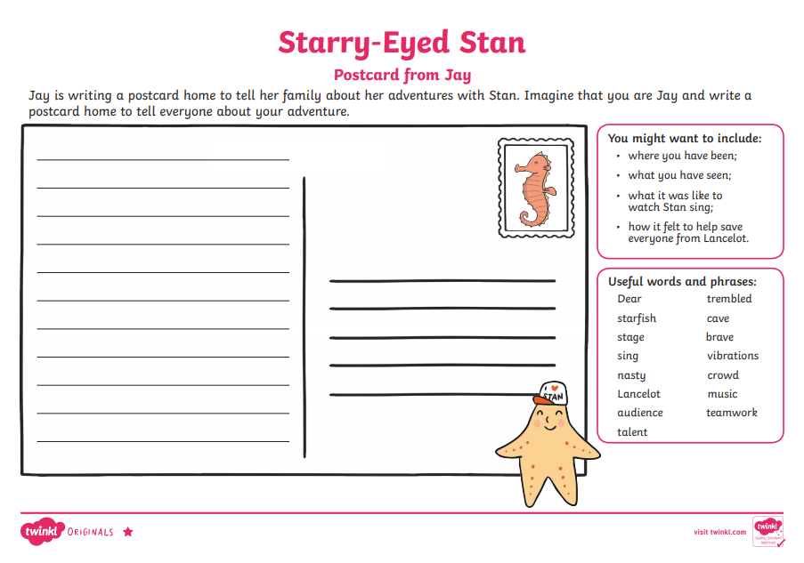
Silver
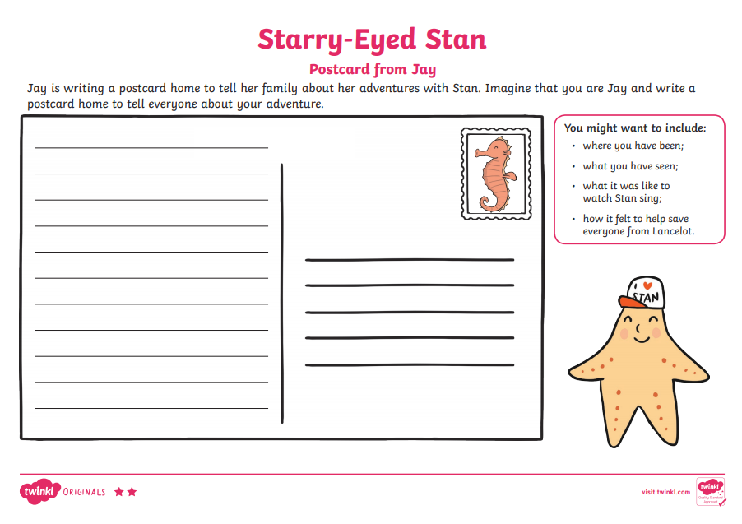
Gold
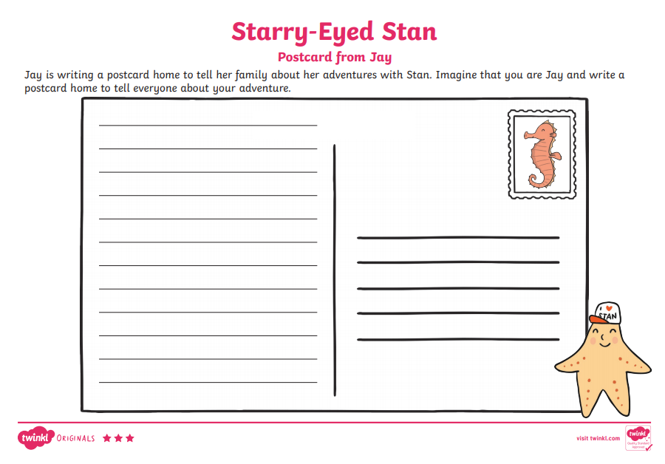
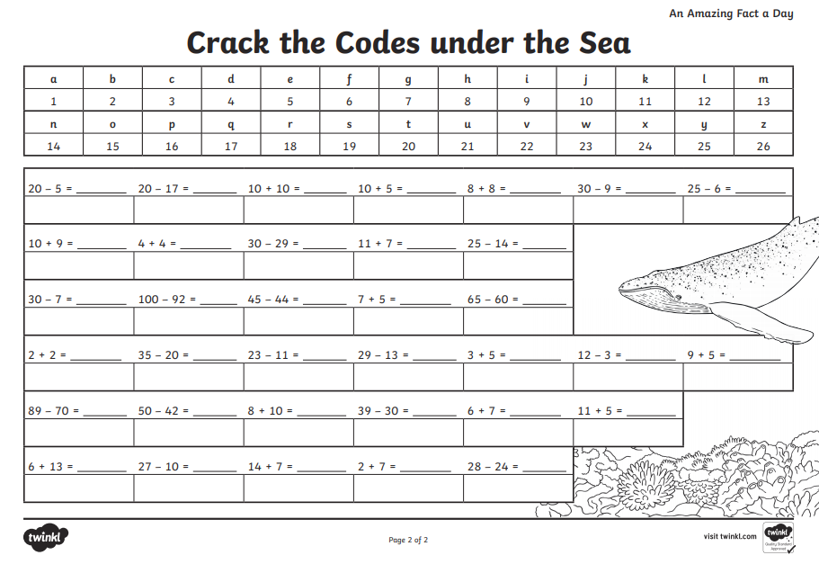
SPAG
