Year 2
All of our work for the next two weeks is based around the book ‘Starry Eyed Stan’ Please find todays learning tasks below.
The table below explains the tasks and you will find the resources underneath. Your child will know which challenge they usually access in each subject and which task will be appropriate for them.
Year group: 2 Date: 07.07.20
English | Starry Eyed Stan.  Please read the story together again –There is a Powerpoint of the story or you can listen or read to the e –book.
 | Bronze | Silver | Gold
 | Today we’d like you to use the word mat to help you when you write a character description – please try hard to use neat presentation and super sentences. | Today we’d like you to use the word mat and your own super adjectives to help you when you write a character description – please try hard to use neat presentation and super sentences. | Today we’d like you to use the word mat, your own super adjectives and a variety of sentence types to write a character description – please try hard to use neat presentation and super sentences.
Maths | Warm Up – follow this link to complete your maths warm up.  https://www.topmarks.co.uk/maths-games/hit-the-button  choose the activity and level which suits you.
 | Bronze | Silver | Gold
 | Today you will be completing a money activity about concert ticket prices – watch the Powerpoint buying concert tickets and complete the activities. | Today you will be completing a money activity about concert ticket prices – watch the Powerpoint buying concert tickets and complete the activities. | Today you will be completing a money activity about concert ticket prices – watch the Powerpoint buying concert tickets and complete the activities.
Reading  Phonics | Choose an activity from the reading bingo sheet and complete it with a book of your own or an on-line book from Oxford Owls.  Log in to use education city and play any phonics and spelling game you like – If year two is too tricky try year one and if you want a challenge try year 3!!

Unless otherwise specified, please complete the tasks in either your home learning book or print out the document below.

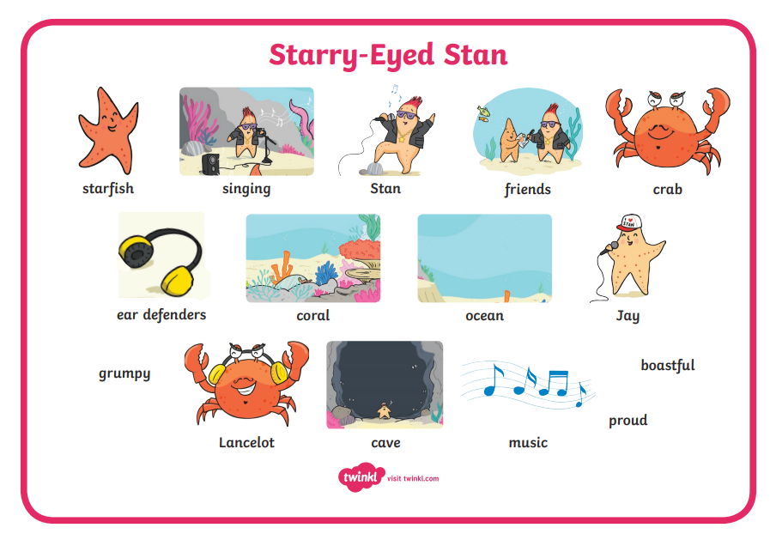
Bronze
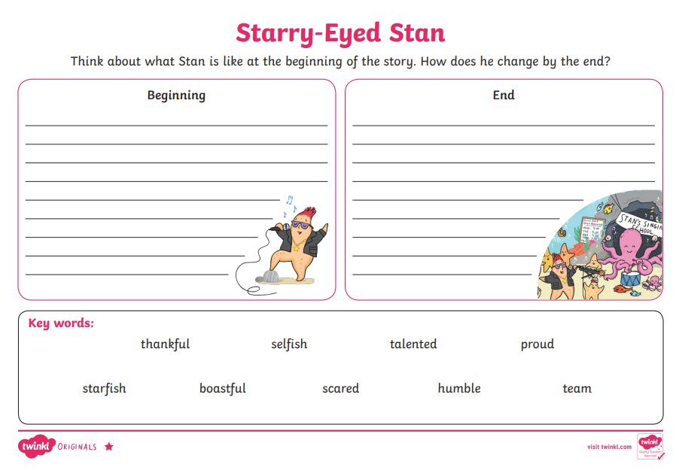
Silver
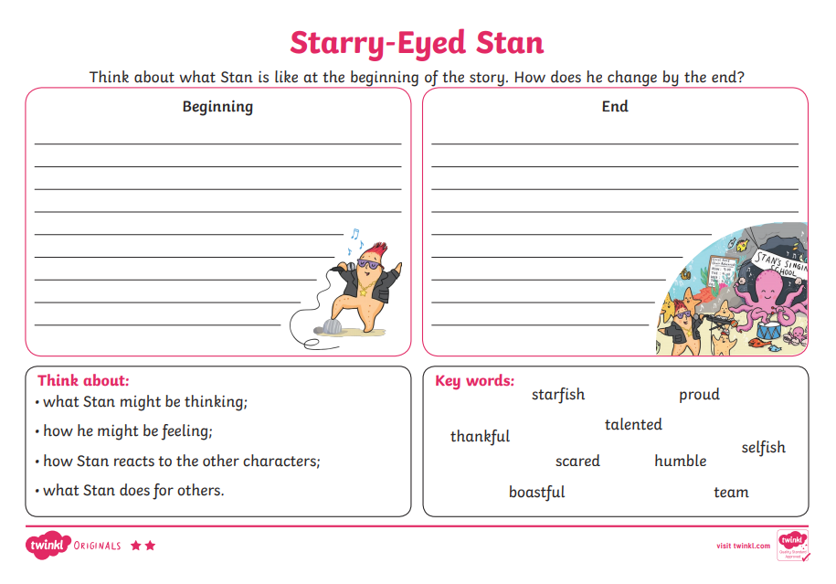
Gold
