Year 2
All of our work for the next two weeks is based around the book ‘Starry Eyed Stan’ Please find todays learning tasks below.
The table below explains the tasks and you will find the resources underneath. Your child will know which challenge they usually access in each subject and which task will be appropriate for them.
Year group: 2 Date: 09.07.2020
English | Starry Eyed Stan.  Please read the story together again –There is a Powerpoint of the story or you can listen or read to the e –book.
 | Bronze | Silver | Gold
 | Today we’d like you to complete the diary writing activity. Use the sheet or write your own in your book. | Today we’d like you to complete the diary writing activity. Use the sheet or write your own in your book. | Today we’d like you to complete the diary writing activity. Use the sheet or write your own in your book.
Maths | Warm Up – follow this link to complete your maths warm up.  https://mathsframe.co.uk/en/resources/resource/116/telling-the-time  try to match the clocks and their times.
 | Bronze | Silver | Gold
 | Complete the time activities. Is it o’clock, half past, quarter past or quarter to? It might help to use the clock here  https://www.topmarks.co.uk/time/teaching-clock  If you don’t have a printer write the times into your book. | Complete the time activities. Can you read the time to the nearest 5 minutes? It might help to use the clock here https://www.topmarks.co.uk/time/teaching-clock  If you don’t have a printer write the times into your book. | Complete the time problem activities. It might help to use the interactive clock to help you. Click the link https://www.topmarks.co.uk/time/teaching-clock  If you don’t have a printer write the times into your book.
Reading  Phonics | Choose an activity from the reading Bingo sheet.  Complete the BBC bite size activity linked to first, second or third person for our grammar activity. https://www.bbc.co.uk/bitesize/topics/zrqqtfr/articles/zxdhsg8 watch the clip then play the sorting game.

Unless otherwise specified, please complete the tasks in either your home learning book or print out the document below.

Bronze
Silver
Gold
Bronze
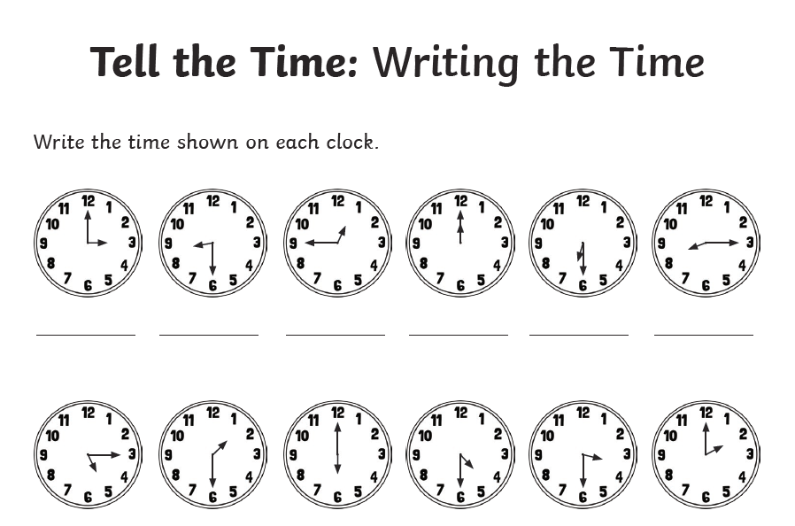
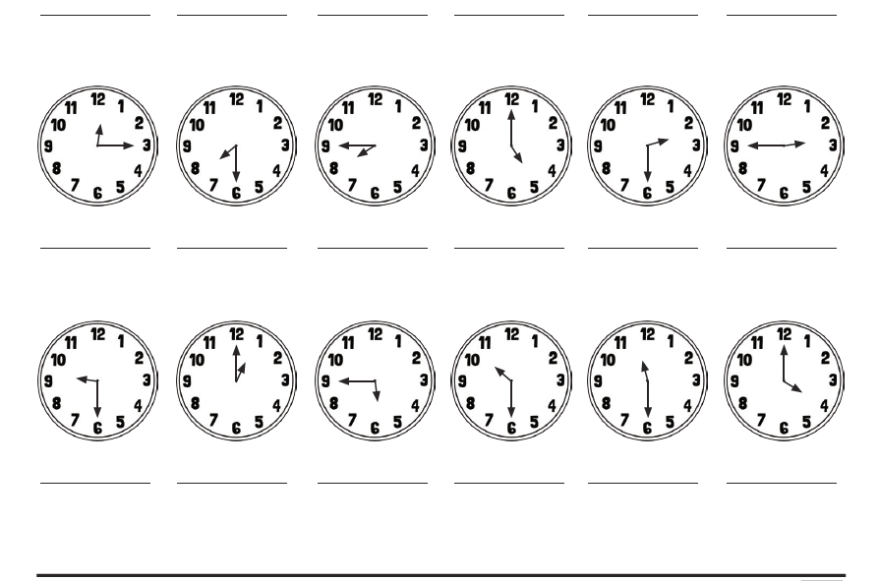

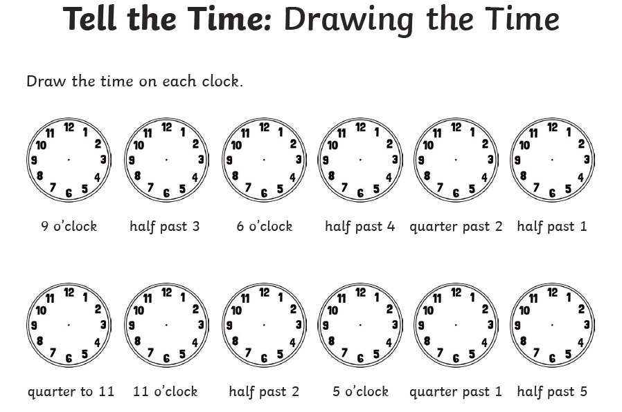
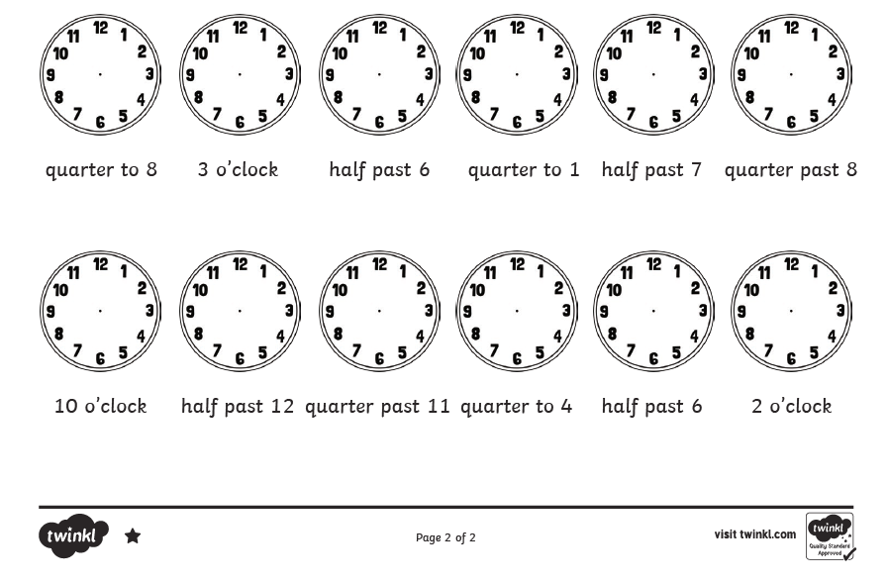

Silver
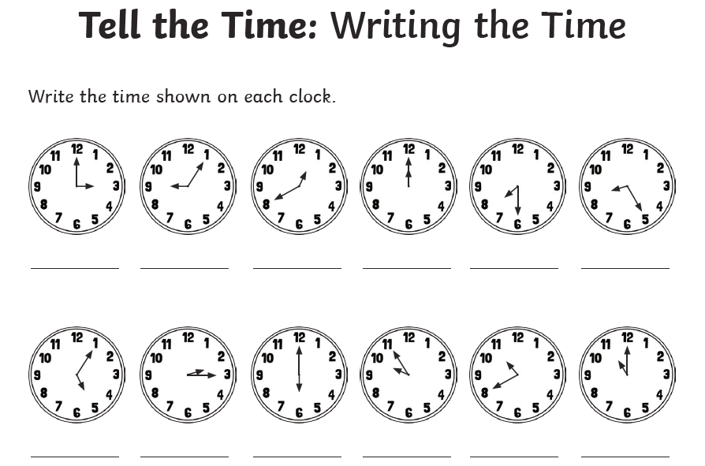
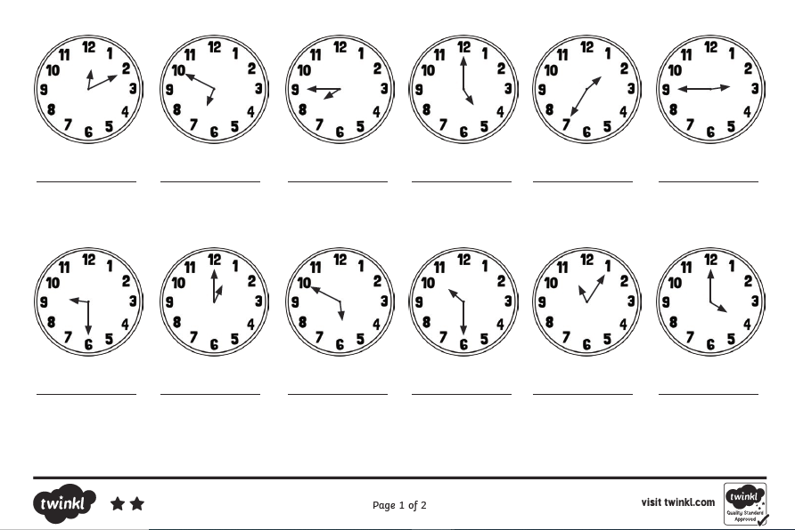

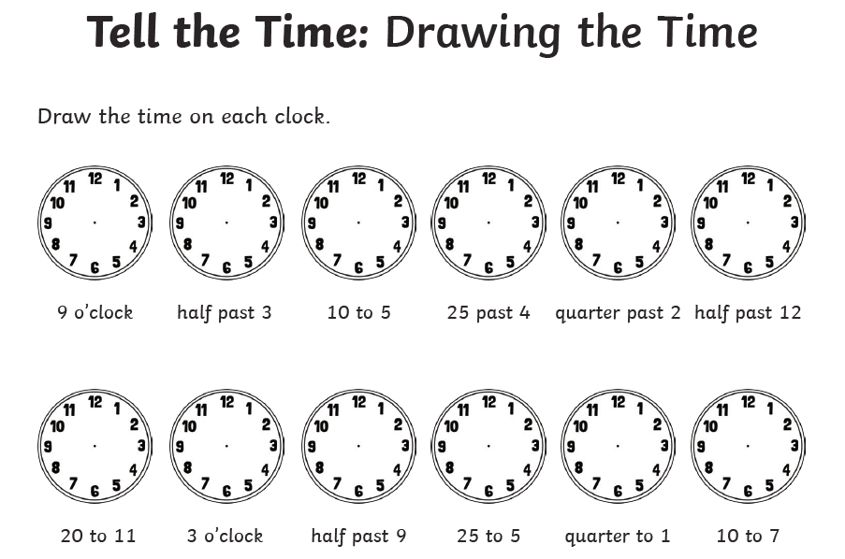
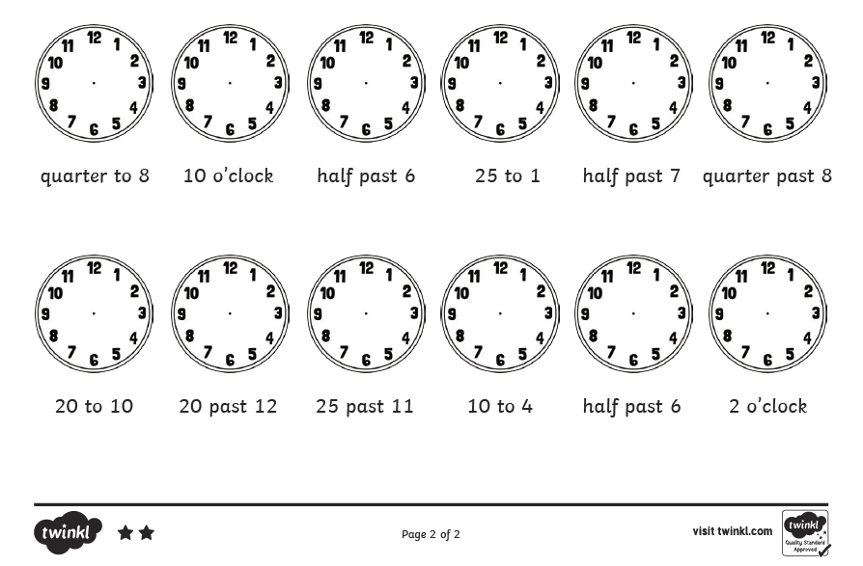

Gold

