Year 2
All of our work for the next two weeks is based around the book ‘Don’t hog the hedge!’ Please find todays learning tasks below.
The table below explains the tasks and you will find the resources underneath. Your child will know which challenge they usually access in each subject and which task will be appropriate for them.
Year group: 2 Date: 23.06.20
English | Don’t hog the hedge!  Please read the story together again. There is a Powerpoint of the story or you can listen or read to the e –book.
 | Bronze | Silver | Gold
 | Today we are going to map the story of Don’t hog the hedge. Use the sheet below to write the main parts or write each sub-heading in your book. You might need some adult help. (Later in the week you will use this to change and write your own story.) | Today we are going to map the story of Don’t hog the hedge. Use the sheet below to write the main parts or write each sub-heading in your book. You might want to talk to an adult to help you remember each part. (Later in the week you will use this to change and write your own story.) | Today we are going to map the story of Don’t hog the hedge. Use the sheet below to write the main parts or write each sub-heading in your book. You might want to talk to an adult to help you remember each part. (Later in the week you will use this to change and write your own story.)
Maths | Warm Up – follow this link to complete your maths warm up.  https://www.topmarks.co.uk/maths-games/hit-the-button  choose the activity and level which suits you.
 | Bronze | Silver | Gold
 | Today there is an emoji code breaker number challenge – choose bronze silver or gold and break the code by using the numbers to find the letters and reveal the message.
Reading  Phonics | Choose an activity from the reading bingo sheet and complete it with a book of your own or an on-line book from Oxford Owls.  Log in to use education city and play any phonics and spelling game you like – If year two is too tricky try year one and if you want a challenge try year 3!!

Unless otherwise specified, please complete the tasks in either your home learning book or print out the document below.
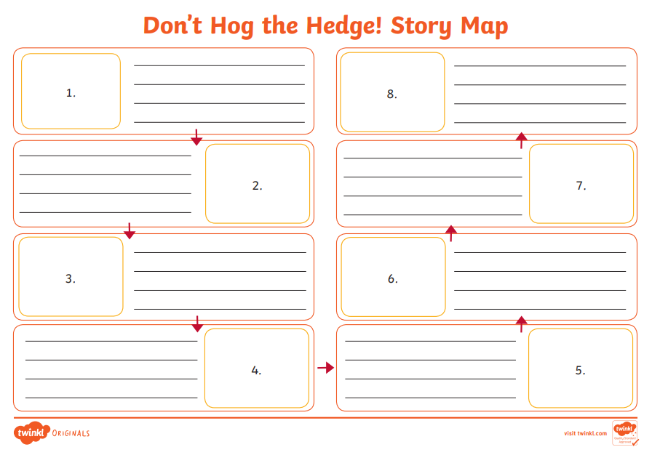
Bronze
Silver
Gold

