Year 2
Please find todays learning tasks below.
The table below explains the tasks and you will find the resources underneath. Your child will know which challenge they usually access in each subject and which task will be appropriate for them.
Year group: 2 Date: 09.06.2020
English | 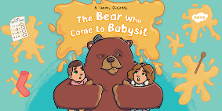  The Bear who came to babysit is the story that we will focus on in our English work this week.  Please share the command sentence powerpoint.
 | Bronze | Silver | Gold
 | Today you are going to learn about command sentences – these tell you to do something. Choose the best bossy verb to add to complete the poster. | Today you are going to learn about command sentences – these tell you to do something. Choose the best bossy verb to add to complete the poster. | Today you are going to write a command sentences on an advertising poster– these tell you what to do e.g. Stop worrying about your children. Leave them in my helpful paws!  You can use the outline below if you like or write your it into your book.
Maths | Warm Up – follow this link to complete your maths warm up.  https://pbskids.org/peg/games/happy-camel  This is a game about mass.
 | Bronze | Silver | Gold
 | Today you will be continuing to learn about mass. If you have some scales in your kitchen (either electronic or mechanical), can you weigh some items and read the scales? | Today you will be continuing to learn about mass. If you have some scales in your kitchen (either electronic or mechanical), can you weigh some items and read the scales? | Today you will be continuing to learn about mass. If you have some scales in your kitchen (either electronic or mechanical), can you weigh some items and read the scales?
Reading  Phonics | Read A monster surprise comprehension sheet and complete the answers on the sheet or write it into your book.(choose bronze, silver or gold)  Log in to use education city and play any phonics and spelling game you like – If year two is too tricky try year one and if you want a challenge try year 3!!

Unless otherwise specified, please complete the tasks in either your home learning book or print out the document below.

Bronze

Silver

Gold

Reading

Bronze

Silver
Gold

Bronze- Maths

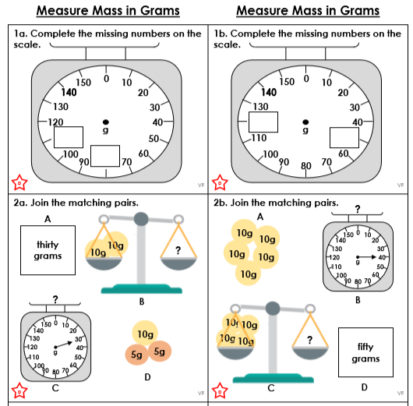

Silver Maths

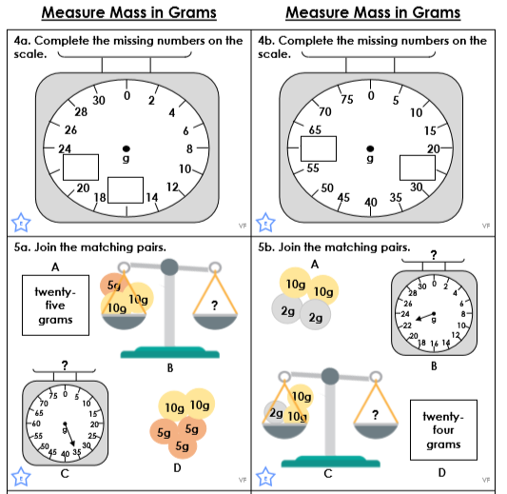
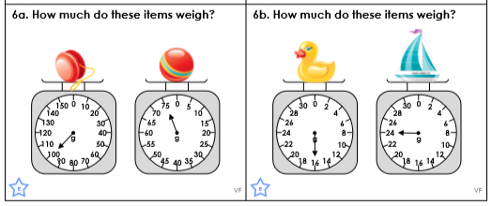

Gold Maths

