Year 2
All of our work for the next two weeks is based around the book ‘Don’t hog the hedge!’ Please find todays learning tasks below.
The table below explains the tasks and you will find the resources underneath. Your child will know which challenge they usually access in each subject and which task will be appropriate for them.
Year group: 2 Date: 15.06.20
English | Don’t hog the hedge!  Please read the story together at least once – maybe you could even try out your own voices for the characters or act it out with your family!!There is a Powerpoint of the story or you can listen or read to the e –book.
 | Bronze | Silver | Gold
 | Today there is a comprehension activity for you to complete about the story  You can use the outline below if you like or write the questions into your book. | Today there is a comprehension activity for you to complete about the story. You can use the outline below if you like or write the questions into your book. | Today there is a comprehension activity for you to complete about the story. You can use the outline below if you like or write the questions into your book.
Maths | Warm Up – follow this link to complete your maths warm up.  https://www.ictgames.com/mobilePage/hickoryDickory/index.html  This is a game linked to time, choose your level.
 | Bronze | Silver | Gold
 | Today you will be completing some time activities.  Complete the sheet below. | Today you will be completing some time activities.  Complete the sheet below. | Today you will be completing some time activities.  Complete the sheet below.
Reading  Phonics | Go to our website and read or share the e book of Don’t hog the hedge!  Complete the activities from the SPAG mat for today, choose bronze silver or gold.

Unless otherwise specified, please complete the tasks in either your home learning book or print out the document below.

Bronze
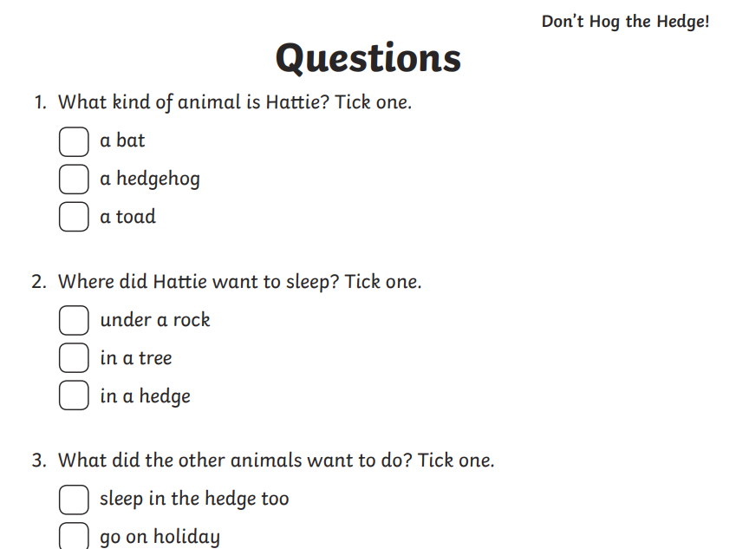

Silver
______________________________________________________________________________________________________________________________
Gold

____________________________________________________________________________________________________________________________________________________________________________________________________________
_____________________________________________________________________________________________________________________________________________________________
Bronze

Silver

Gold

Bronze SPAG
Silver SPAG
Gold SPAG

