Year Group: Year 4 Date 30.06.2020
 | Bronze | Silver | Gold
English | Performing Poetry  We want you to have loads of fun today with this. Watch Spike Milligan’s performance of ‘On the Ning, Nang, Nong’ using the link below.  Next, work through the different activities to prepare yourself for giving a performance of the poem yourself! | Performing Poetry  We want you to have loads of fun today with this. Watch Spike Milligan’s performance of ‘On the Ning, Nang, Nong’ using the link below.  Next, work through the different activities to prepare yourself for giving a performance of the poem yourself! | Performing Poetry  We want you to have loads of fun today with this. Watch Spike Milligan’s performance of ‘On the Ning, Nang, Nong’ using the link below.  Next, work through the different activities to prepare yourself for giving a performance of the poem yourself!
Maths | Area – Making Shapes  We want to work through the different challenges about the area of shapes. Can you correctly work out each shape’s area through counting different squares correctly? Can you also use your times tables to make it easier to work out the area? | Area – Making Shapes  We want to make different shapes from the various instructions of the worksheet. Can you solve some of the problems you have been given too? | Area – Making Shapes  We want to make different shapes from the various instructions of the worksheet. Can you solve some of the problems you have been given too?
Phonics/  Reading | Look at the image.  Can you answer the questions about the text? You may choose to answer these questions verbally with a grown up. Do they answer the question differently to you?

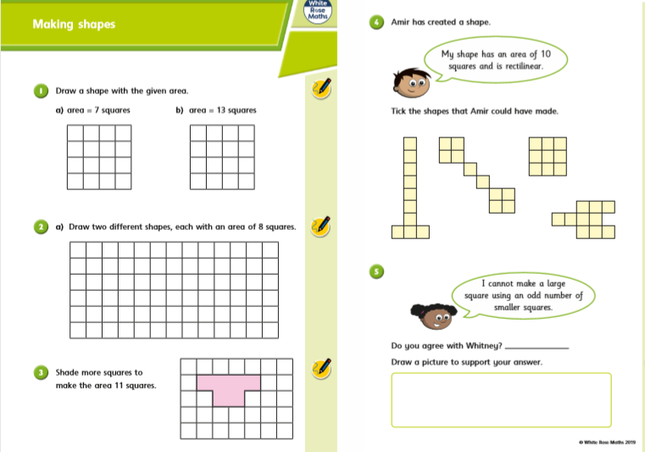
Silver Gold Maths

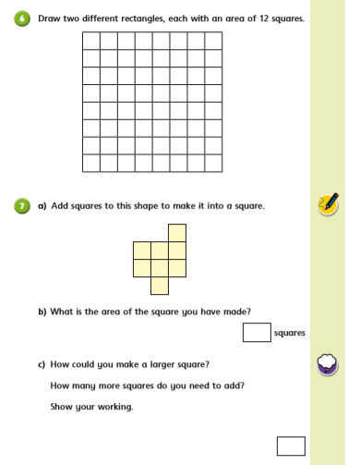
.

Bronze Maths
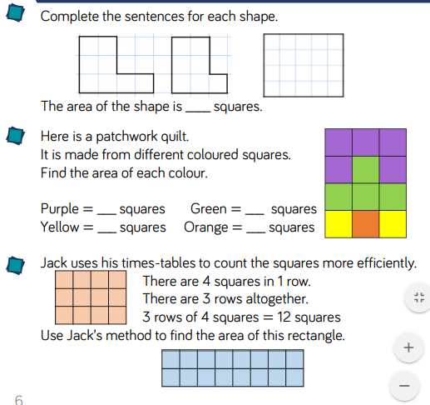

Use the link below to watch Spike Milligan perform ‘On the Ning, Nang, Nong’ and complete the following tasks.
Bronze Silver Gold English

https://www.bbc.co.uk/bitesize/articles/zs9csk7

Activity 1
Think about how Spike Milligan performed his poem, then answer these questions.
You could write your answers down on paper, discuss them or just think about them in your head.
1. What did you like about Spike Milligan’s performance? Why?
2. What do you notice about how he says the words in the poem?
3. Will you copy anything that Spike Milligan did when you perform this poem?
4. What do you notice about the rhythm and rhyme in this poem? Do you think this made it easier or harder to remember the poem?

Activity 2
Read the first six lines of ‘On the Ning Nang Nong’ yourself, then copy them out carefully onto a piece of paper.
On the Ning Nang Nong
Where the Cows go Bong!
and the monkeys all say BOO!
There's a Nong Nang Ning
Where the trees go Ping!
And the tea pots jibber jabber joo.
Now draw pictures around your writing of the images that come into your head for each line.
For example: Next to the first three lines, you might draw a cow, a monkey and whatever you think a ‘Ning Nang Nong’ looks like!
Activity 3
Now try and memorise these six lines.
Remember: There are things you can do to make this easier.
- Think about the story the poem is telling. Your images from Activity 2 should help with this.
- Focus on the rhythm of the poem.
- Looking at the rhyming words used.
- Think of actions to go with each line.
For example: You could put two fingers up on each side of your head like horns for ‘The cows go bong’.
Cover one line at a time and see if you can remember it. Then keep going until you can do all six without looking.
Take your time and keep practising. Memorising takes time and focus.

Activity 4
Have a go at performing these six lines from memory.
You could perform it for someone at home, perform it to yourself in the mirror or you could even get an adult at home to video it and show some of your friends or your teacher. Make sure to get permission from an adult before you film yourself though.
See if you can get all the way to the end of the six lines without looking at the words!
Top tips!
- Stand up straight and face forward.
- Speak clearly and say each word carefully.
- Don’t rush!
- Change your speed and volume as you are performing. Changing from slow to quick and loud to quiet can make your performance more dramatic!

Reading

How is their journey to school different to yours?
Where do you think they are? What country might it be?
How long do you think it takes them to get to school?
What time is it in the picture?
What do you think they all had for breakfast?
What do they have inside their rucksacks?
Where are their parents?
What is their school/teacher like? How is it similar/different to yours?
Are the children happy?

