Year Group: Year 4 Date 29.06.2020
 | Bronze | Silver |  | Gold
English | Exploring Poetry  We are exploring, learning about and writing various different poems this week so this week. Today we want you to look at changing the content of classic poems and nursery rhymes. In your first task you will change your main character into a villain. Follow the advice below carefully to help you.  Your second task is a set of comprehension questions about a classic nursery rhyme character who has turned evil. Read the text and your questions carefully and answer in detail where necessary. ENJOY! | Exploring Poetry  We are exploring, learning about and writing various different poems this week so this week. Today we want you to look at changing the content of classic poems and nursery rhymes. In your first task you will change your main character into a villain. Follow the advice below carefully to help you.  Your second task is a set of comprehension questions about a classic nursery rhyme character who has turned evil. Read the text and your questions carefully and answer in detail where necessary. ENJOY! |  | Exploring Poetry  We are exploring, learning about and writing various different poems this week so this week. Today we want you to look at changing the content of classic poems and nursery rhymes. In your first task you will change your main character into a villain. Follow the advice below carefully to help you.  Your second task is a set of comprehension questions about a classic nursery rhyme character who has turned evil. Read the text and your questions carefully and answer in detail where necessary. ENJOY!
Maths | Area – Counting Squares  Work through the different shapes on the worksheet and count the squares to find the area of each shape. Remember to include your metric units | Area – Counting Squares  Work through the different questions on the worksheet. Can you use your knowledge of counting squares to find the area of each shape? | Area – Counting Squares  Work through the different questions on the worksheet. Can you use your knowledge of counting squares to find the area of each shape?
Phonics/  Reading | Look at the image.  Can you answer the questions about the text? You may choose to answer these questions verbally with a grown up. Do they answer the question differently to you?

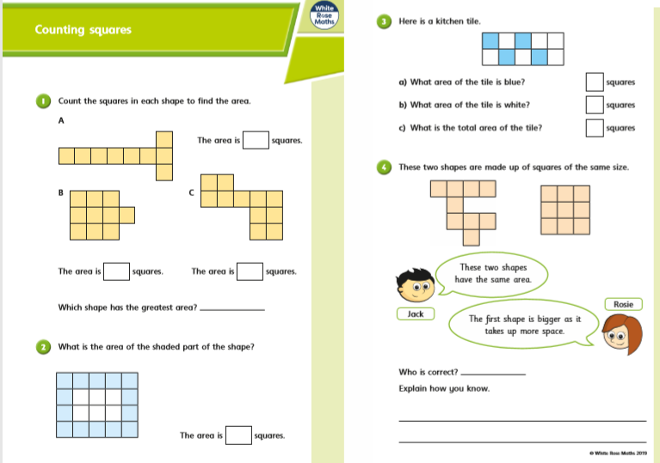
Silver Gold Maths

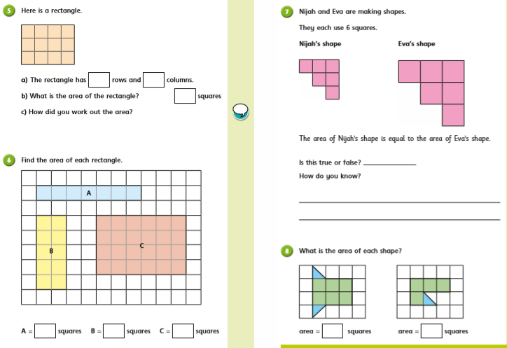
.

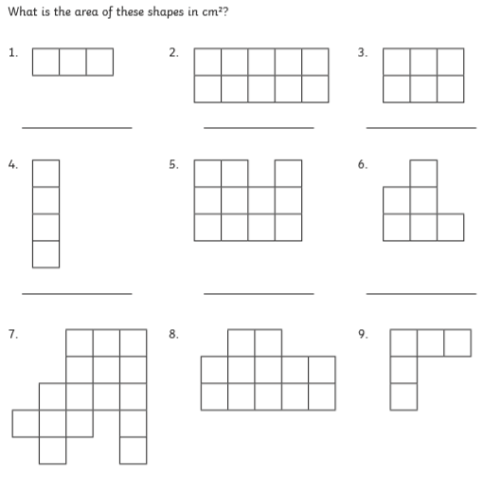
Bronze Maths

Bronze Silver Gold English
Follow the link below to help you with your work on exploring poetry.
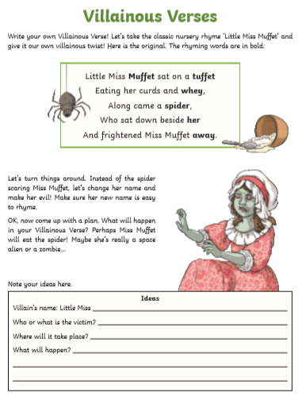
https://www.bbc.co.uk/bitesize/articles/z97n2v4
_______________________________________________________________________________________________________________________________________
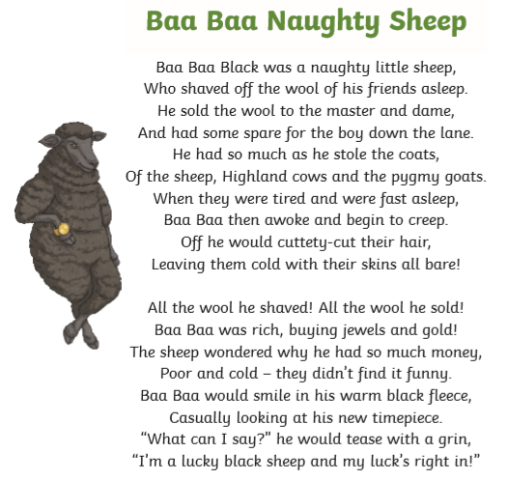

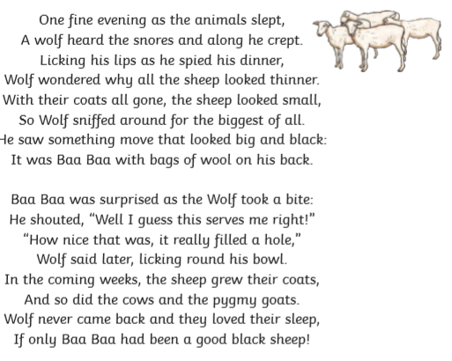

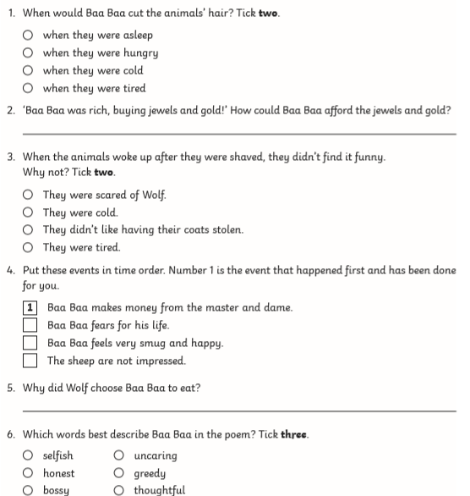

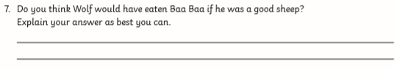

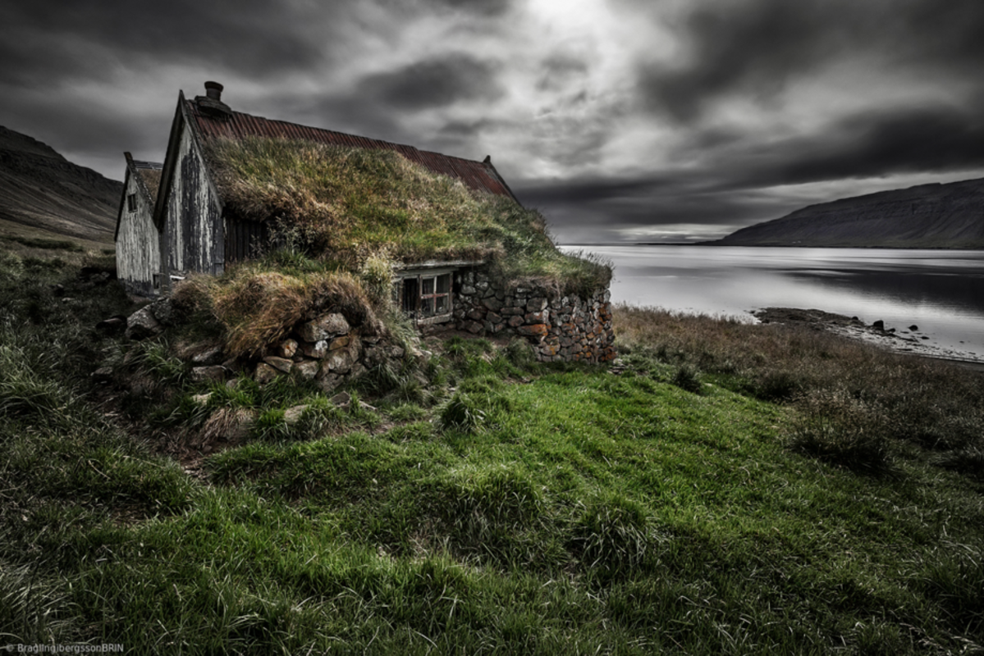
Reading

Would you rather live here or on the mainland?
What do you think the weather is like up here?
Do you think there are places like this in Britain?
How long do you think this house has been standing here for?
Why do think people would choose to live here?

