Please find todays learning tasks below.
The table below explains the tasks and you will find the resources underneath. Your child will know which challenge they usually access in each subject and which task will be appropriate for them.
Year group: 3 Date: 3rd July
 | Bronze | Silver | Gold
English | 60 second reads- Today we would like you to read the text ‘A Space Adventure’ then answer the questions. Remember to answer in full sentences. | 60 second reads- Today we would like you to read the text ‘Fun in the Sun for Heatwave Britain’ then answer the questions. Remember to answer in full, detailed sentences. | 60 second reads- Today we would like you to read the text ‘Help!’ then answer the questions. Remember to answer in full, detailed sentences.
Maths | Complete the mental maths sheet using all of the skills you have learned this year.  Then complete at least 5 games of TTRockstars.
Reading/Spelling | Please follow the link below to access online reading books. Please see the list of books for your child’s reading band in their red book. https://www.oxfordowl.co.uk/  Please read at least 2 pages of a book and record it in the red school links book.  Spelling test day! Ask your adult to read the questions out to you. Try your best to spell the words in your yellow book. We can’t wait to hear your scores!
Unless otherwise specified , please complete the tasks in either your homework book or on a word document
Bronze- Spellings

Spelling | Write | Write | Write
climb
most
only
both
pretty

Silver/Gold- Spellings

Spelling | Write | Write | Write
guide

heard

heart

height

history

increase

knowledge

English- Bronze

English- Silver
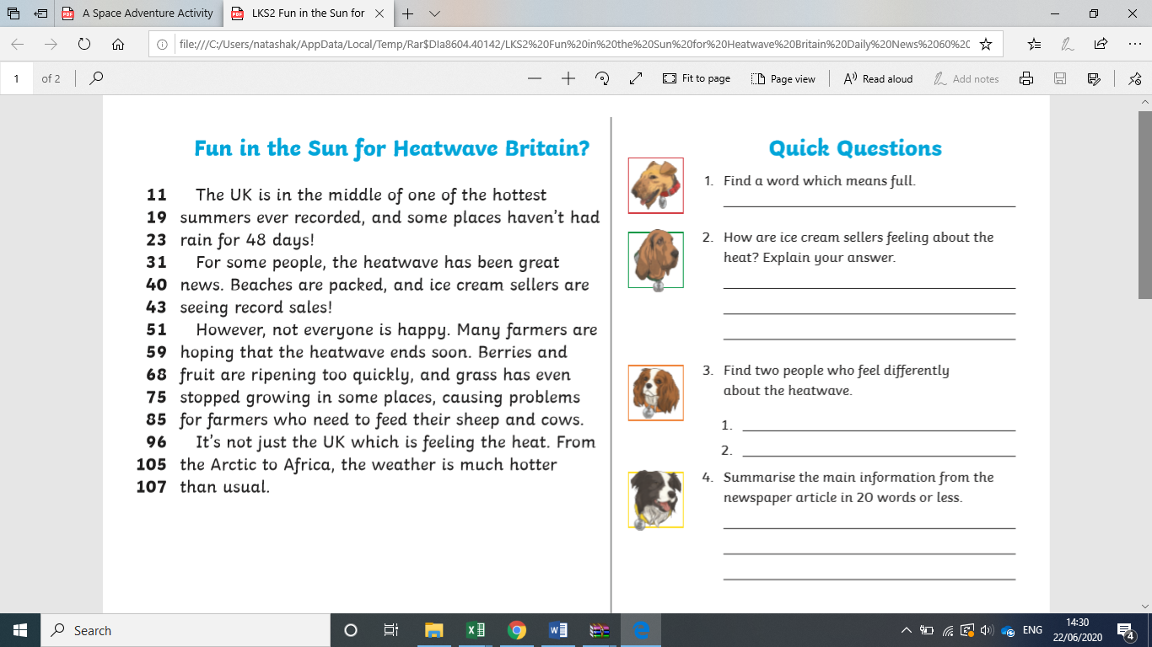

English- Gold

Maths- Bronze
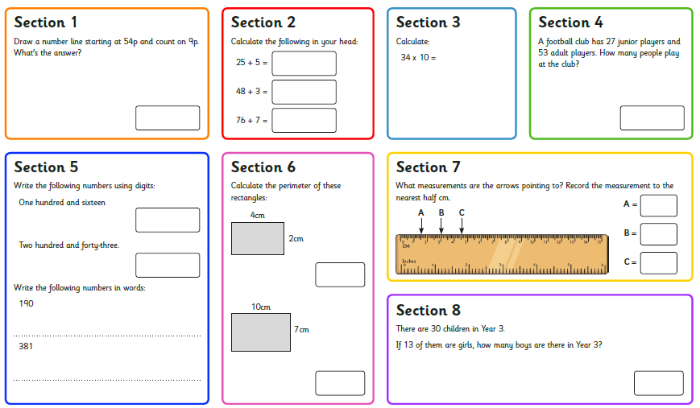

Maths- Silver

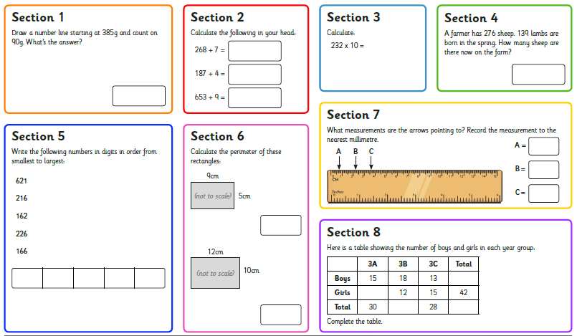
Maths- Gold
