Year Group: Year 4 Date 03.07.2020
 | Bronze | Silver | Gold
English | Haiku Poems  Enjoy finishing the week by creating a haiku poem about your lockdown experience. Read the information below and watch the videos available on the webpage provided to gain insight into the rules you need to follow. | Haiku Poems  Enjoy finishing the week by creating a haiku poem about your lockdown experience. Read the information below and watch the videos available on the webpage provided to gain insight into the rules you need to follow. | Haiku Poems  Enjoy finishing the week by creating a haiku poem about your lockdown experience. Read the information below and watch the videos available on the webpage provided to gain insight into the rules you need to follow.
Maths | Area – Assessment  See what you now know about Area by answering the various questions. | Area – Assessment  See what you now know about Area by answering the various questions. | Area – Assessment  See what you now know about Area by answering the various questions.
Phonics/  Reading | 60 second read  Have a read of a short story and then answer various comprehension questions about what you have read.

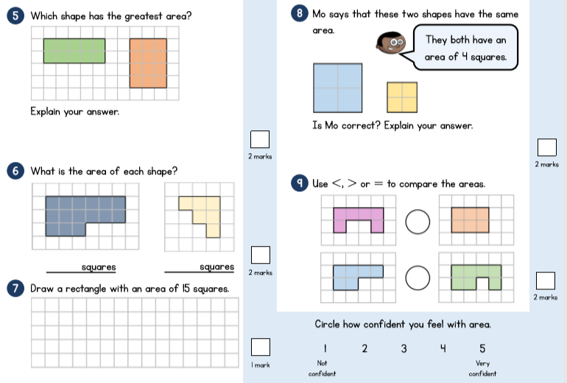
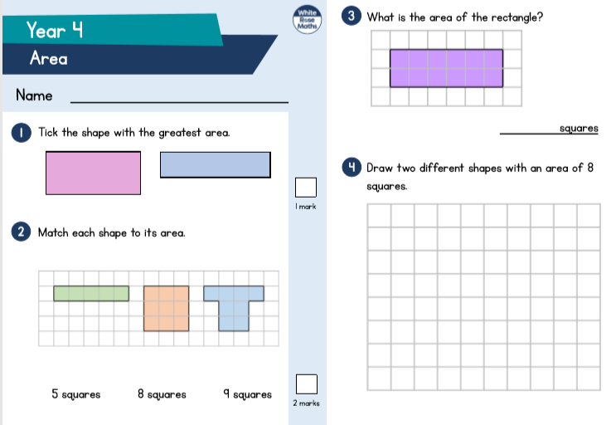
Bronze, Silver Gold Maths
Bronze Silver Gold English
What is a Haiku?
A haiku is a traditional form of Japanese poetry.
Haikus do not require a rhyming pattern but they do require a particular pattern of syllables.

What is a syllable?

Syllables are the separate beats/parts of words.
Can you work out how many syllables are in these words? BANANA APPLE CHOCOLATE PUDDING
Clap them out as you say them if it helps.

A haiku has the syllable pattern of 5, 7, 5. Here are two examples

Keeping in Touch
Communicating (5)
in high-tech ways with loved ones (7)
so our world can heal. (5)
Showing Our Thanks
We clap together, (5)
with our neighbours and our friends, (7)
thanking those who help. (5)

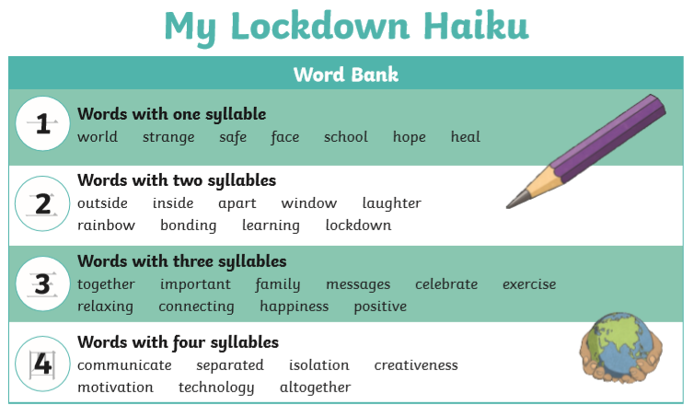

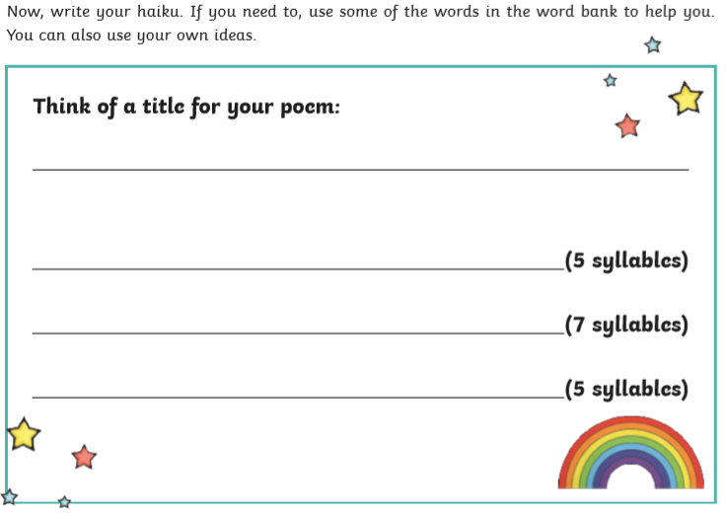

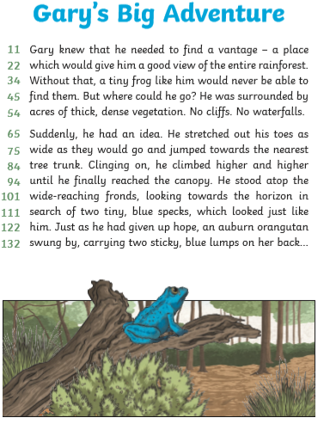
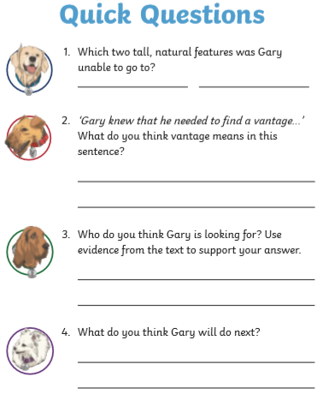

use the remaining lines to continue your answer should you need to.
Reading

___________________________________________________________________________________________________________________________________________________________________________________________________________________________________________________________________________________________________________________________

