Please find todays learning tasks below.
The table below explains the tasks and you will find the resources underneath. Your child will know which challenge they usually access in each subject and which task will be appropriate for them.
Year group: 2 Date: 20.05.20
English | Katie in London.  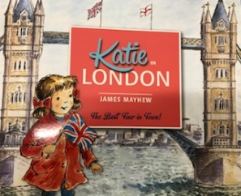  Click on the link below to listen to the story being read aloud to you. Can you spot any of the landmarks that you have been learning about?  https://www.youtube.com/watch?v=2rB_ywMoWCk
 | Bronze | Silver | Gold
 | Can you cut out the pictures from the story and sequence them in the correct order? If you don’t have a printer, you could draw the pictures in the correct order, or talk to your grown up about which is the correct order.  Use the pictures to help you to tell the story in your own words. | Can you cut out the pictures from the story and sequence them in the correct order? If you don’t have a printer, you could draw the pictures in the correct order, or talk to your grown up about which is the correct order.  Use the pictures to help you to tell the story in your own words. Can you write a sentence for each picture that helps you to tell the story? Remember capital letters and full stops and your neatest cursive writing. | Can you cut out the pictures from the story and sequence them in the correct order? If you don’t have a printer, you could draw the pictures in the correct order, or talk to your grown up about which is the correct order.  Use the pictures to help you to tell the story in your own words. Can you write sentences for each picture that helps you to tell the story? Remember capital letters, full stops, exciting vocabulary, conjunctions and your neatest cursive writing.
Maths | Log in to TT Rockstars to boost your score and your class score.
 | Bronze | Silver | Gold
 | Can you use your number bonds to help you with the addition and subtraction number sentences below? | Can you use your known number bonds to 10, to help you with your number bonds to 100? | Complete the multiplication questions to reveal the hidden picture.
Reading  Spelling | Follow the link to listen to the story of The Queen’s Knickers!  https://www.youtube.com/watch?v=DlKtVg0GXAc  Can you find the Common Exception Words in the wordsearch? Can you write each word three times in rainbow colours and then use it in a sentence?
Other | As today is Well-being Wednesday, select an activity from the ideas sheet in today’s daily email, or simply choose an activity that you enjoy doing and makes you happy!

Unless otherwise specified, please complete the tasks in either your home learning book or print out the document below.

English
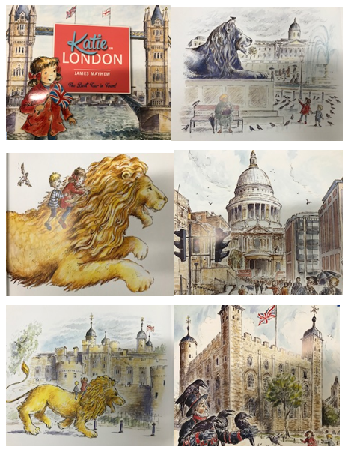
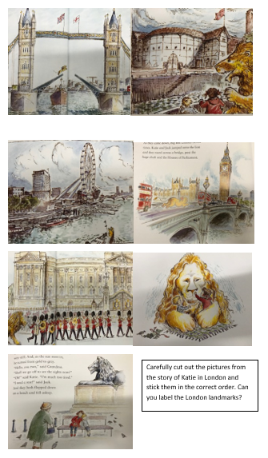

Bronze Maths
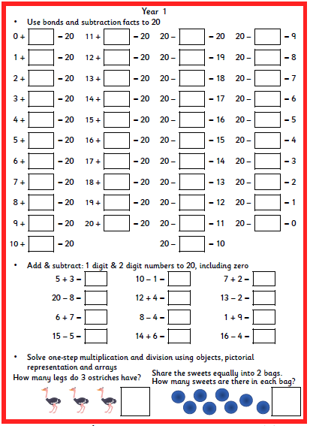

Silver Maths
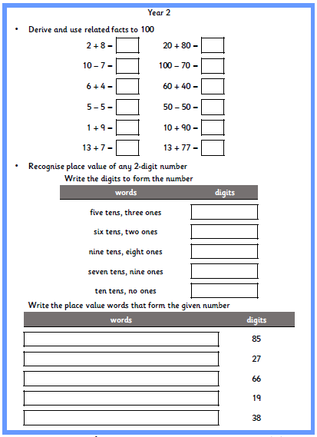

Gold Maths
