Please find todays learning tasks below.
The table below explains the tasks and you will find the resources underneath. Your child will know which challenge they usually access in each subject and which task will be appropriate for them.
Year group: 2 Date: 19.05.20
English | Re-read the PowerPoint on the website to learn about Samuel Pepys and why he is famous.  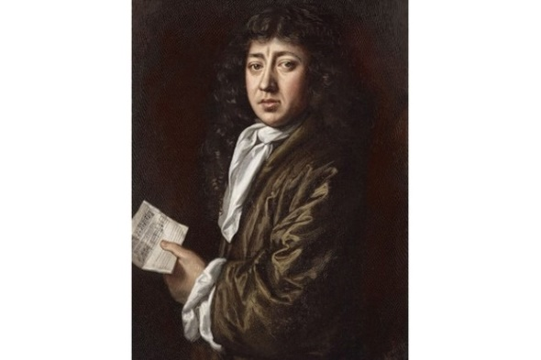  Then follow the link below to watch a short clip about Samuel Pepys.  https://www.bbc.co.uk/bitesize/topics/z7d7gwx/articles/zhgxcqt
 | Bronze | Silver | Gold
 | Can you use the information in the PowerPoint to complete the fact file about Samuel Pepys below? | Using the information you have learnt about Samuel Pepys and the fact file below, can you use the template to write facts about Samuel Pepys? Can you include who he was, why he was famous and any other interesting facts?
Reading  Spelling | Follow the link to listen to another of Paddington’s adventures in London.  https://www.youtube.com/watch?v=9fnRlux-QgU  Play the games on Spelling Shed linked to this week’s spelling patterns.
Maths | Log in to TT Rockstars to boost your score and your class score!
 | Bronze | Silver | Gold
 | Can you fill in the missing numbers on the 100 square? Can you say the number that is one more and one less than the numbers given? | Can you complete the counting activities and times tables facts on the sheet below? | Can you complete the fractions sheet below?
Other | Today’s activity will have a history and geography focus.  Read the PowerPoint about the Royal family.  Can you label the name of each member of the family?  Can you complete the questions based upon the Royal family tree?  Challenge Activity-Can you think of some questions of your own, based upon the Royal family tree?

Bronze-English
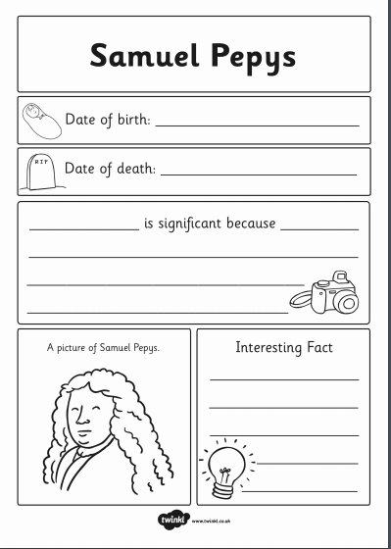

Silver and Gold

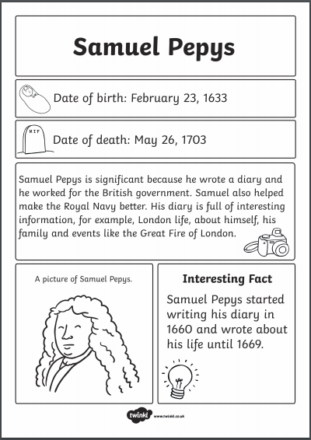

Silver and Gold English

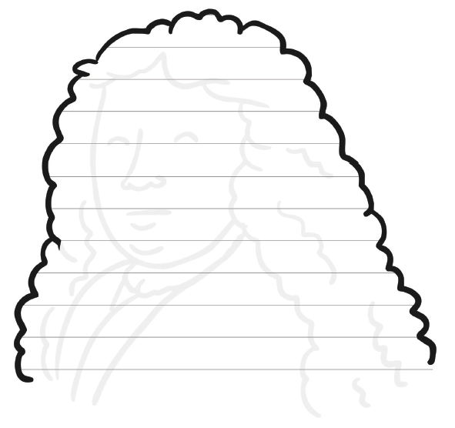

Bronze Maths
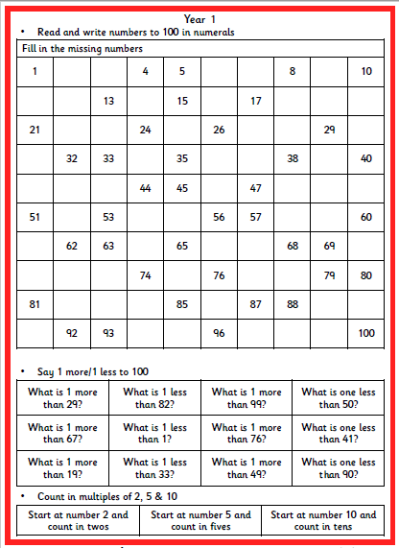

Silver Maths
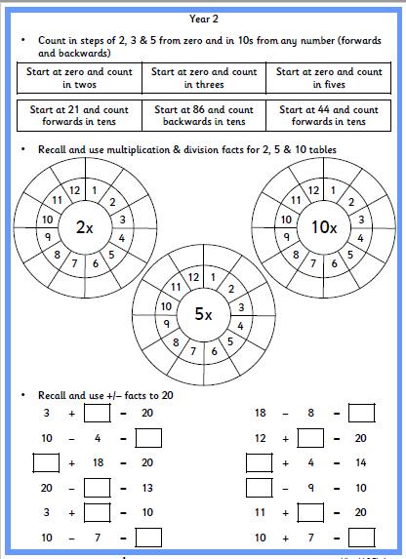

Gold Maths
