Please find todays learning tasks below.
The table below explains the tasks and you will find the resources underneath. Your child will know which challenge they usually access in each subject and which task will be appropriate for them.
Year group: 2 Date: 21.05.20
English | Katie in London.  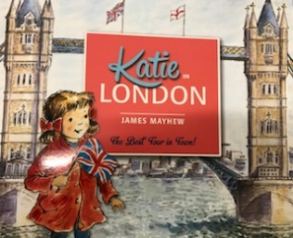  Click on the link below to listen to the story again.  https://www.youtube.com/watch?v=2rB_ywMoWCk
 | Bronze | Silver | Gold
 | Using your work from yesterday, choose three pictures to write a simple sentence about. Remember capital letters, finger spaces, cursive writing that sits on the line and full stops. | Can you write a diary entry pretending to be Katie or Tom after their day out in London? Write about the landmarks that you visited, what you could see and hear and how you felt. Remember to write in clear sentences and use capital letters and full stops correctly. | Can you write a diary entry pretending to be Katie or Tom after their day out in London? Write about the landmarks that you visited, what you could see and hear and how you felt. Remember to start your sentences in different ways, use exciting vocabulary and conjunctions.
Maths | Log in to TT Rockstars to boost your score and our class score.
 | Bronze | Silver | Gold
 | Can you complete the worksheet below? | Can you complete the various addition and subtraction number sentences below? | Can you complete the fractions sheet below? Remember when finding ¾ you first need to split the amount or shape into four parts, for ¾ you will need 3 of the equal parts.
Reading  Phonics | Follow the link to listen to the story of The Mr Men in London.  https://www.youtube.com/watch?v=YfCN3D6-HEo  Complete the sheet to select the correct suffix-ful or –less.
Other | Read the PowerPoint about the Royal family again. Then click on the following link to take a tour of Windsor Castle and Buckingham Palace.  https://www.royal.uk/virtual-tours-windsor-castle  https://www.royal.uk/virtual-tours-buckingham-palace  On the sheet below write what you have learnt and what you would like to find out.

English

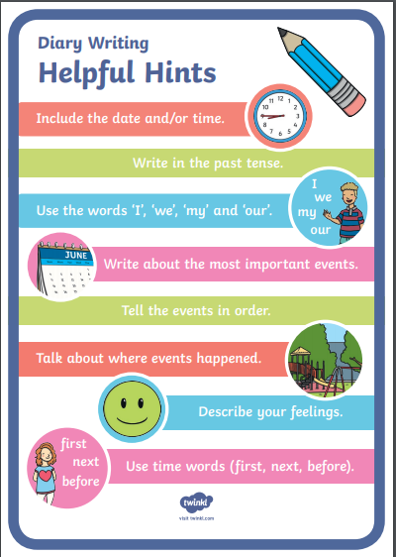
Bronze Maths
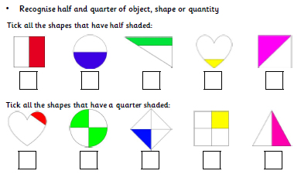

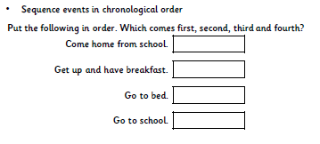
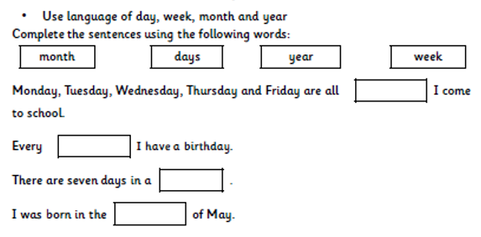
Silver Maths
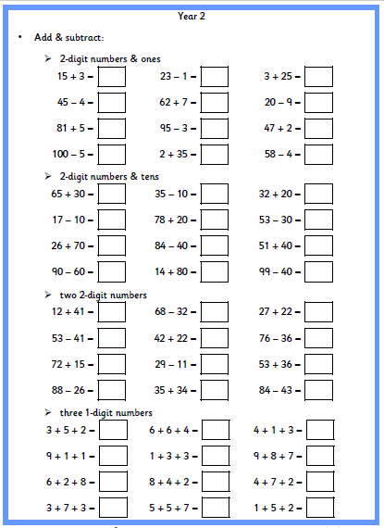

Gold Maths
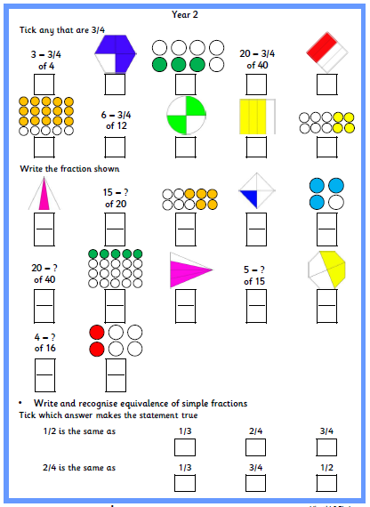

Phonics
