Please find todays learning tasks below.
The table below explains the tasks and you will find the resources underneath. Your child will know which challenge they usually access in each subject and which task will be appropriate for them.
Year group: 2 Date: 18.05.20
English | Today we are going to be learning about a famous person from the past, Samuel Pepys. Read the PowerPoint on the website to learn more about Samuel Pepys and why he is famous.  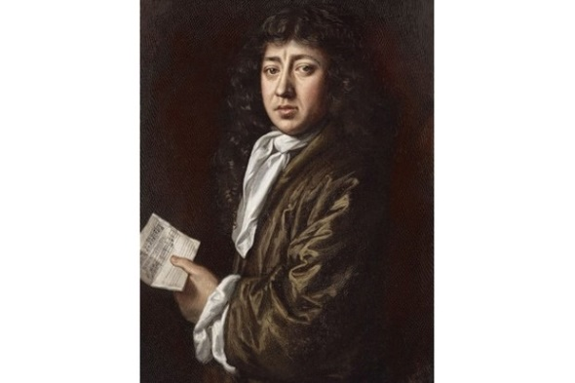
 | Bronze | Silver | Gold
 | Below there is an extract from Samuel Pepys’ diary. Read the information and then complete the questions below. | Below there is an extract from Samuel Pepys’ diary. Read the information and then complete the questions below. | Below there is an extract from Samuel Pepys’ diary. Read the information and then complete the questions below.
Reading  Phonics | Follow the link to listen to the story of Paddington at the Palace.  https://www.youtube.com/watch?v=J_zhBpgMnPI  Please complete the sheet below with the correct suffixes –ment, -er and –ness.
Maths | Log in to TT Rockstars to boost your score and our class score!
 | Bronze | Silver | Gold
 | Please complete the counting activities and then the missing numerals and number name sheet below. | Can you compare the numbers on the sheet below and write the correct numerals and words? | Can you use your knowledge of fact families to write the number sentences on the sheet below? And then use your multiplication facts knowledge to help you with the multiplication and division questions.
Other | Today’s activity will be PE.  Click on one of the following links to an activity of your choice and then complete the challenge card below.  YOGA  Positive Thinking Yoga  https://www.youtube.com/watch?v=1ae7Tj8blkc  FITNESS  Animal Movement  https://www.youtube.com/watch?v=KuLyI-3qnN8  DANCE  Move it Move it!  https://www.youtube.com/watch?v=ymigWt5TOV8

Bronze-English
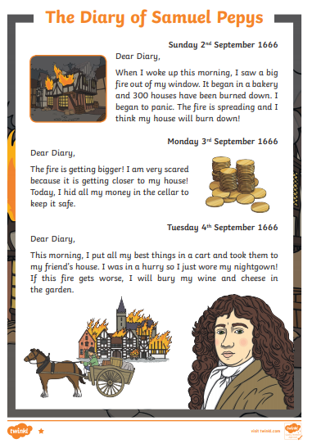

Bronze-English
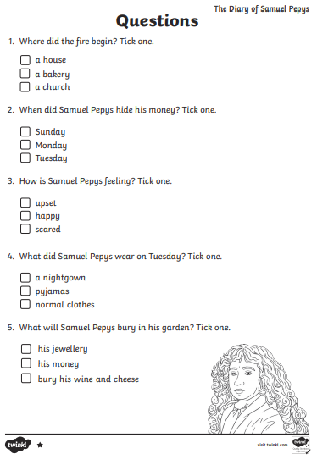

Silver English
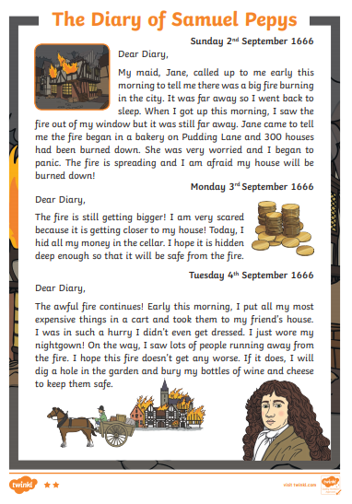

Silver English

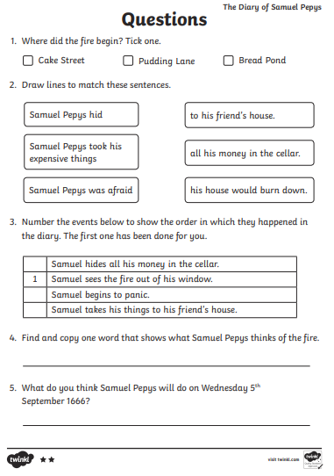
Gold English
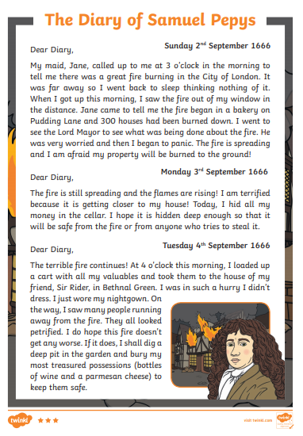

Gold English

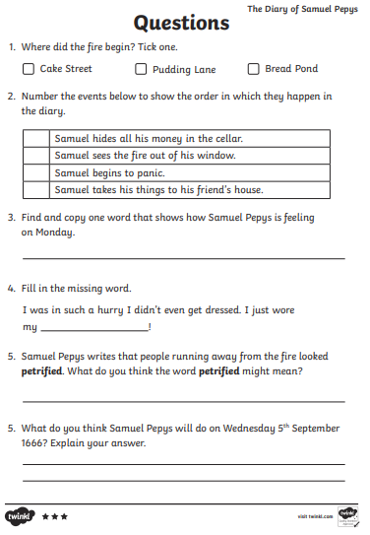

Phonics
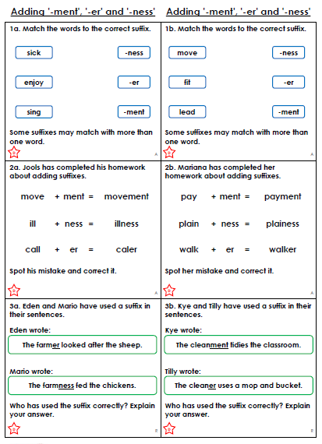

Bronze-Maths
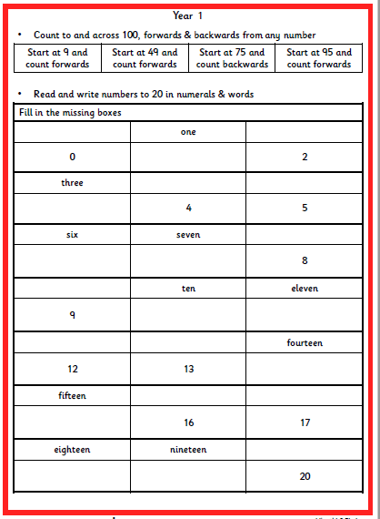

Silver Maths

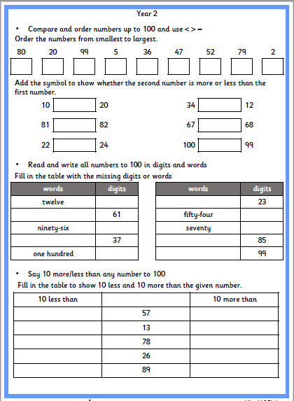

Gold Maths
