Please find todays learning tasks below.
The table below explains the tasks and you will find the resources underneath. Your child will know which challenge they usually
access in each subject and which task will be appropriate for them.
Year group: 2 Date: 22.05.20
English | Paddington and the Grand Tour  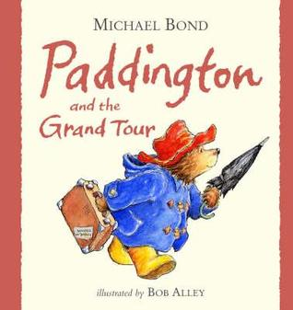  Click on the link below to listen to the story.  https://www.youtube.com/watch?v=ojBUZUReSY4
 | Bronze | Silver | Gold
 | Today I would like you to create a leaflet or poster to encourage people to visit London. Try to include facts and make your poster attractive with pictures and bright colours. Use the sheet below to help you to include all the correct features of posters and leaflets. There is a template below that you can use if you would like to.
Reading  Spelling | Please complete the 60 second read activity about The Great Fire of London below.  Play this week’s games on Spelling Shed to boost your own score and our class score.
Maths | First watch the PowerPoint to help you with telling the time.  Then play the time games that are saved on Education City in the ‘Classwork’ section of ‘My City’ (your passwords are in the front of your red home-school links book).
 | Bronze | Silver | Gold
 | Can you tell the time shown on the clocks? Can you then draw the hands on the clocks in the correct positions to tell the time? Remember the minute hand is longer than the hour hand. | Can you tell the time shown on the clocks? Can you then draw the hands on the clocks in the correct positions to tell the time? Remember the minute hand is longer than the hour hand. | Can you tell the time shown on the clocks? Can you then draw the hands on the clocks in the correct positions to tell the time? Remember the minute hand is longer than the hour hand.
Other | Today’s learning focus will be Science.  We are going to investigate micro habitats and the types and numbers of mini beasts that you would find there.  Read the PowerPoint to discover information about microhabitats around where we live.  Select two different microhabitats that you will use to carry out your survey.  Complete the survey record sheet below.

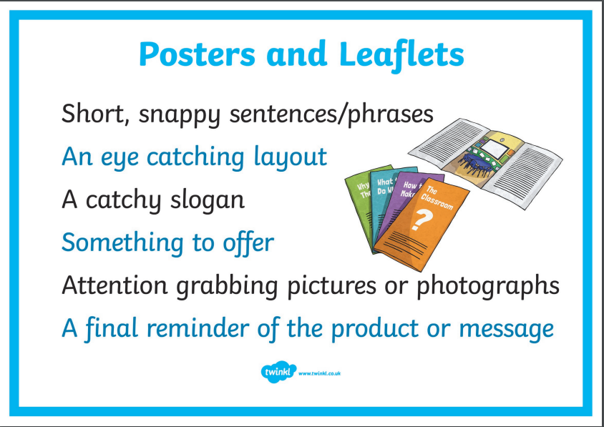
Maths Bronze
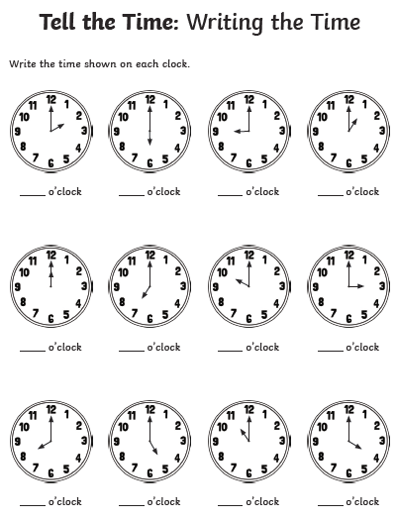

Maths Bronze-Continued
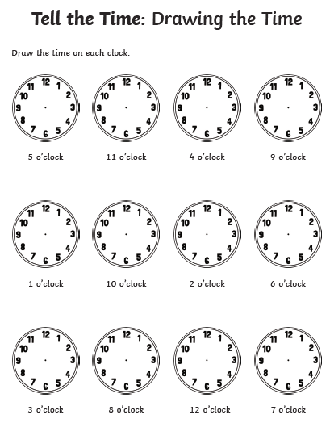

Silver Maths

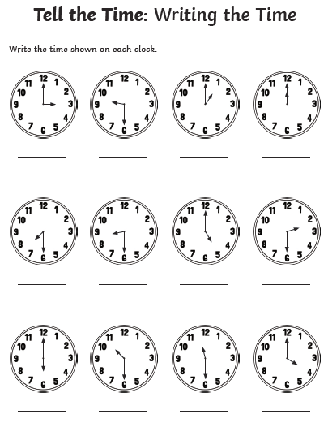

Silver Maths-Continued

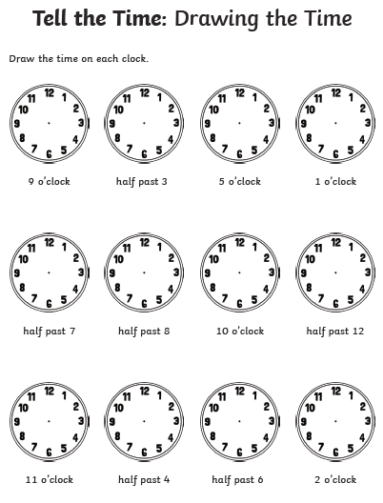

Gold Maths

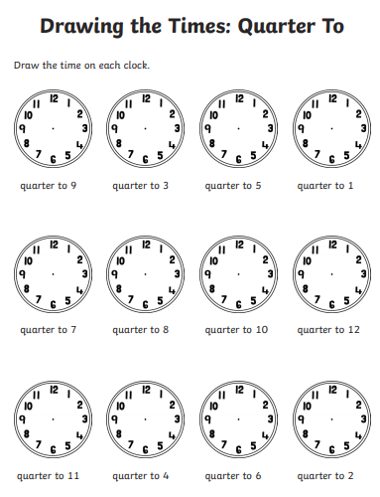

Gold Maths-Continued

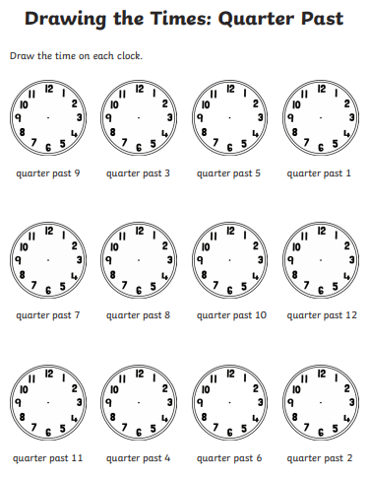
Reading
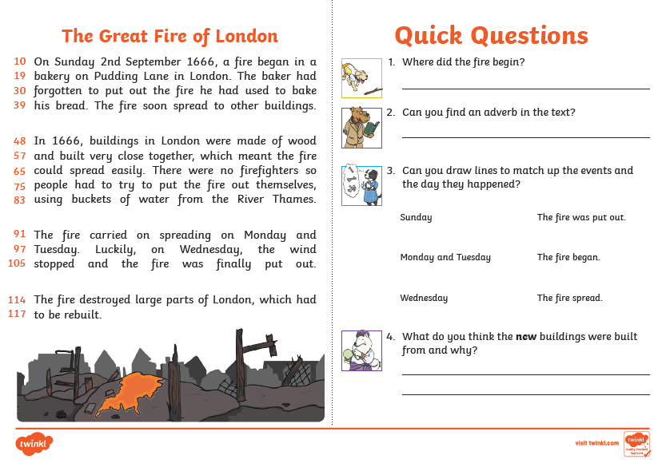

Science
