Year 2
Please find todays learning tasks below.
The table below explains the tasks and you will find the resources underneath. Your child will know which challenge they usually access in each subject and which task will be appropriate for them.
Year group: 2 Date: 13.05.2020
English | View the pictures on the English Starter (below) and  begin to think about the character of the Giant from Jack and the Beanstalk.
 | Bronze | Silver | Gold
 | Draw a picture of the giant – come up with at least 6 adjectives.  Write your own descriptive sentence including some conjunctions e.g. and / but / because / so. | Draw a picture of the giant – come up with at least 8 adjectives.  Write 2A sentences to describe the character of the giant – remember you need to put a comma between your adjectives (see the example below). | Draw a picture of the giant – come up with at least 10 adjectives.  Write complex sentences to describe the character of the giant – remember you need to put a comma between your adjectives for the 2A part and add some more information (see the example below).
Maths | Warm Up – complete  ‘On the face of it’ Education City- Find it in-Home-Subjects- Maths- Year 2- Activities- Geometry  Remember your log in is in your red home link book!
 | Bronze | Silver | Gold
 | Complete the 2D on 3D shape activity on the sheet below – if you can’t print out you can find some of the 3D shapes around your house and draw around the bottom shape!  Remember to complete you reasoning tasks. | Complete the 2D on 3D shape activity on the sheet below – if you can’t print out you can find some of the 3D shapes around your house and draw around the bottom shape!  Remember to complete you reasoning tasks. | Complete the 2D on 3D shape activity on the sheet below – if you can’t print out you can find some of the 3D shapes around your house and draw around the bottom shape!  Remember to complete you reasoning tasks.
Reading  Phonics | Follow the link https://www.oxfordowl.co.uk/api/digital_books/1262.html and read the text Finn Macool and the Giants Causeway. Once read complete the Play Activities at the top of the screen.  Can you solve the muddled words? (see below)
Other | Today’s subject focus will be Art  Can you create a piece of artwork showing the Great Fire of London? Look below for some ideas to inspire you.

Unless otherwise specified, please complete the tasks in either your home learning book or print out the document below.

English Starter – look at the slides below and start to think about how you can describe the giant.
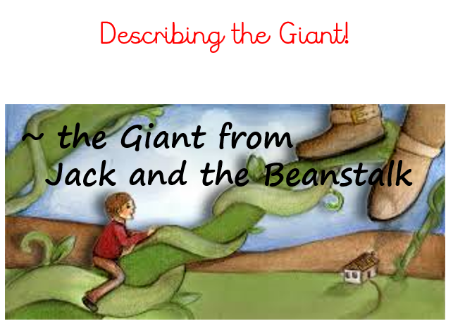

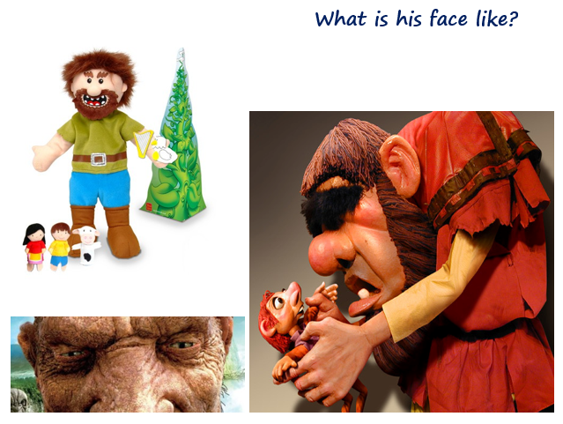

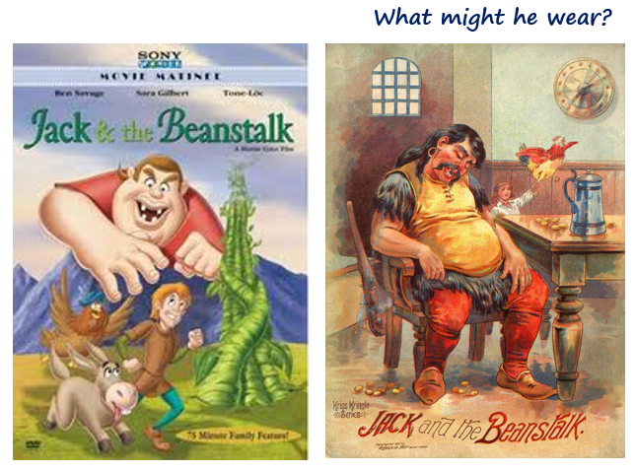

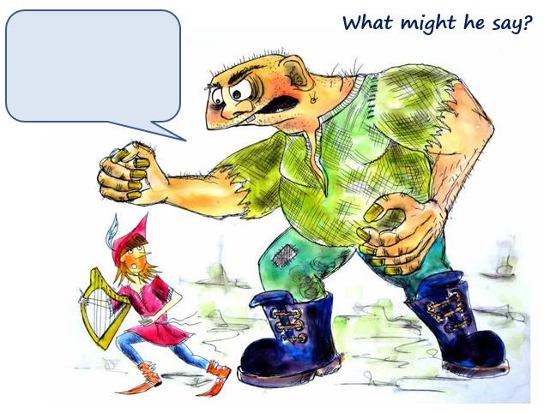

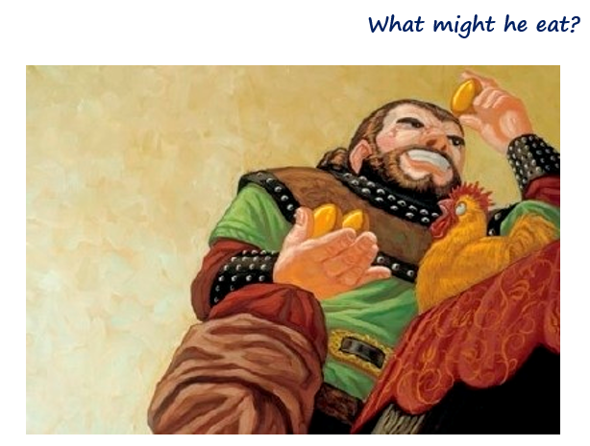

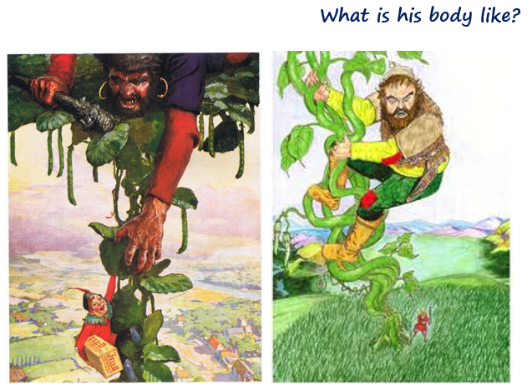

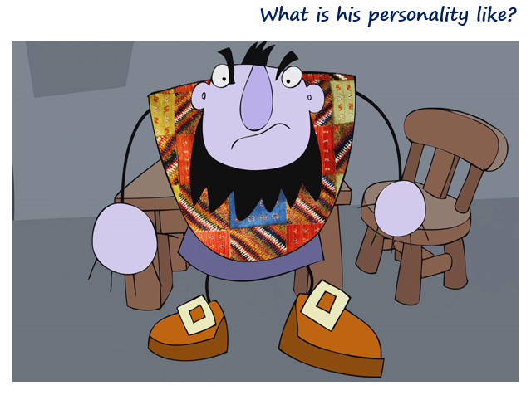

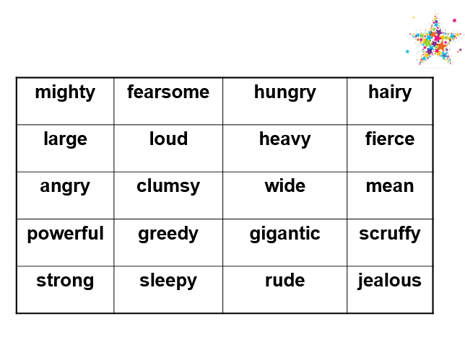
Use these adjectives to help you with your description.

English Bronze
Draw your own picture of the Giant and add some adjectives to label it.
Now write your own descriptive sentences to describe your giant.
e.g. The giant has ________________________ feet.
His nose is _______________________ and ____________________________.

English Silver
Draw your own picture of the Giant and add some adjectives to label it.
Now write your own 2A sentences to describe your giant.
e.g. The ________________ , _______________________ giant has ________________ , _____________________ feet.

English Gold
Draw your own picture of the Giant and add some adjectives to label it.
Now write your own complex sentences to describe your giant.
e.g. The gigantic, fierce giant stamps around the castle, making a thunderous noise.

Maths Bronze
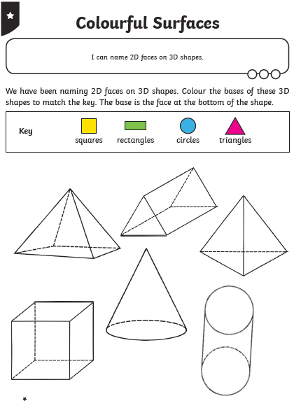

Maths Silver

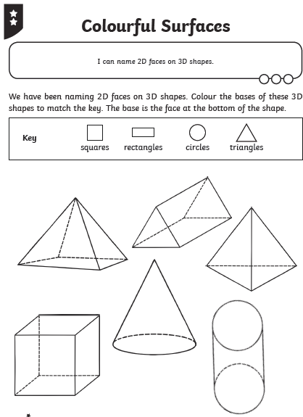
Maths Gold
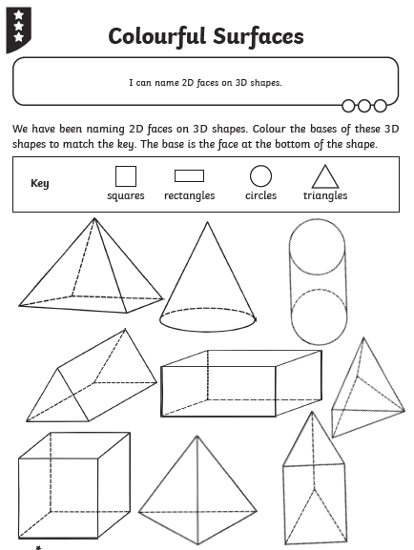

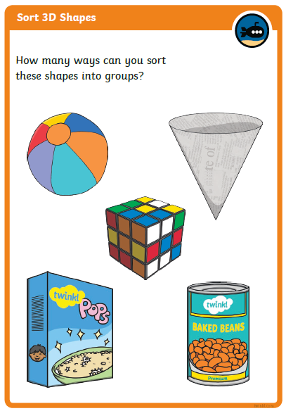
Reasoning All groups
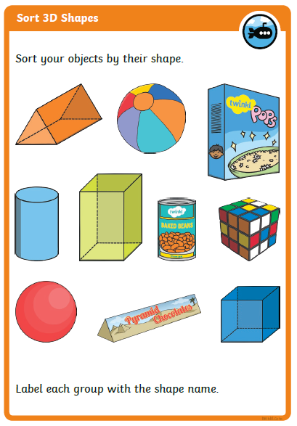

Phonics / Spelling
Can you spell these muddled words?

frtae = ________ slao = ____________
lopepe = _____________ ehwn = ____________
ebfroe = ____________ ecbsaue = ______________
cwcih = ______________ thfear = _______________
bmicl = _______________ twear = _______________

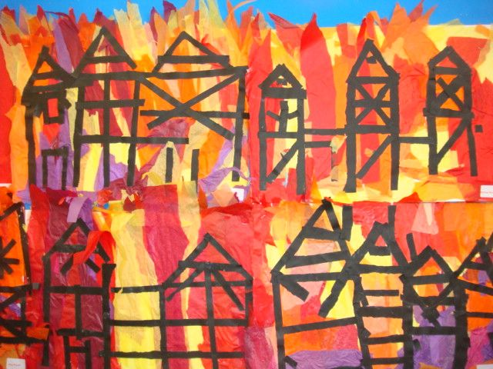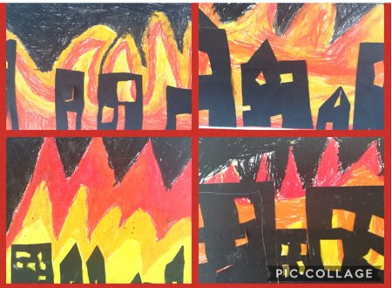
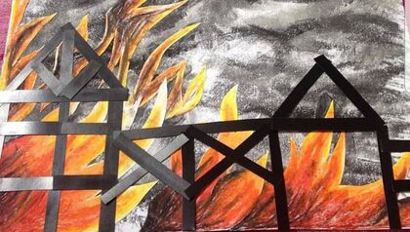
You could paint a picture, use crayons, felt tips or collage to create a picture of the Great Fire of London.
Be as creative as you can! Have fun!

