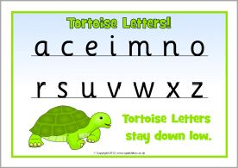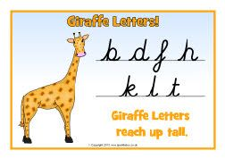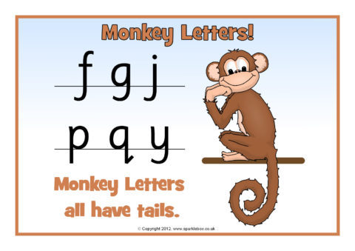

Can you practise writing these tortoise letters? Tortoise letters are short.

a ____________________________

e_____________________________

c_____________________________

o_____________________________

i______________________________

n_____________________________

m____________________________

r_____________________________

English Bronze

If you can write the tortoise and giraffe letters correctly and the correct size, you can practise these diagonal joins.

ad ________________________________________________

al_________________________________________________

at_________________________________________________

ed ________________________________________________

el_________________________________________________

et_________________________________________________

Can you practise joining the letters in these words?

mad ________________________________________________

let _________________________________________________

cat_________________________________________________

Can you practise writing these giraffe letters? Giraffe letters are tall. They need to be taller than the tortoise letters.

d ________________________________________________

l_________________________________________________

t_________________________________________________

Can you practise writing these tortoise letters? Tortoise letters are short.

a ________________________________________________

e_________________________________________________

c_________________________________________________

English Silver

If you can write the tortoise and monkey letters correctly and the correct size, you can practise these horizontal joins.

og ________________________________________________

oy_________________________________________________

om_________________________________________________

am ________________________________________________

ow_________________________________________________

on_________________________________________________

Can you practise joining the letters in these words?

boy________________________________________________

won_______________________________________________

dog_______________________________________________

Can you practise writing these tortoise letters? Tortoise letters are short.

o________________________________________________

w_________________________________________________

n_________________________________________________

Can you practise writing these monkey letters? Monkey letters sit on the line with their tails underneath.

g________________________________________________

y_________________________________________________

p_________________________________________________

English Gold

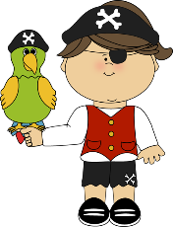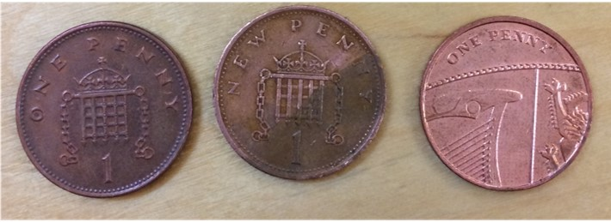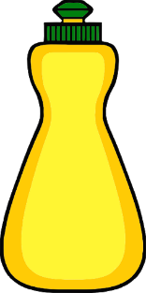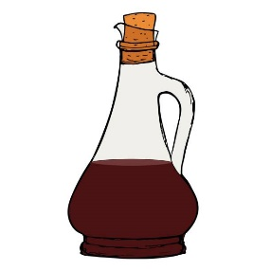

**Pirate Science Experiment**

**To be completed with adult supervision!**

You will need:

• Some pennies (dirty ones)

• Containers (cups or bowls)

• Measuring jug, spoon or cup

• Range of liquids to test e.g.

vinegar, washing up liquid, water, pop, juice, milk, ketchup, soy sauce, oil. You do not need all of these, just choose how many you want to test from what you have. You might also think of your own

ideas.

Instructions:

1. Put a penny in each of the containers.

2. Add a different liquid to each container. Measure the liquid to make sure the same amount of

liquid goes in each container.

1. Observe what happens.

Challenge

Can you predict which liquids will clean the penny?

Can you predict which liquid will make the cleanest penny?

Were you correct?

Can you put the pennies in order from cleanest to dirtiest? Which was the most effective liquid for cleaning the pennies?

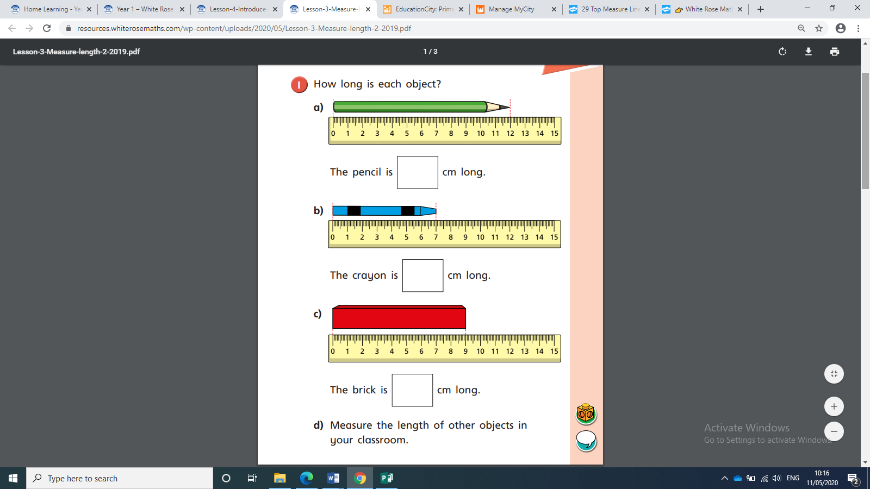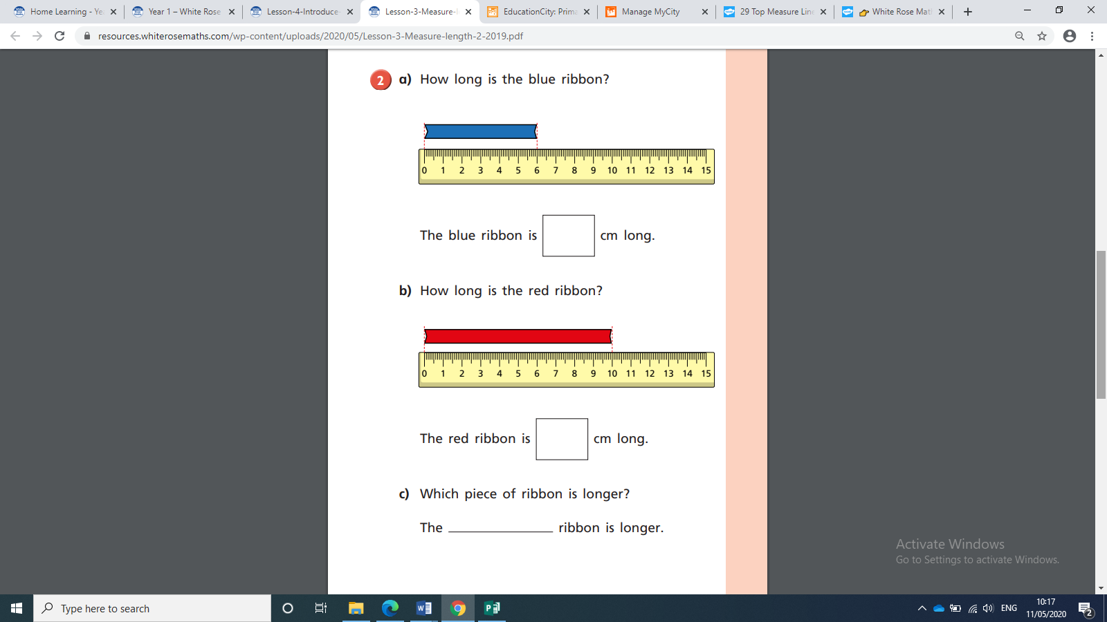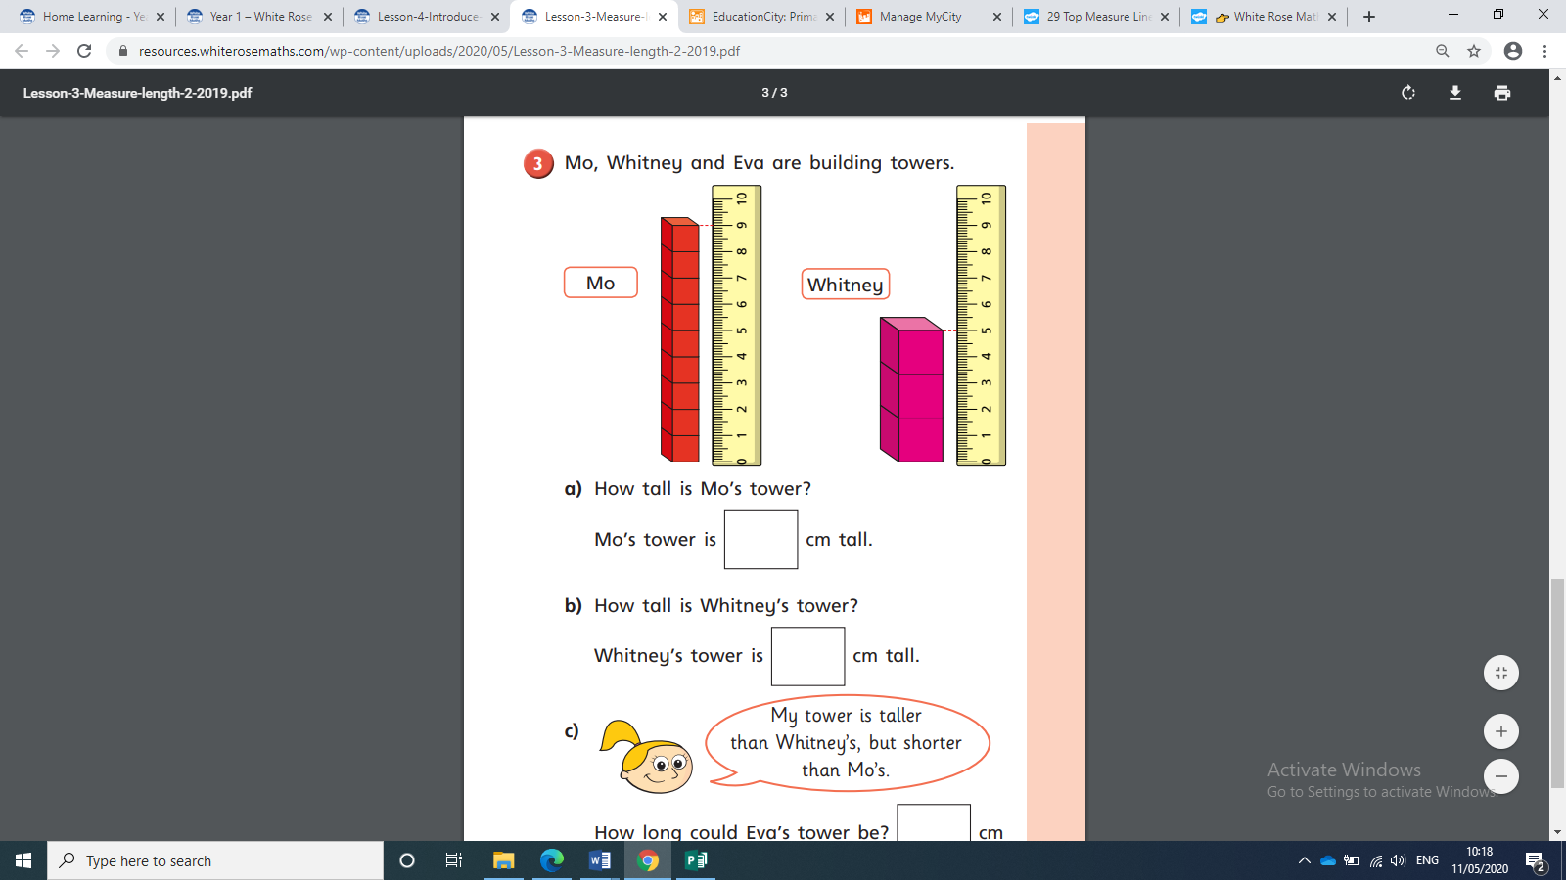

**Bronze/Silver Maths**