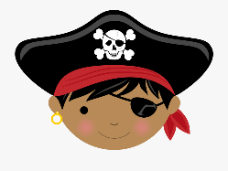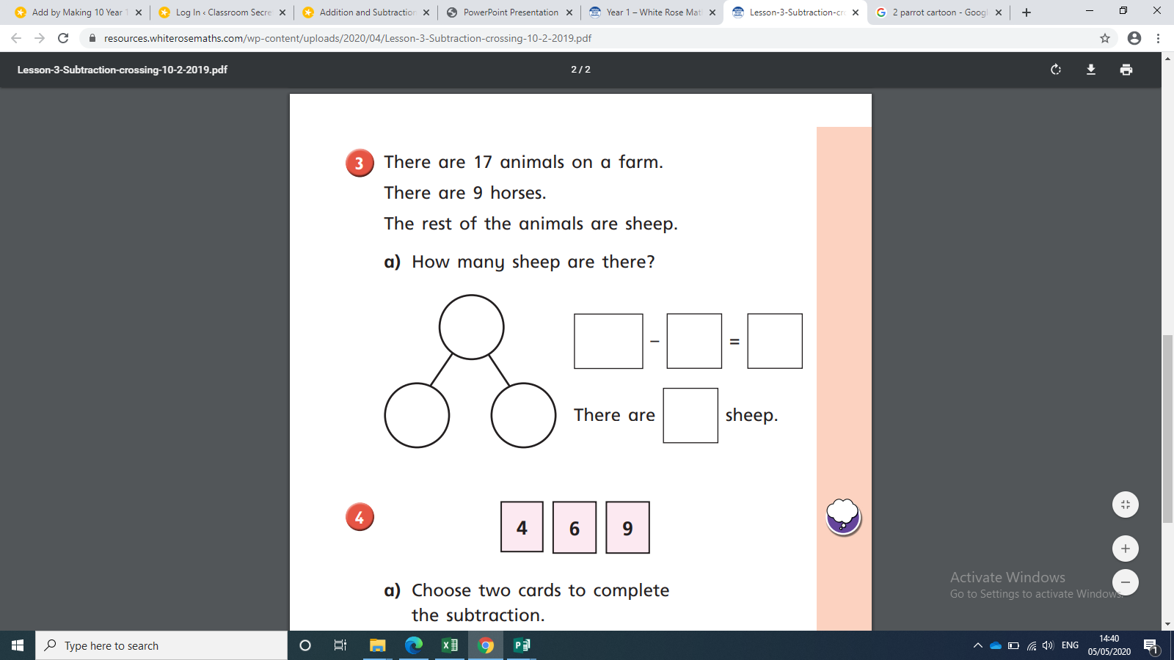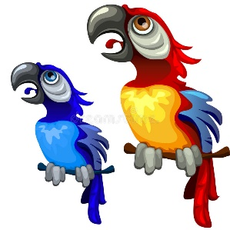

4 6 9

Choose two numbers to complete the subtraction:

1__ - ___ = ___

How many different subtractions can you make? Work out the answers to each one!

____________________________________________________________________________________________________________________________________________________________

There are 17 pirates on the ship.

9 have eye patches.

The rest do not.

How many pirates do not have eye patches?

___ - ___ = ___

___ pirates do not have eye patches.

Polly has 13 seeds.

Pete has 6 seeds.

How many more fish does Polly have than Pete?

___ - ___ = ___

Polly has ___ more seeds than Pete.

Mary

Jack

SILVER MATHS

Jack has 11 red gems.

Mary has 5 red gems.

How many more gems doe Jack have than Mary?

Tick the number sentence that answers the question:

11 + 5 = 16 16 —5 = 11



BRONZE MATHS

3 10 7

Make up your own pirate subtraction word problem using the numbers above!

____________________________________________________________________________________________________________________________________________________________

There are 8 pirates on the ship.

3 have eye patches.

The rest do not.

How many pirates do not have eye patches?

___ - ___ = ___

___ pirates do not have eye patches.

Polly has 10 seeds.

Pete has 6 seeds.

How many more fish does Polly have than Pete?

___ - ___ = 4

Polly has ___ more seeds than Pete.

Mary

Jack

Jack has 9 red gems.

Mary has 5 red gems.

How many more gems doe Jack have than Mary?

Tick the number sentence that answers the question:

9 + 5 = 14 9—5 = 4



GOLD MATHS

Jack has 21 red gems.

Mary has 13 red gems.

How many more gems doe Jack have than Mary?

Tick the number sentence that answers the question:

21 + 13 = 24 24 —13 = 11

Jack

Mary

Polly has 26 seeds.

Pete has 10 seeds.

How many more fish does Polly have than Pete?

___ - ___ = ___

Polly has ___ more seeds than Pete.

There are 20 pirates on the ship.

9 have eye patches.

The rest do not.

How many pirates do not have eye patches?

___ - ___ = ___

___ pirates do not have eye patches.

4 6 9

Choose two numbers to complete the subtraction:

1__ - ___ = ___

How many different subtractions can you make? Work out the answers to each one!

____________________________________________________________________________________________________________________________________________________________

|  |  |  |  |
| --- | --- | --- | --- |
| b | aw | d | g |
| h | ow | t | k |
| ear | r | p | s |
| ee | oe | i-e | e |

**BOGGLE**

________________________________________________________________________________________________________________________________________________________________________________________________________________________________________________________________________________________________________

Silver Phonics

How many words can you make with the sounds?