Year 2
Please find todays learning tasks below.
The table below explains the tasks and you will find the resources underneath.
Your child will know which challenge they usually access in each subject and which task will be appropriate for them.
Year group: 2 Date: 12.05.20
English | Click on the link below to start to think about the Giant’s Castle.  https://www.bbc.co.uk/teach/class-clips-video/english-ks1-jack-and-the-beanstalk-pt8/zbcmy9q
 | Bronze | Silver | Gold
 | Look at the picture of the Giant’s castle and think of 10 adjectives. Use these to write some 2A sentences about the castle. | Write a description of the Giant’s Castle. Use some super 2A sentences in your description.  Remember you are only describing the castle not writing the story! | Write a description of the Giant’s Castle. Use some adventurous adjectives and complex sentences in your description. Remember you are only describing the castle not writing the story!
Maths | Warm Up – follow this link to complete your maths warm up.  http://www.wldps.com/gordons/Paying_for_ice_creams.swf  Start with up to 50p and then move onto £1 - £3 if you feel confident!
 | Bronze | Silver | Gold
 | Complete the properties of shapes activity below.  . | Complete the properties of shapes activity (below).  Can you name the shapes using the following words?  quadrilateral triangle heptagon  Remember to complete your reasoning task. | Complete the properties of shapes activity (below).  Can you name the shapes using the following words?  quadrilateral triangle heptagon  Remember to complete your reasoning task.
Reading  Phonics | Please follow the link below to access online reading books.  Go to https://www.roythezebra.com/guided-reading-stories/chapter2.html#/section0  Roy the Zebra website tells the story of the worst zoo in the world. You can read or listen to the story, answer questions before and after reading.  Complete a quick spell of these 10 Common Exception Words.  Father plant path everyone kind beautiful Mr Mrs  Money children
Other | 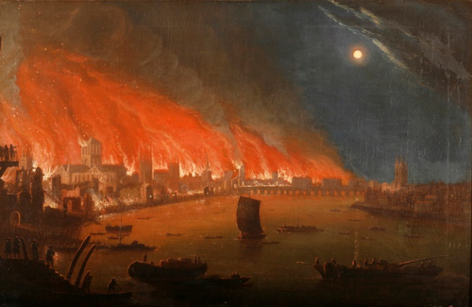  Today’s subject focus will be History and The Great Fire of London  Watch the link here:  https://www.youtube.com/watch?v=Er3GKw8Z3R4  After watching the video then click on the link here to play a wonderful interactive game about The Great Fire of London.  http://www.fireoflondon.org.uk/game/

Unless otherwise specified, please complete the tasks in either your home learning book or print out the document below.

English Bronze
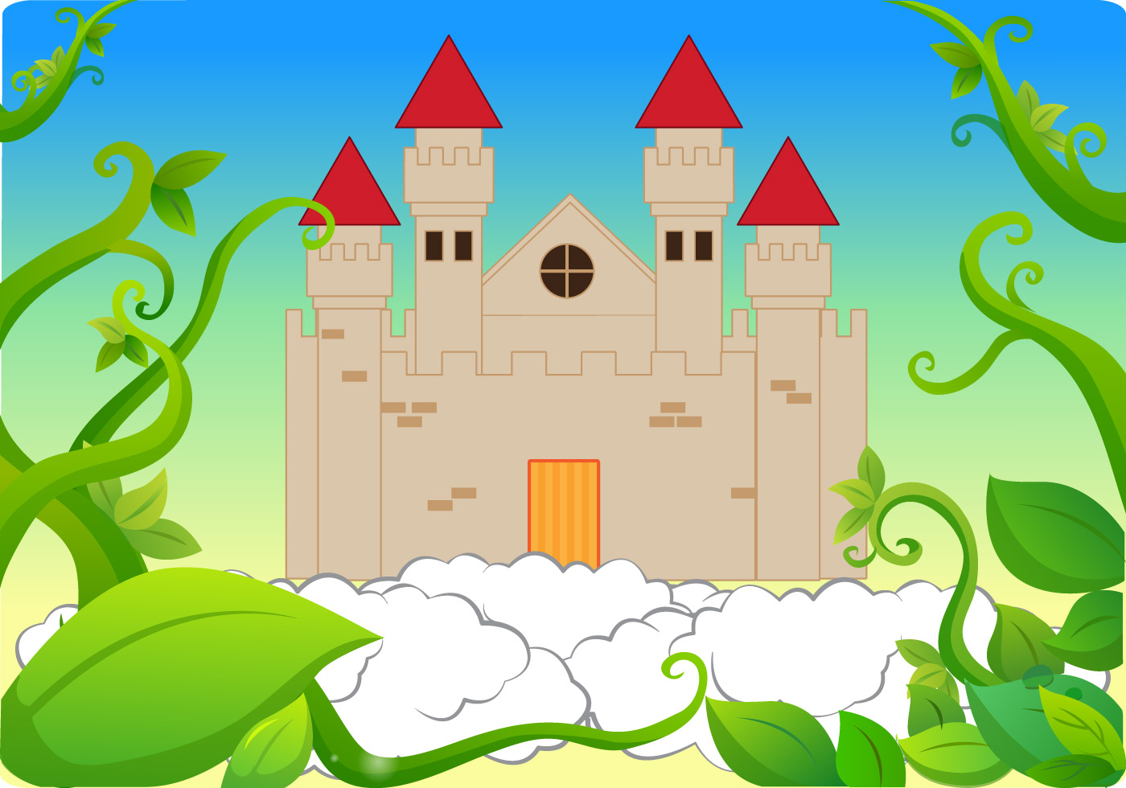
Think of 10 of your own adjectives to describe the castle.

Write some 2A sentences – like the one below.

The dark, towering castle in the clouds.

English Silver and Gold – Write a description of the Giant’s castle.

________________________________________________________________________________________________________________________________________________________________________________________________________________________________________________________________________________________________________________________________________________________________________________________________________________________________________________________________________________________________________________________________________________________________________

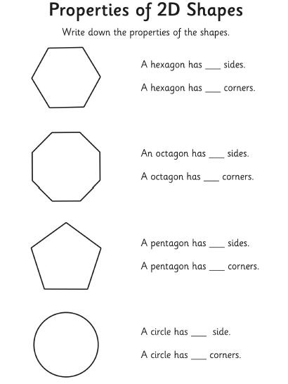
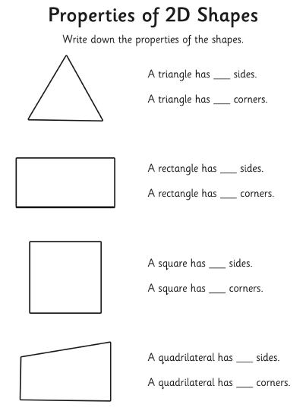
Maths Bronze

Maths Silver
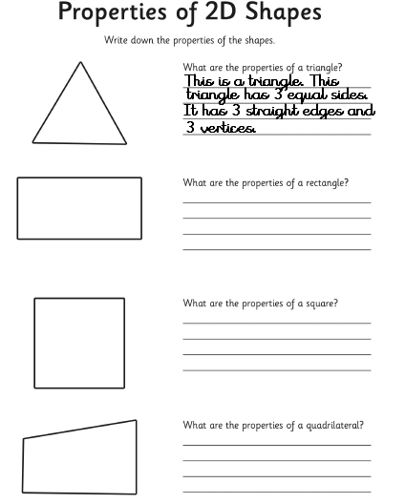

Name these shapes!
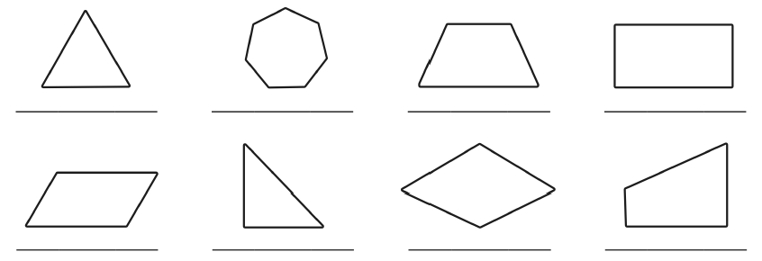
Maths Challenge Silver and Gold
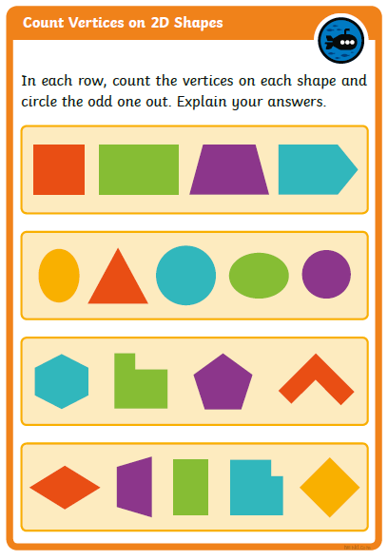

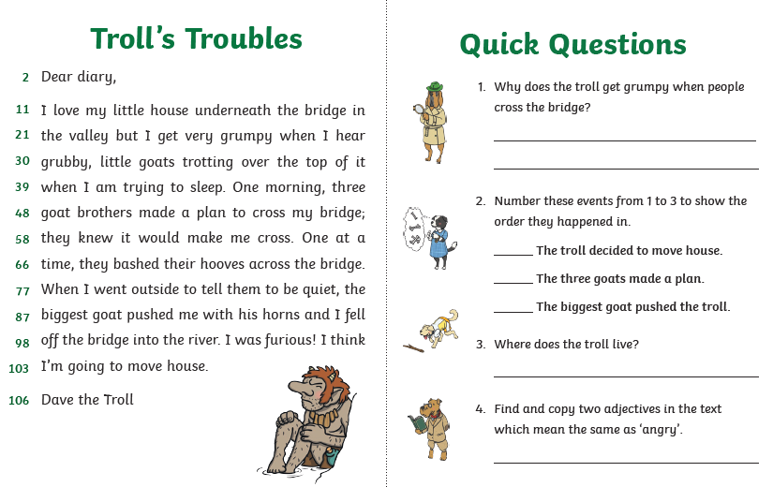
Reading Activity

