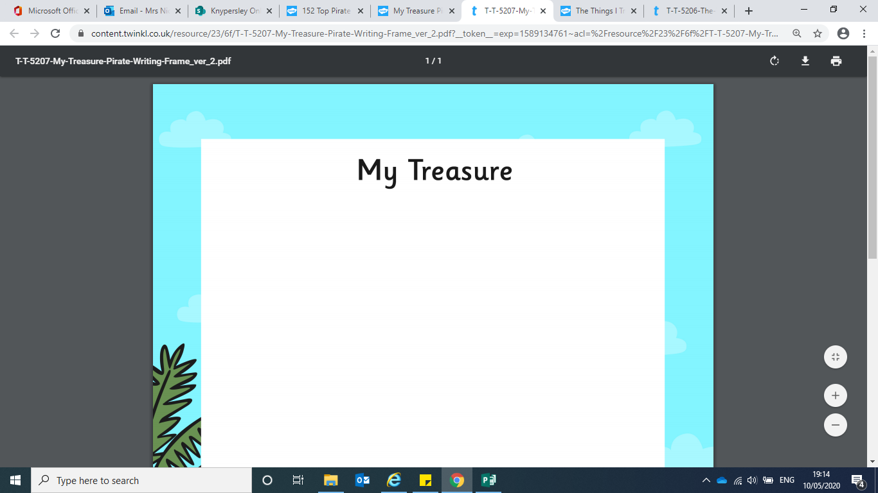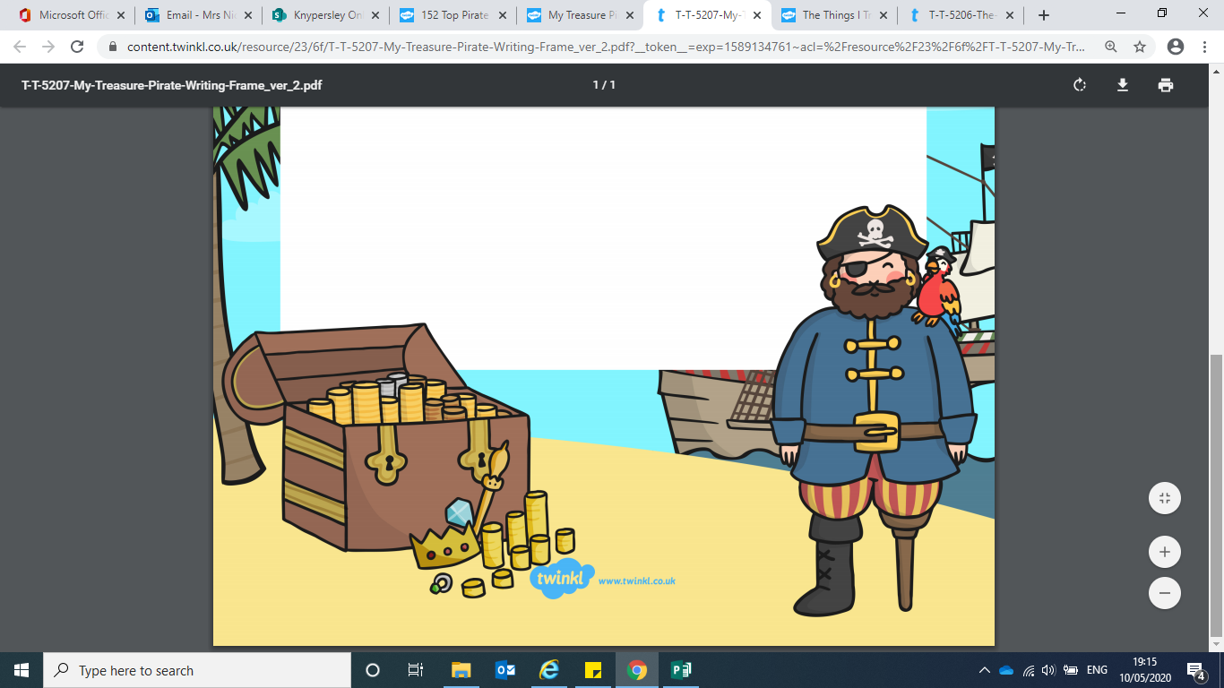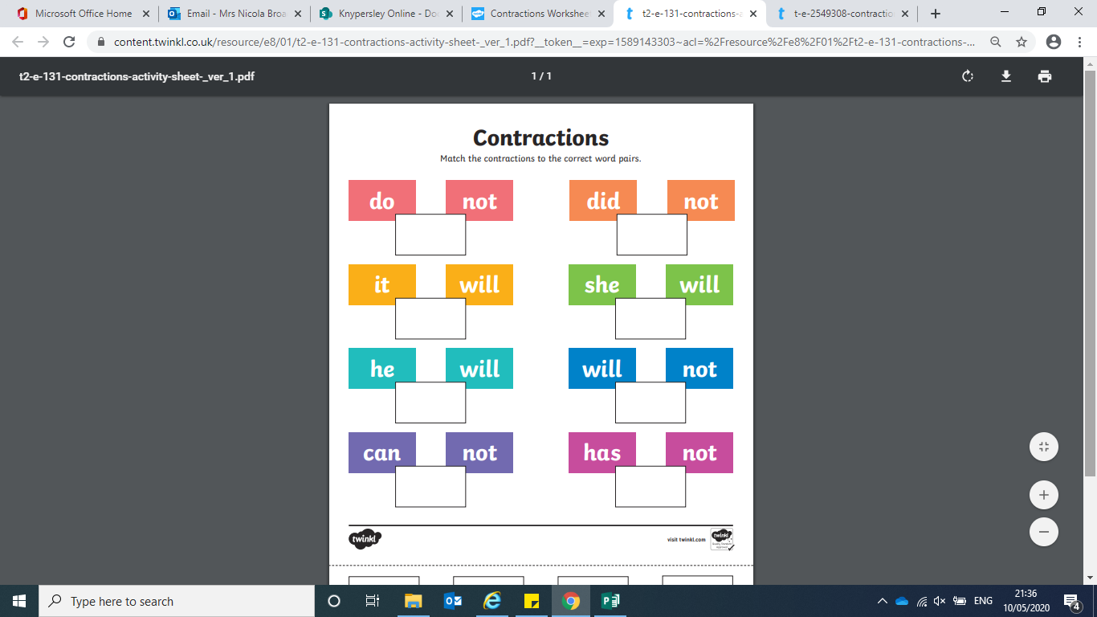

Bronze English

don’t

won’t

he’ll

didn’t

she’ll

hasn’t

it’ll

can’t

Silver English

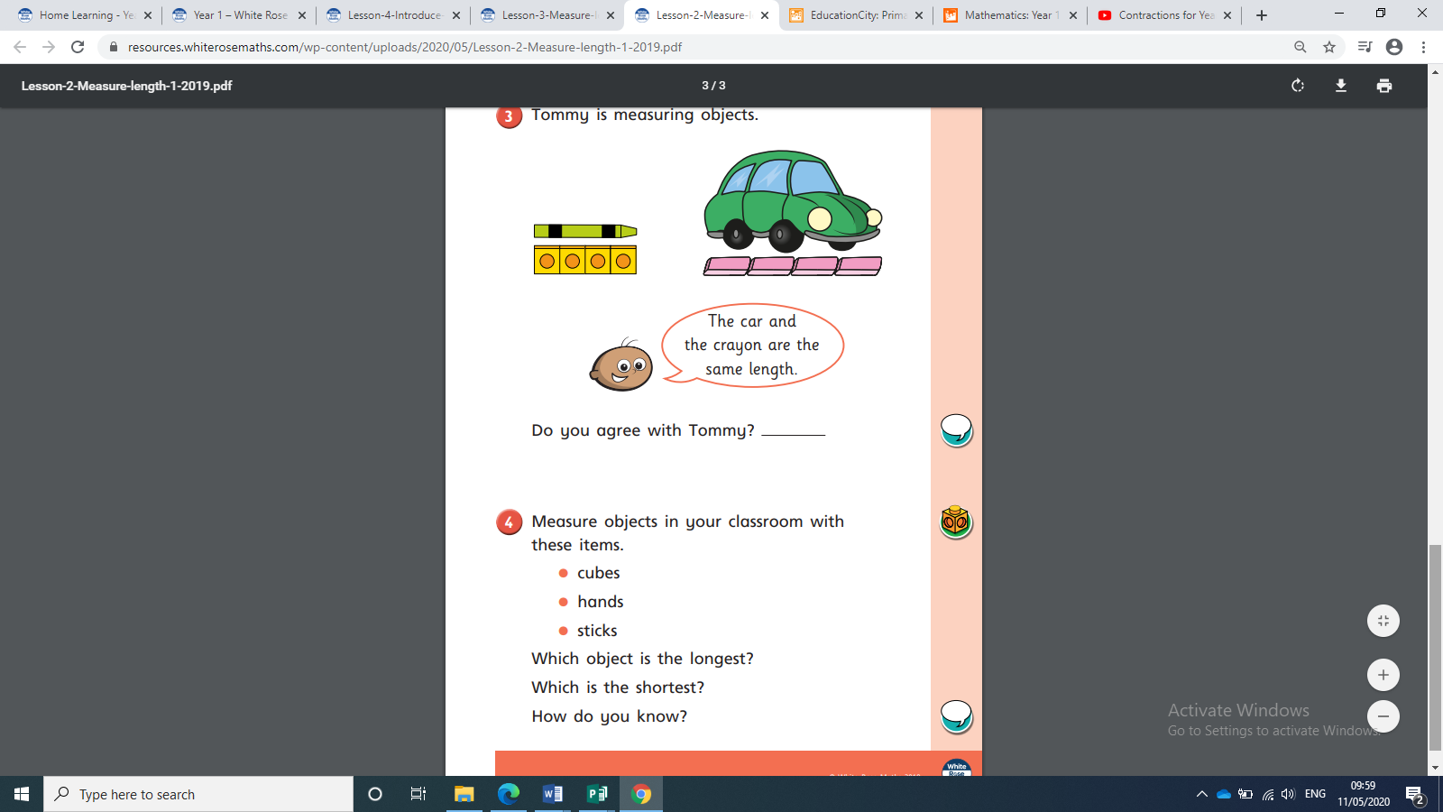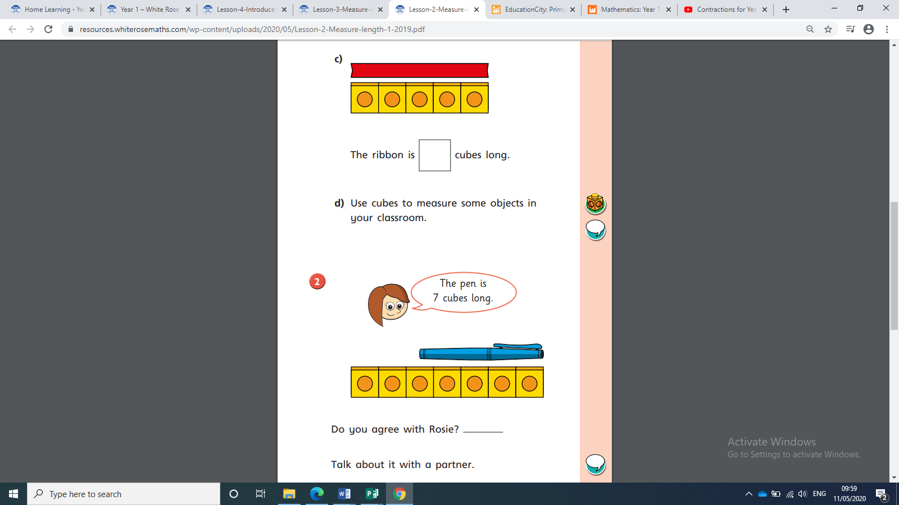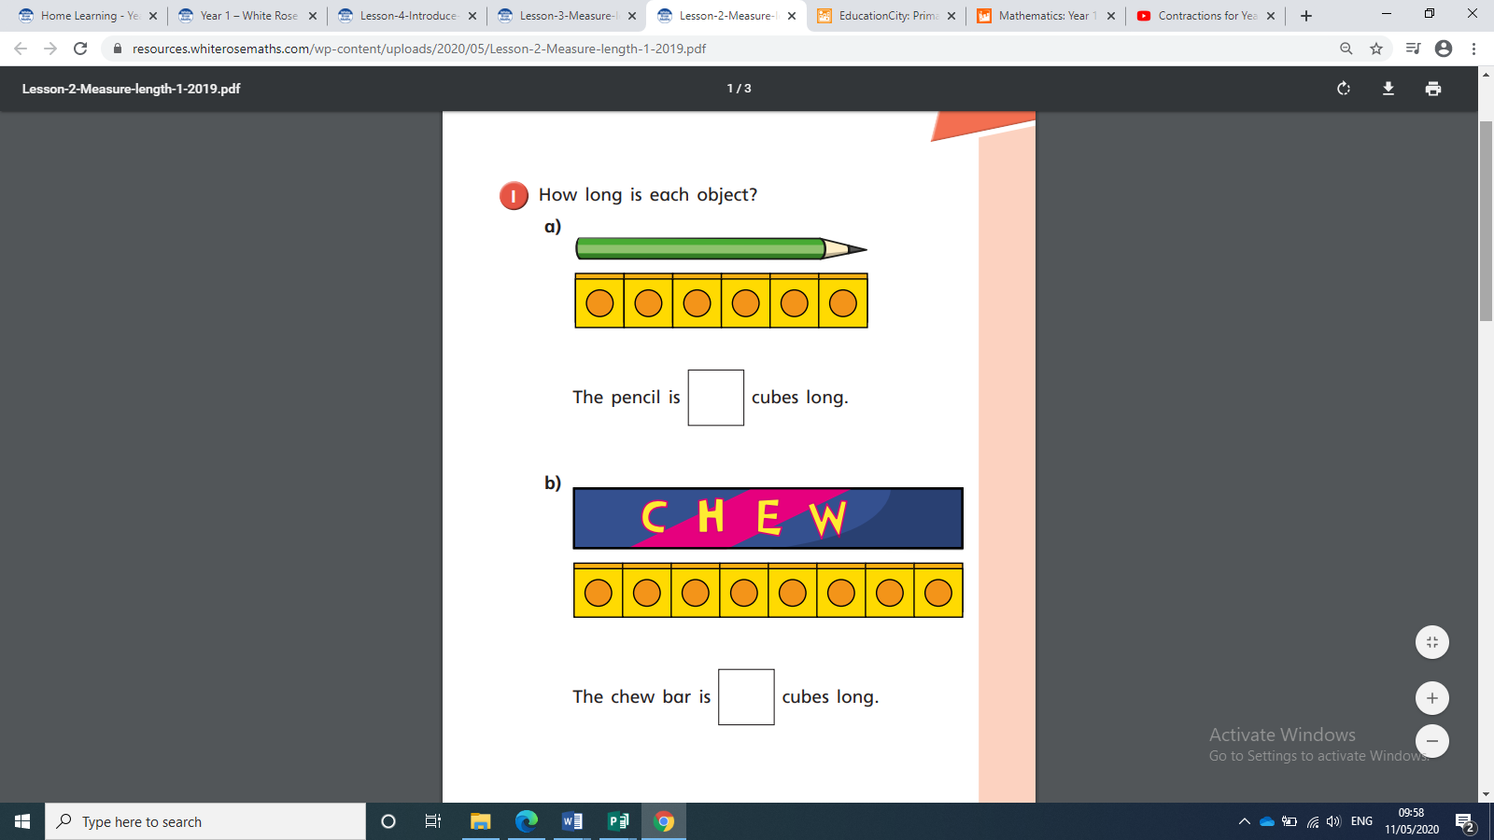

Gold English

**Now complete your measuring tasks from the table above!**

Talk about this with your grown up!

**Gold/Silver Maths**

Pirate Food