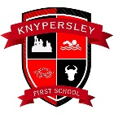
Year 2 Topic Menu! Week Beginning 1st June and 8th June 2020
Pick and choose from the subjects and activities below to complete over the next two weeks. Can you challenge yourself to complete 3 a week?

Science | PE | Art
- Go on a materials hunt in your house and garden. Can you make a list of all of the different materials that you can find?  - Can you make a collage of as many different materials as you can find? E.g. paper, plastic, wood.  - Can you sort a selection of materials into natural and man made and take a photograph of them? | Disney Dance 2  https://www.youtube.com/watch?v=mUSgKSgS4-E  s  Farm Fitness  https://www.youtube.com/watch?v=Tjiim9QG9Vk  Pokemon Yoga  https://www.youtube.com/watch?v=tbCjkPlsaes | - Can you paint or draw a picture of Paddington?  - Maybe you would like to make a model of Paddington instead? https://www.youtube.com/watch?v=4zvRqXzLwe0  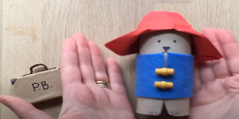  - Can you design a new stamp on A4 paper? Perhaps it could have your portrait on it instead of the Queens?
Geography/History | Music | Well Being
Can you design and create your own Time Capsule about the time we were in lockdown? Remember you are part of History and in the future people will ask you about what happened. Can you decorate a box to turn it into your time capsule? What will you put into your time capsule to tell people about this time? Photographs, letters, newspapers. What would you want people in the future to know about this time? What has changed in the world over the past few months? | - Listen to the National anthem and learn the words  https://www.youtube.com/watch?v=G9eK9fWUb3s  - Learn the song- London’s Burning-  https://www.youtube.com/watch?v=9RkX8WG6HS0  Can you sing it in a round with someone at home?  - Learn the song Power in Me!!  https://www.youtube.com/watch?v=5CAL3OC-Qfk | - Help to make a healthy meal using different coloured veg or fruit. Make a rainbow dish!  - Make an A-Z of things that make you happy.  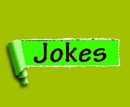  - Ask everyone in the house to tell you their favourite joke. Can you write them down and make them into your own joke book?

