Year 2
Please find todays learning tasks below.
The table below explains the tasks and you will find the resources underneath. Your child will know which challenge they usually access in each subject and which task will be appropriate for them.
Year group: 2 Date: 14.05.20
English | Watch the clip below again;  https://learnenglishkids.britishcouncil.org/short-stories/jack-and-the-beanstalk  As you are watching the clip – think about the sequence of the story.
 | Bronze | Silver | Gold
 | Complete the sequence task (below) and then draw a story board to explain the sequence of the story – draw 1 picture for each sentence. | Complete the sequence task (below) and then complete a story board to retell the story. Draw 1 picture for each sentence – copy / add your own sentences. | Complete the sequence task (below) and then complete a story board to retell the story. Draw 1 picture for each sentence – copy / add your own sentences.
Maths | Warm Up – follow this link to complete your maths warm up.  http://www.wldps.com/gordons/Bingo_-_addition.swf  Complete the adding TO +TO within 100 game.
 | Bronze | Silver | Gold
 | Complete the symmetry activity sheet below. If you can’t print the task draw some shapes in your book using a ruler or find some shapes around the house to draw around.  Remember to complete you reasoning tasks. | Complete the symmetry activity sheet below. If you can’t print the task draw some shapes in your book using a ruler or find some shapes around the house to draw around.  Remember to complete you reasoning tasks. | Complete the symmetry activity sheet below. If you can’t print the task draw some shapes in your book using a ruler or find some shapes around the house to draw around.  Remember to complete you reasoning tasks.
Reading  Phonics | Read the text about Butterfly Life Cycle (see below) and complete the questions.  Can you find the Common Exception Words in the word search? (see below)
Other | Today’s subject focus will be Music  Share the link below:  https://www.bbc.co.uk/teach/school-radio/music-jack-and-the-beanstalk-song1/z7m67nb  Follow the tasks on the screen to learn the song ‘What shall we do?’ – clap the rhythms.

Unless otherwise specified, please complete the tasks in either your home learning book or print out the document below.

Writing Challenge (Part 1) – All groups.
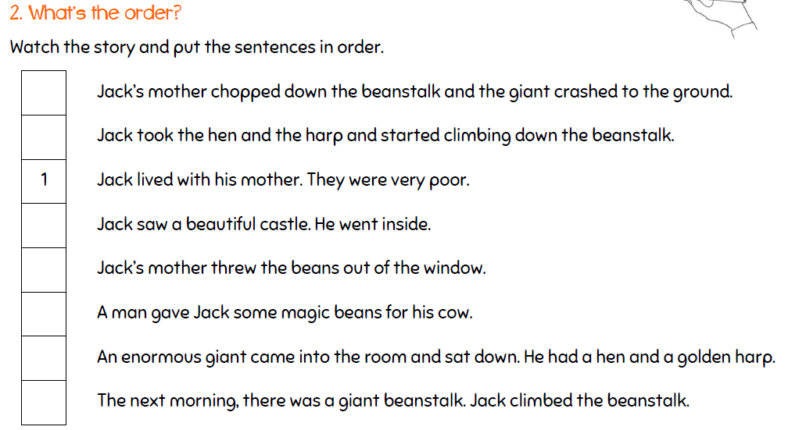

Writing Challenge (Part 2)
Complete a picture storyboard (as below) to retell of the story Jack and the Beanstalk. You can use the sentences above to help you and draw 8 different pictures – you can copy / add your own sentences or alternatively write a retell of the story in your own words.
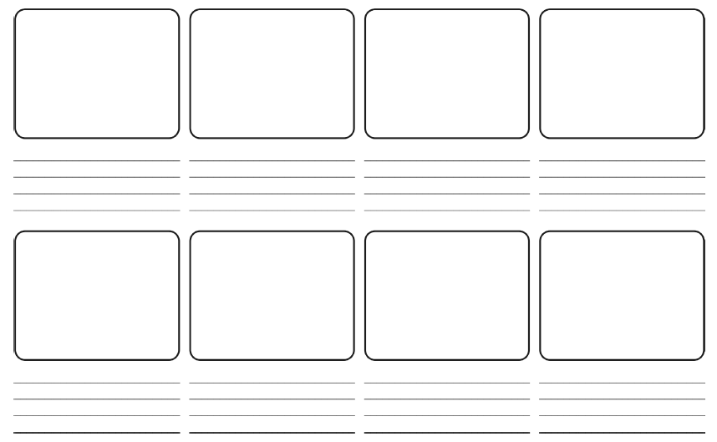

Print this if you want to / split your page into 8 sections.

Phonics / Spelling
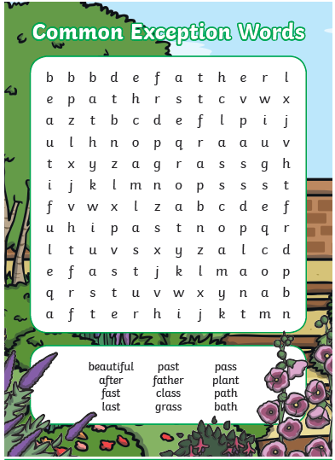

Extension task – write each word into a sentence.
Maths Bronze
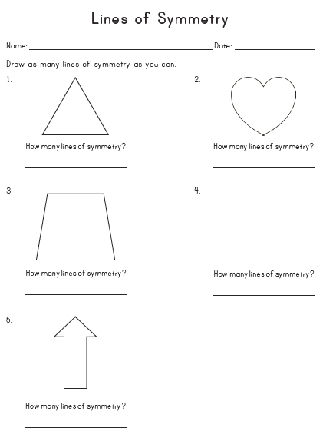

Maths Silver

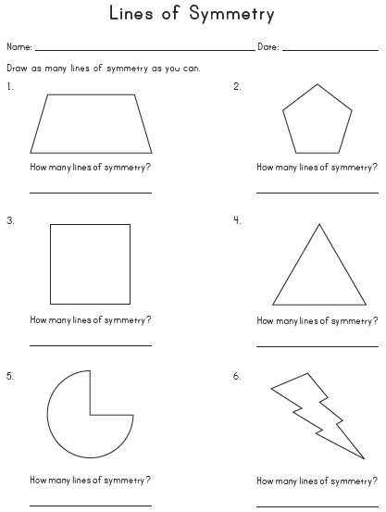
Maths Gold

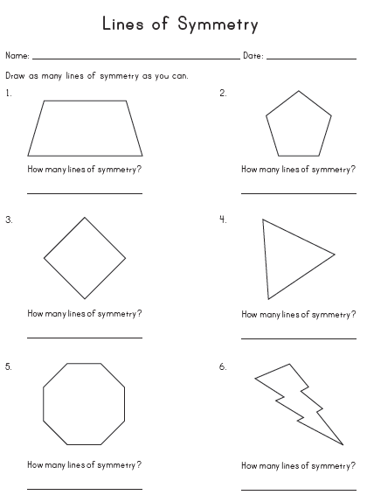

Reasoning Tasks (all groups)
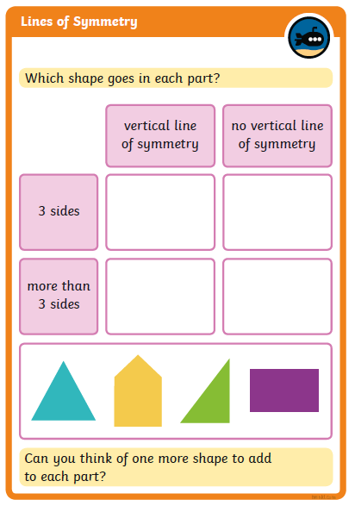

Reading Task

