Year 2
Please find todays learning tasks below.
The table below explains the tasks and you will find the resources underneath. Your child will know which challenge they usually access in each subject and which task will be appropriate for them.
Year group: 2 Date: 4.06.20
English | A Postcard from London  Imagine that you have visited London for the first time (before lockdown!!!) and you are writing a postcard to your family at home.  You might want to include  - Where you have been  - What you have seen  - What the best thing was
 | Bronze | Silver | Gold
Use the sheet below or draw your own and write about all the marvellous things you have seen and done.
Don’t forget to include as much detail as you can and definitely different sentence starts, 2A sentences and a range of conjunctions.

Maths | Warm Up – follow this link to complete your maths warm up.  https://www.ictgames.com/mobilePage/chimney/index.html  Odd and Even  Numbers Game on ICT GAMES
 | Bronze | Silver | Gold
 | Complete the activity sheets below about coins, which we have learnt about previously.  Remember you can draw / jot things down in your book to help you work it out.  After, complete your reasoning task. | Complete the activity sheet below about coins, which we have learnt about previously.  Remember you can draw / jot things down in your book to help you work it out.  After, complete your reasoning task.
Reading  Phonics | Complete the reading comprehension task below.  Go to this link (chrome works best) https://www.ictgames.com/mobilePage/lcwc/index.html (if link doesn’t work copy into browser).  Choose Year 2 – click on patterns and then choose ing, ed, er, est and press go!  Read the words carefully and then use the keyboard to retype them.

Unless otherwise specified, please complete the tasks in either your home learning book or print out the document below.

English All challenges
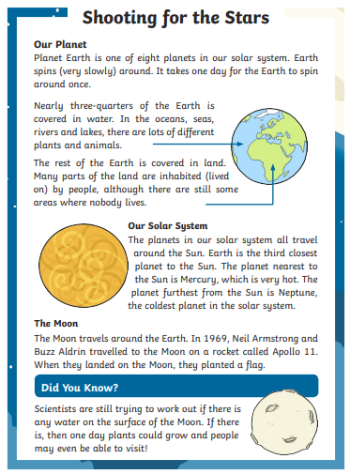
Reading Task
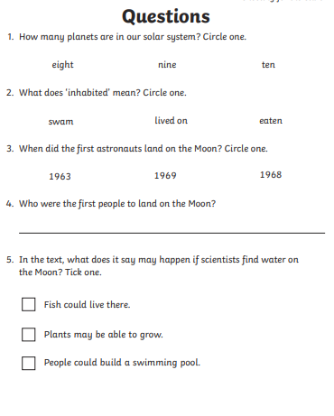

Maths Bronze
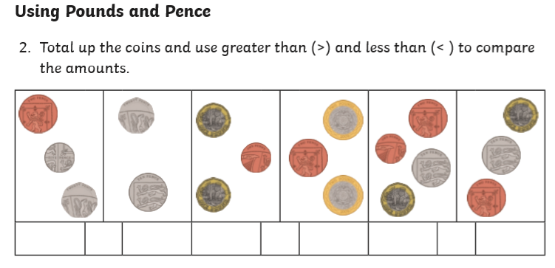

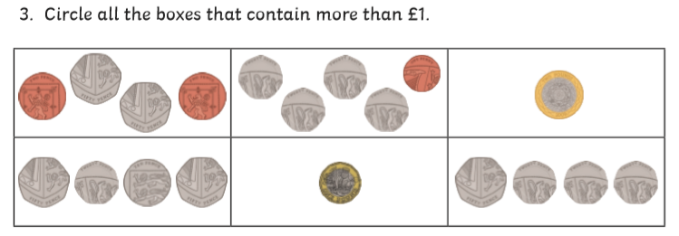

Bronze Challenge

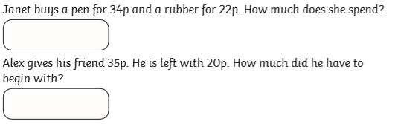

Maths Silver and Gold
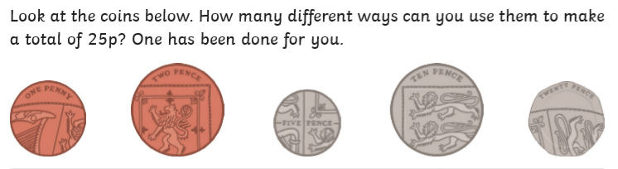
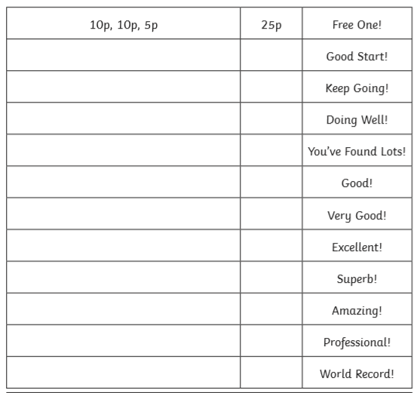

Silver and Gold Challenge
