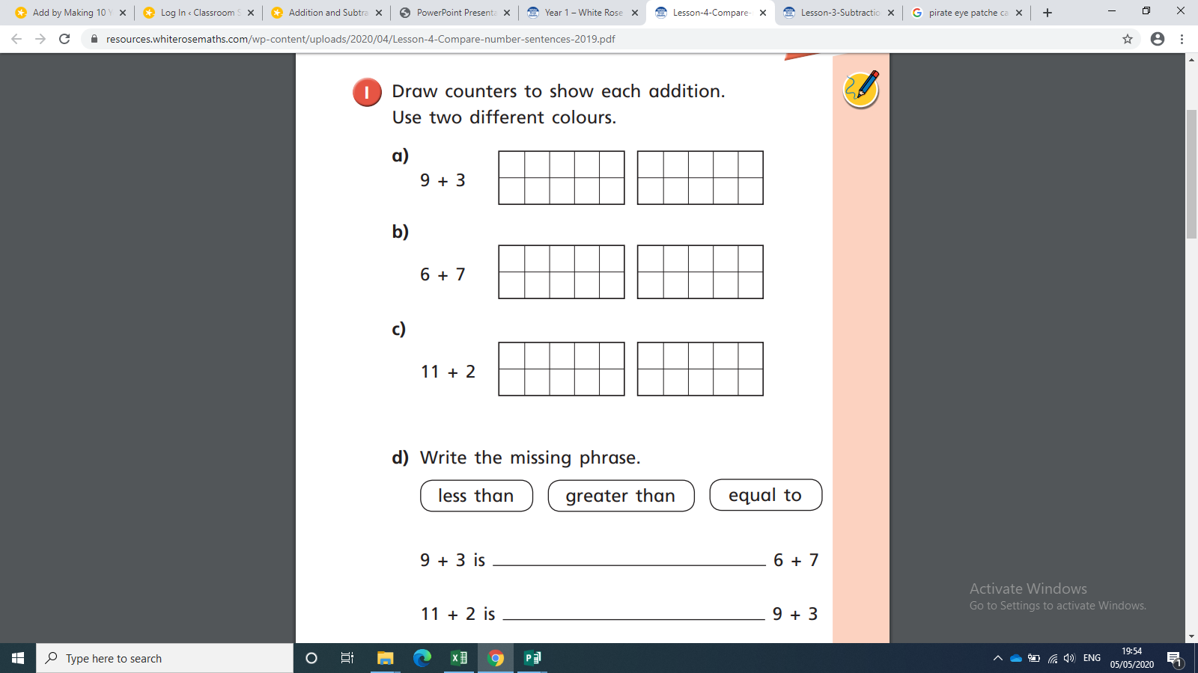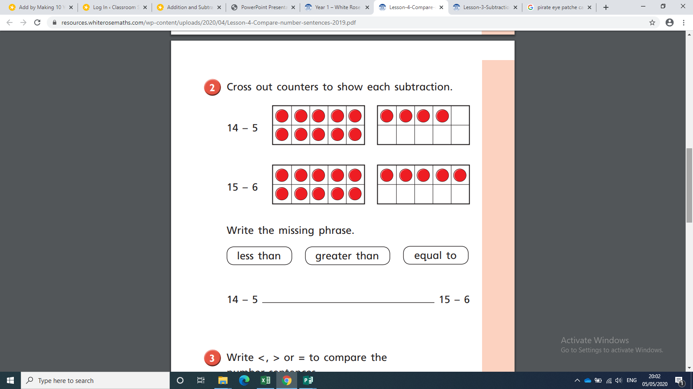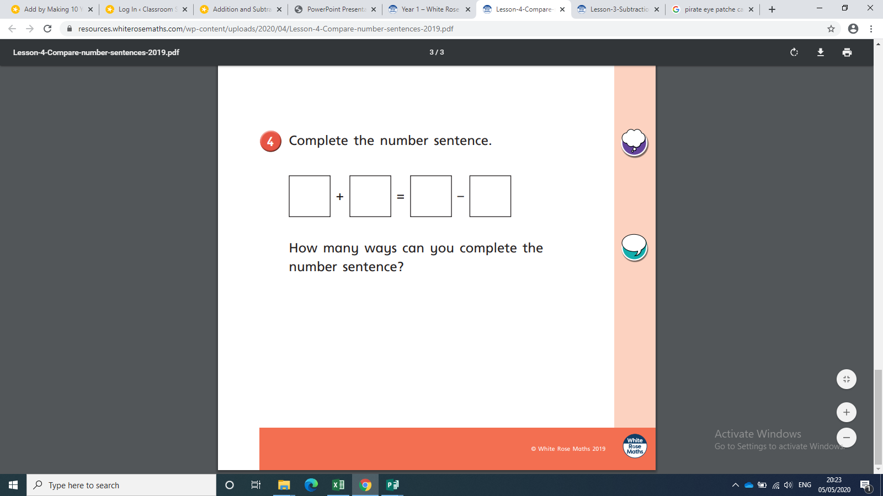

BRONZE MATHS

Use <, > or = to compare the number sentences:

6 + 3 6—3

7—4 7-6

4 + 6 6 + 4

8—8 1 + 0

Use two colours to complete the ten frames:

**greater than**

**Less than**

**equal to**

6 + 2 is ____________________ 4 + 5

4 + 5 is _____________________ 6 + 2

6 + 2 is _____________________ 5 + 3

Cross out to show the subtractions:

**greater than**

**Less than**

**equal to**

9-4 is _____________________ 8-5

5+3

4+5

6+2

9-4

8-5

14-5 is _____________________ 15-6

**equal to**

**Less than**

**greater than**

Cross out to show the subtractions:

9 + 3 is ____________________ 6+7

11+2 is _____________________ 9+3

6+7 is _____________________ 11+2

**equal to**

**Less than**

**greater than**

Use two colours to complete the ten frames:

Use <, > or = to compare the number sentences:

12 + 3 12—3

17—4 17-6

13 + 6 6 + 13

14—4 1 + 0

SILVER MATHS

GOLD MATHS

37—13 is _________________ 25 + 14

34+15 is _________________ 19—7

21+18 is __________________ 28—11

Complete the number sentences:

Use <, > or = to compare the number sentences:

22 + 3 22—3

17—4 17-6

13 + 6 6 + 13

14—4 1 + 0

How many ways can you complete the number sentences?

Show the number sentences, using dienes:

37 - 13 =

25 + 14 =

34 + 15 =

21 + 18 =

28 - 11 =

19 - 7 =

**greater than**

**Less than**

**equal to**

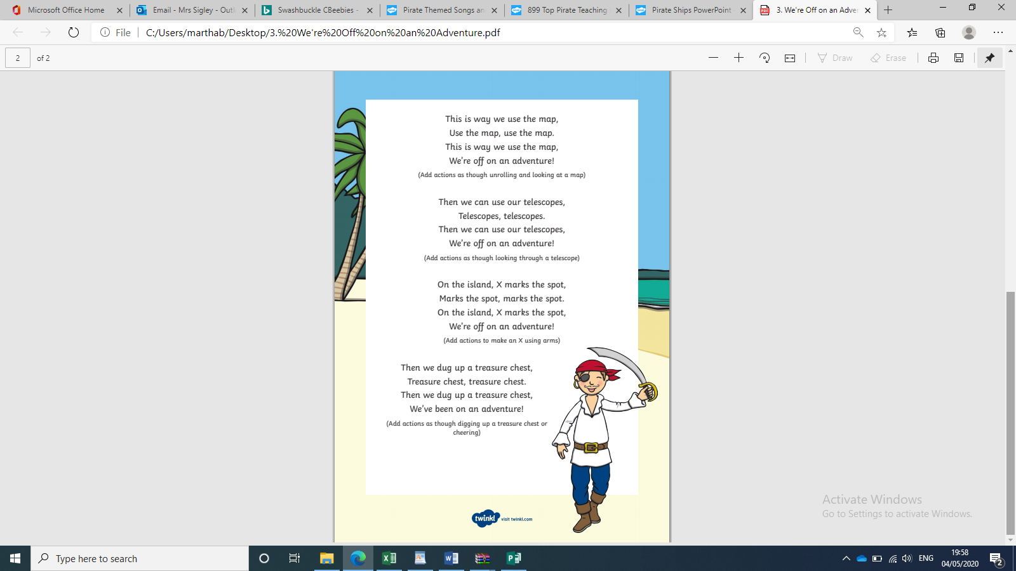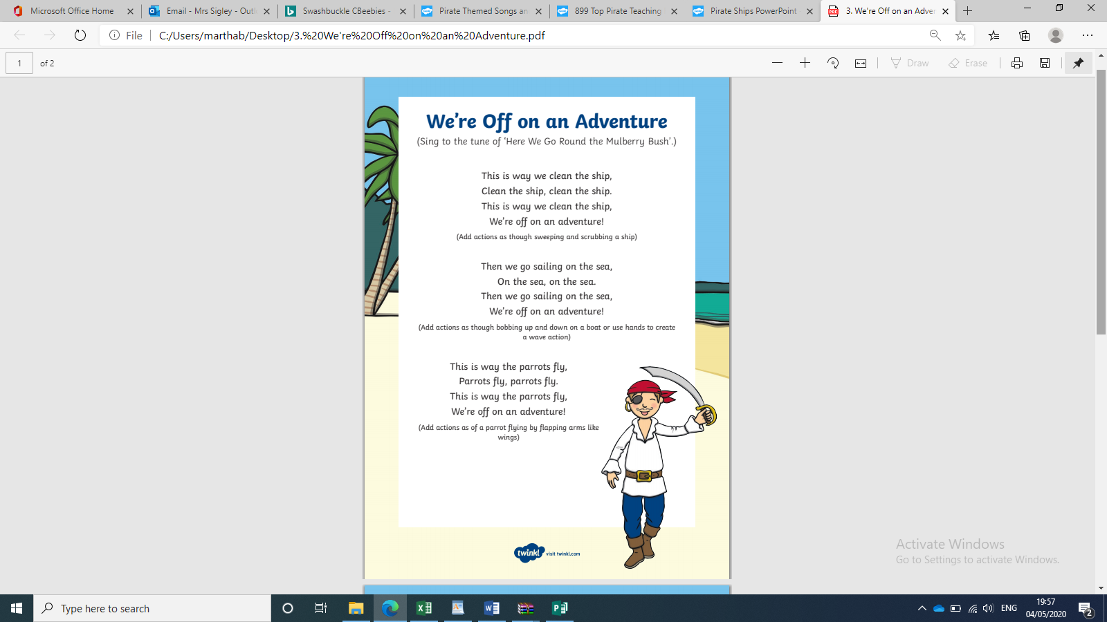

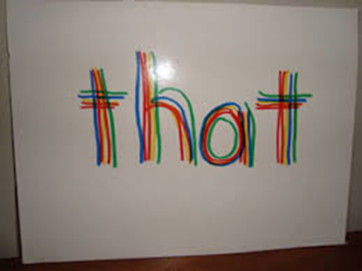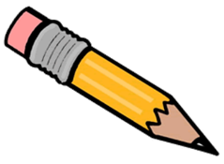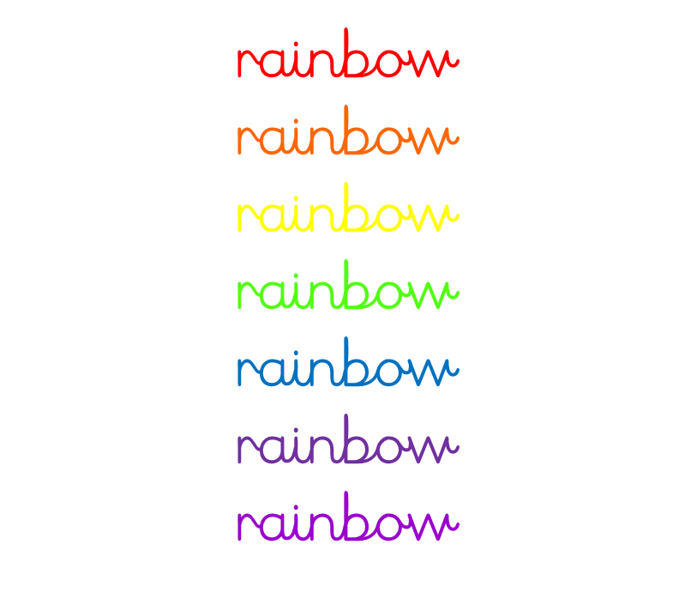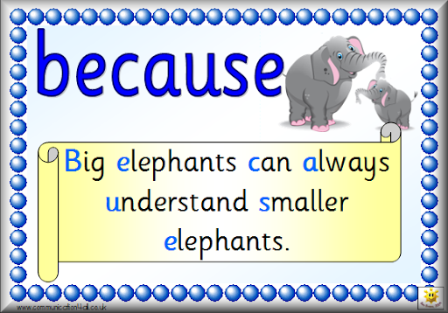Free Free Bee Clipart, Download Free Clip Art, Free Clip Art on ...Free Leaf Cliparts, Download Free Clip Art, Free Clip Art on ...Free Free Flowers Images, Download Free Clip Art, Free Clip Art on ...

Example ways to help you remember how to spell common exception words. Can you use these methods to help you learn the spelling of the common exception words that you find difficult to spell?

Write the word out lots of times in different colours until you can remember it.

Think of a rhyme

beautiful

Draw pictures around the word that will help you to remember

Gold Phonics/Spelling

First

Next

Finally

After that

Bronze English