Year group: Nursery Date: 18.05.2020
 | Challenge 1 | Challenge 2 | Challenge 3
English/Listening/Speaking and Understanding | “The life of a builder”  Watch an episode of Topsy and Tim meeting the builders.  Talk about what has happened in the story. What did you see? Who were the characters? What was happening? What happened at the beginning, middle and end? Use good sentence structure to explain your answers. | “The life of a builder”  Watch an episode of Topsy and Tim meeting the builders.  Talk about what has happened in the story. What did you see? Who were the characters? What was happening? What happened at the beginning, middle and end? Use good sentence structure to explain your answers. Can you think of a time that you have seen a builder and explain where and what they were doing? | The life of a builder”  Watch an episode of Topsy and Tim meeting the builders.  Talk about what has happened in the story. What did you see? Who were the characters? What was happening? What happened at the beginning, middle and end? Use good sentence structure to explain your answers. Can you think of a time that you have seen a builder and explain where and what they were doing?
Maths | You are going to be a super builder today, put on your jacket and a hat.  Can you use building blocks and build towers of given numbers from 0-10. | You are going to be a super builder today, put on your jacket and hat.  Can you use building blocks and build towers of a given number from 0-15.  Can you write the number you have built on a post it note and stick it on your tower? | You are going to be a super builder today, put on your jacket and hat.  Can you use building blocks and build towers of a given number from 0-20.  Can you write the number you have built on a post it note and stick it on your tower?  Can mummy and daddy take some bricks off your tower? Has the number of bricks now changed? Why?
Phonics/Reading | Choose a story from home which has some Rhyming words in it. Julia Donaldson books are good for Rhyme. You could you tube a story if you don't have one. Listen out for Rhyming words “words that sound the same”  Complete the worksheet below. | Choose a story from home which has some Rhyming words in it. Julia Donaldson books are good for Rhyme. You could you tube a story if you don't have one. Listen out for Rhyming words “words that sound the same”  Complete the worksheet below. | Choose a story from home which has some Rhyming words in it. Julia Donaldson books are good for Rhyme. You could you tube a story if you don't have one. Listen out for Rhyming words “words that sound the same”  Complete the worksheet below.
Wellbeing | Enjoy some art and crafts together.  Maybe you could create a picture for thanking someone for doing something nice. | Enjoy some art and crafts together.  Maybe you could create a picture for thanking someone for doing something nice. | Enjoy some art and crafts together.  Maybe you could create a picture for thanking someone for doing something nice.

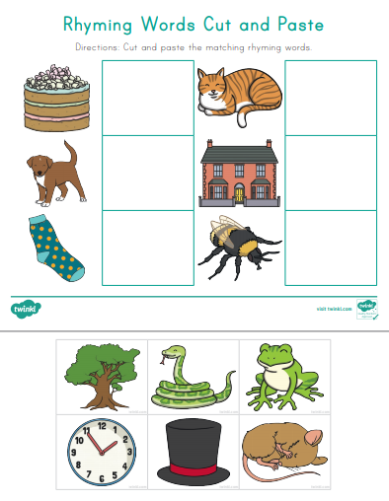
Challenge 1 – Phonics
Can you find the rhyming picture that matches?

Challenge 3 – Phonics

Can you make a rhyming string? Use your sound mat to help you write some words that Rhyme.
