Year 2
Please find todays learning tasks below.
The table below explains the tasks and you will find the resources underneath. Your child will know which challenge they usually access in each subject and which task will be appropriate for them.
Year group: 2 Date:
English | Share the story (read / listen) by the following the link below;  https://learnenglishkids.britishcouncil.org/short-stories/jack-and-the-beanstalk
 | Bronze | Silver | Gold
 | Once you have listened to or read the story – complete the word mat and some simple sentences / captions.  (see bronze below) | Once you have listened to or read the story – complete the word mat and write some 2A sentences for each picture.  (see silver below) | Once you have listened to or read the story – complete the word mat and some complex sentences for each picture.  (see gold below)
Maths | 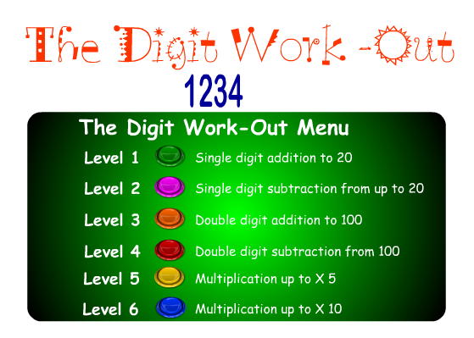  Warm Up – follow this link to complete your maths warm up.  http://www.crickweb.co.uk/ks1numeracy.html
 | Bronze | Silver | Gold
 | Complete the 2D shape activity below look carefully and colour the shapes using the key.  Complete your reasoning task. | Complete the 2D shape grid below look carefully at the shapes and complete the grid.  Complete your reasoning task. | Complete 2D shape grid below – think about each shape. I have put the shapes underneath for you to check if you are unsure.  Remember to complete your reasoning task.
Reading  Phonics | Please see English starter for today.  Find the suffix ‘ful’ words in the wordsearch.
Other | Today’s subject focus will be Science  As we come to the end of our topic on plants – we wanted to explain quite a tricky concept about how the roots of the plant works, we found this lovely creative activity that you can easily complete to show absorption and capillary action (see below).

Unless otherwise specified, please complete the tasks in either your home learning book or print out the document below.

English Bronze - Print / Draw and copy the word matching the initial sound.
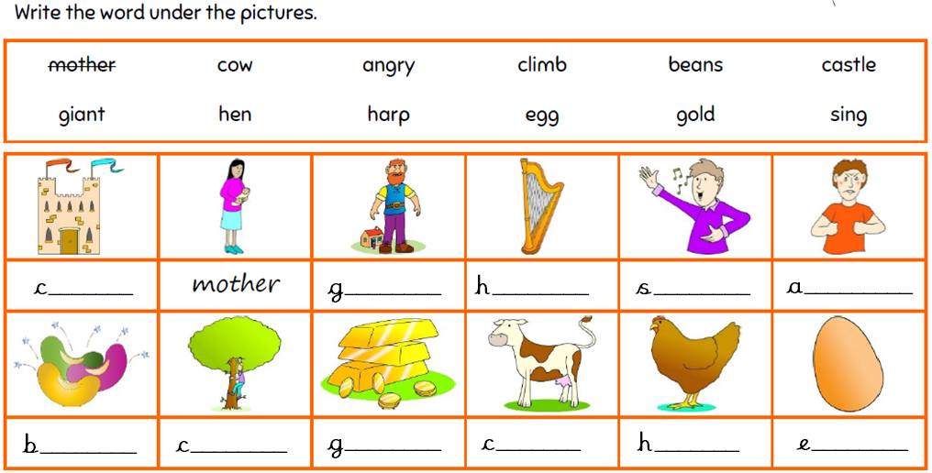

Write a caption / sentence for some of the pictures.

English Silver - Print / Draw and copy the word to match the picture.
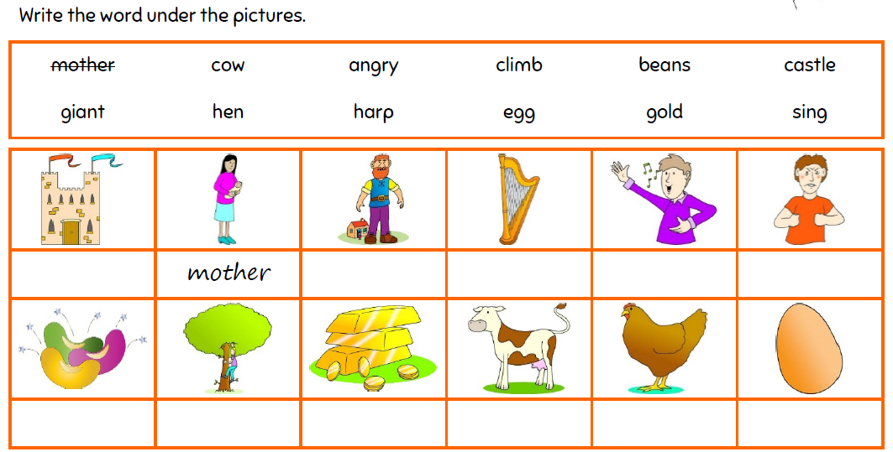

Write some sentences for each picture. Try and include some 2A sentences.

English Gold – Print / Draw and label each picture.
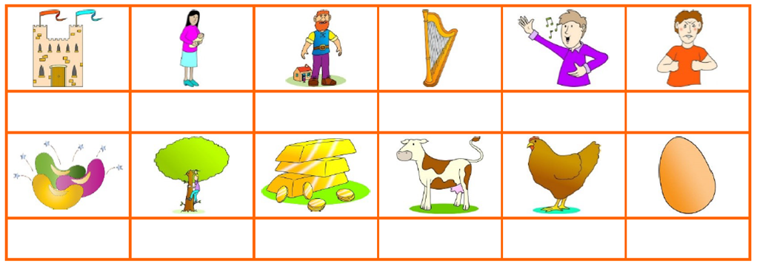

Write a complex sentence for each of the pictures
e.g. The enormous, turreted castle stands high in the sky, above the clouds.
(2A sentence and some more information)

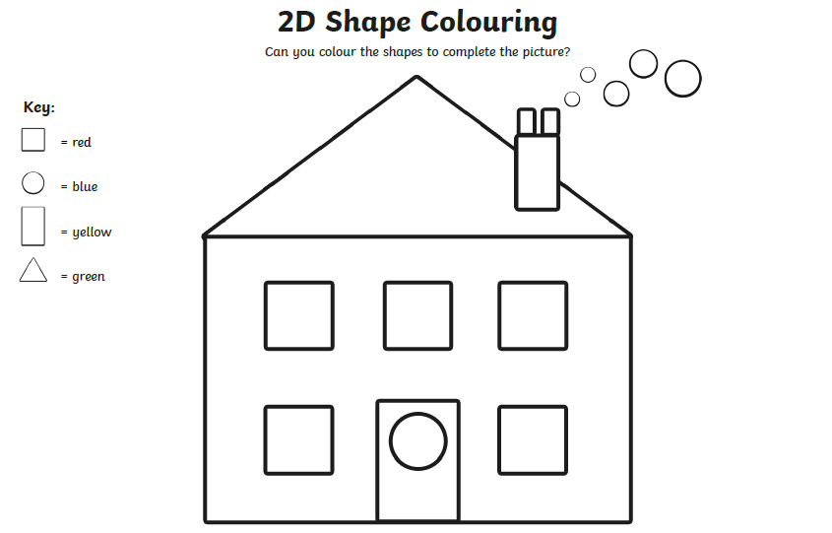
Maths Bronze
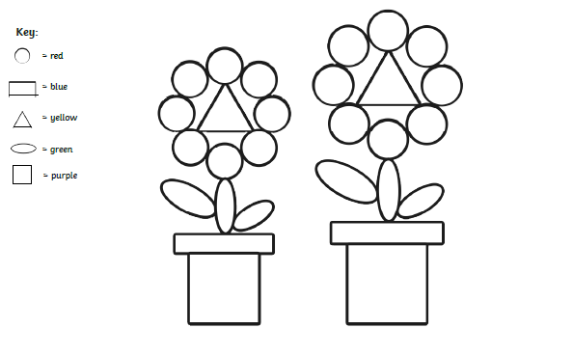

Reasoning Bronze
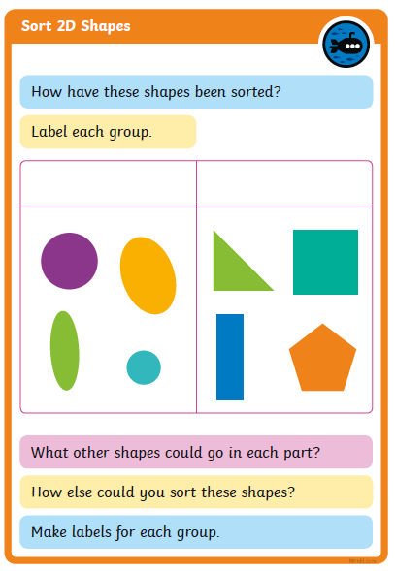

Maths Silver
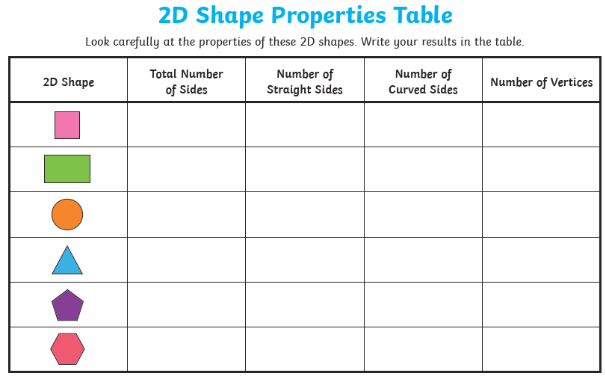

Reasoning Task Silver

Maths Gold
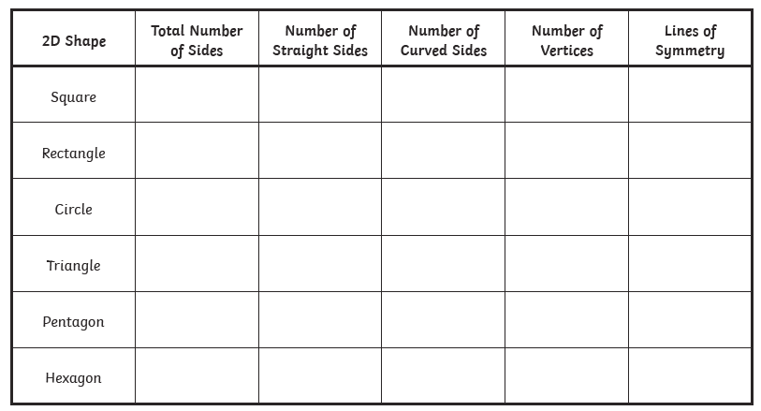
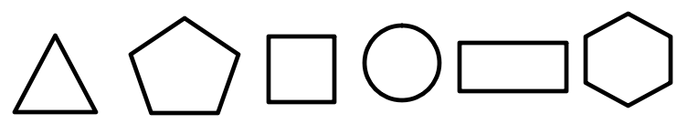

Reasoning Task Gold
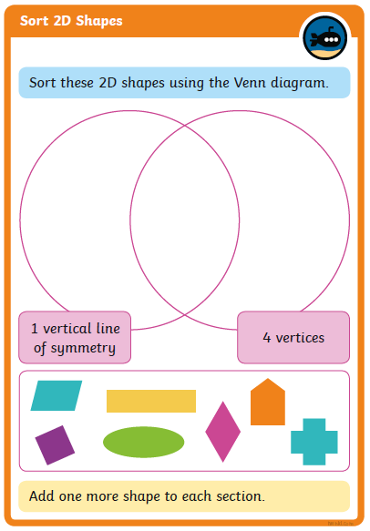

Phonics
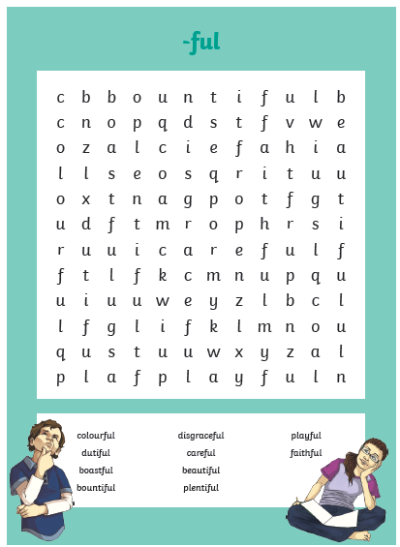

Science Task
