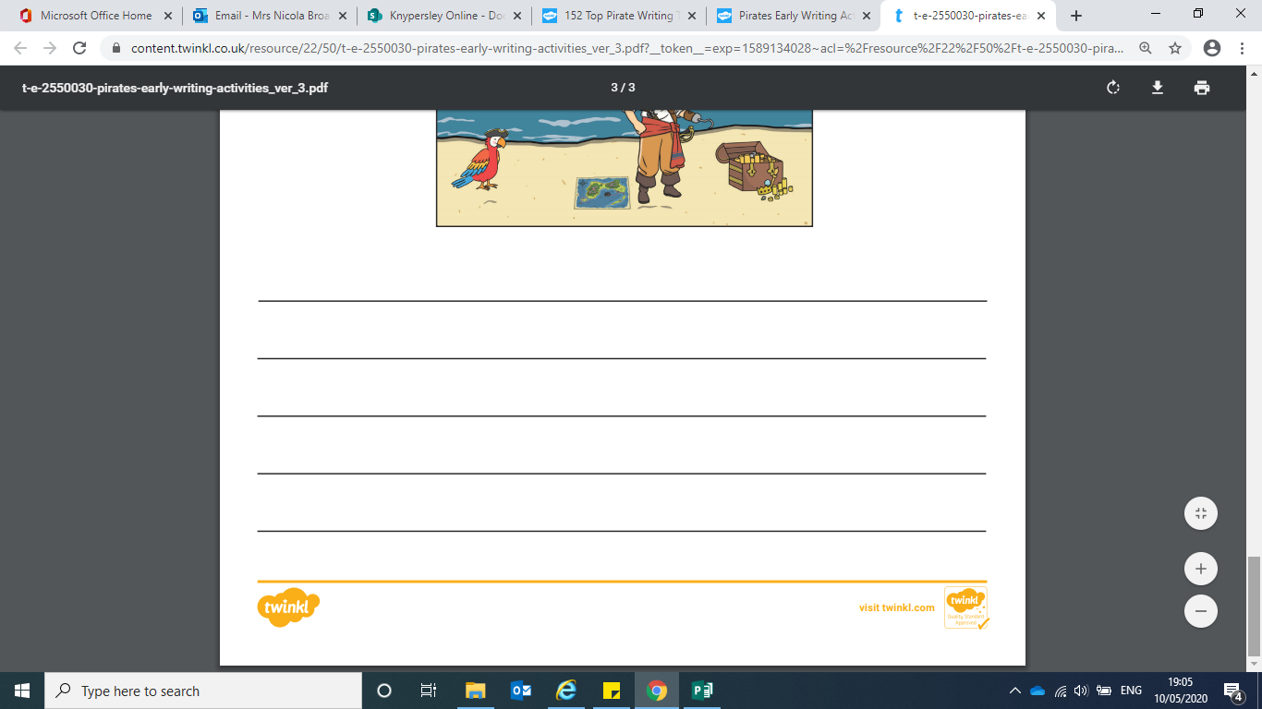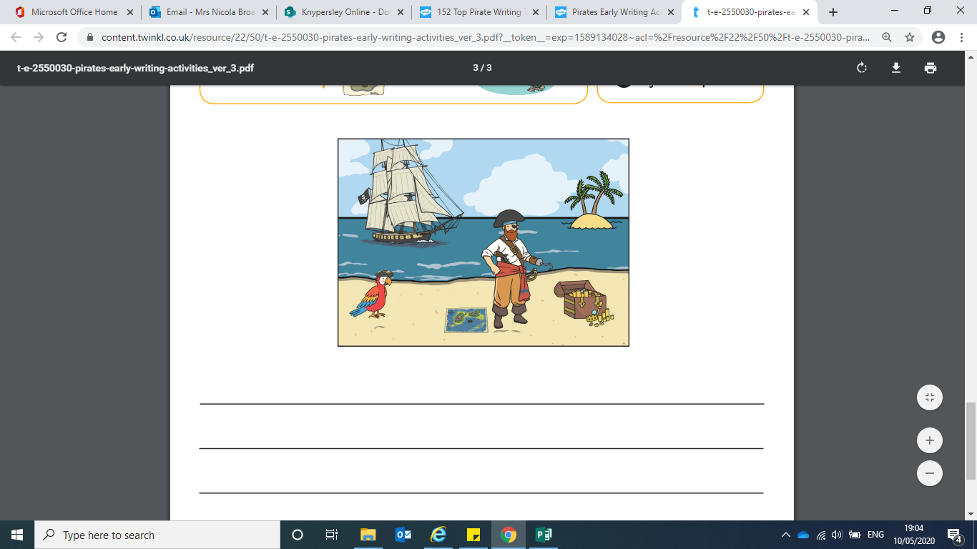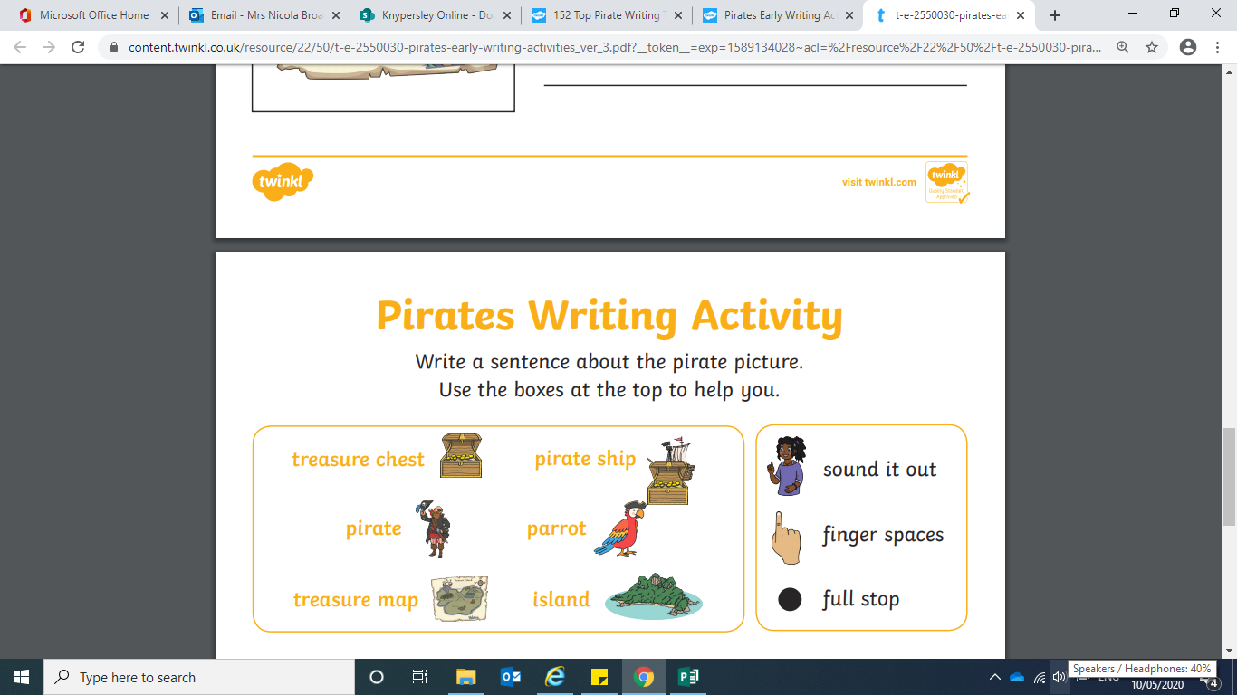

Bronze English

|  |  |  |
| --- | --- | --- |
| Silver |  |  |
| I will |  | can’t |
| they are |  | it’s |
| might have |  | he’d |
| can not |  | I’ll |
| he would |  | they’re |
| it is |  | might’ve |

Gold English

|  |  |  |
| --- | --- | --- |
| I will |  |  |
|  |  |  |
| they are |  |  |
|  |  |  |
| might have |  |  |
|  |  |  |
| can not |  |  |
|  |  |  |
| he would |  |  |
| it is |  |  |

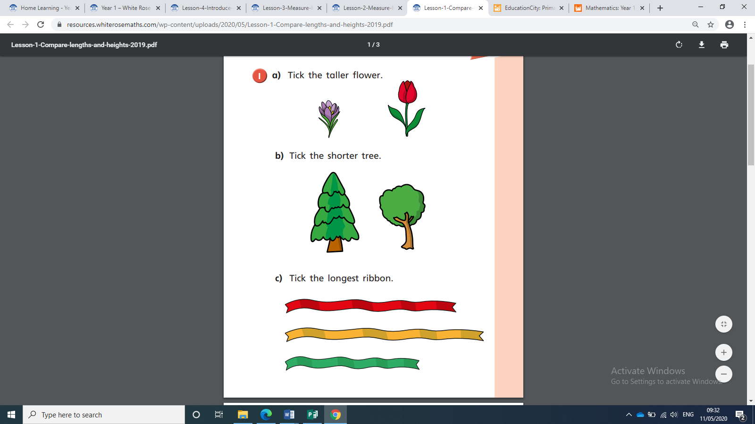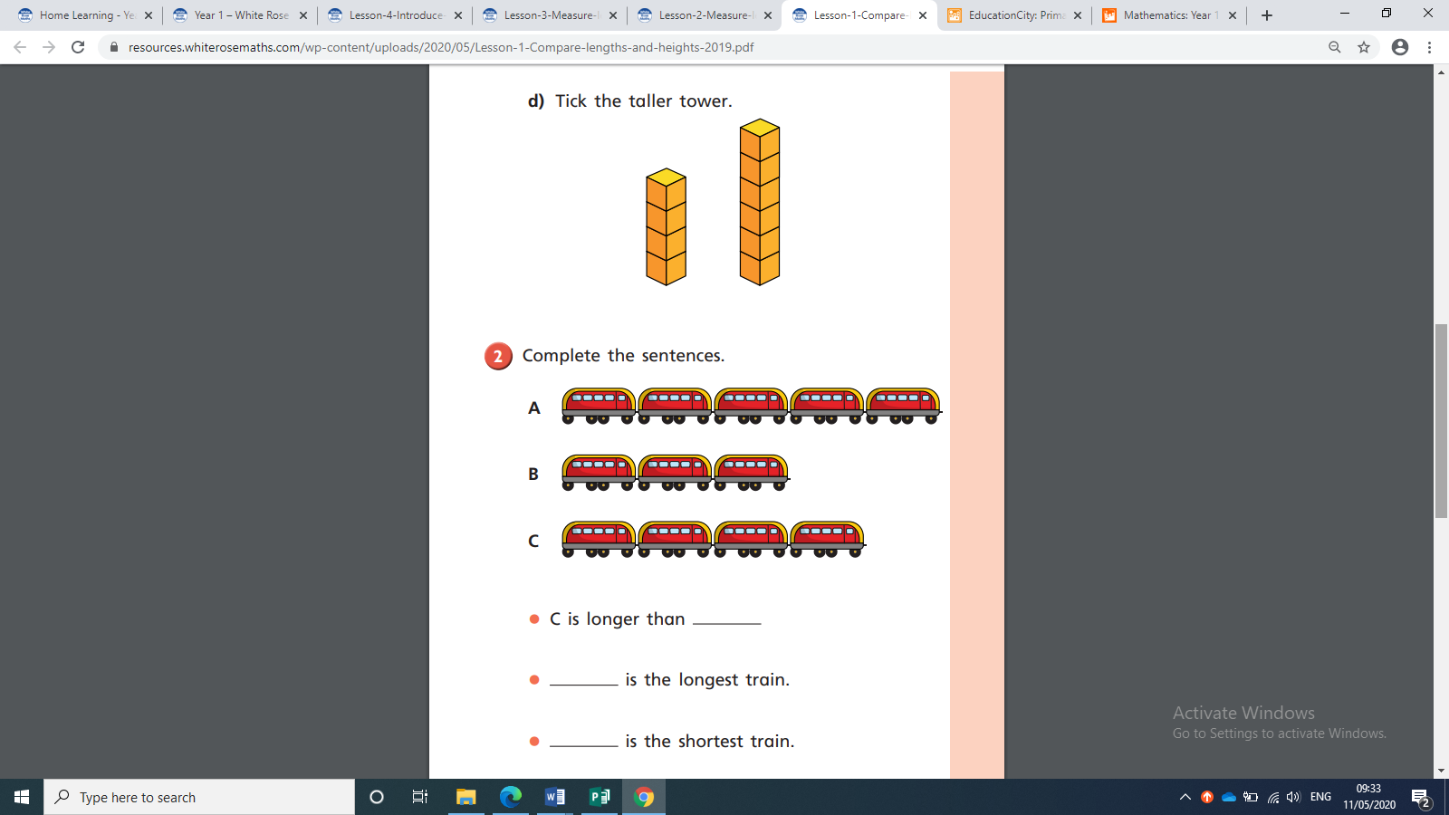

_______________________________________________________________________________________________________________________________________________________________________________________________________________________

**Maths**

**Bronze—Discuss, using the vocabulary: taller, shorter, tallest, shortest...**

**Silver- Write on**

**Gold—Create own sentences for the a,b,c,d.**

Year 1 Common Exception Words

|  |  |  |  |  |  |
| --- | --- | --- | --- | --- | --- |
|  | Free Tick Cliparts, Download Free Clip Art, Free Clip Art on ... |  | Free Tick Cliparts, Download Free Clip Art, Free Clip Art on ... |  | Free Tick Cliparts, Download Free Clip Art, Free Clip Art on ... |
| the |  | you |  | where |  |
| a |  | your |  | love |  |
| do |  | they |  | come |  |
| to |  | be |  | some |  |
| today |  | he |  | one |  |
| of |  | me |  | once |  |
| said |  | she |  | ask |  |
| says |  | we |  | friend |  |
| are |  | no |  | school |  |
| were |  | go |  | put |  |
| was |  | so |  | push |  |
| is |  | by |  | pull |  |
| his |  | my |  | full |  |
| has |  | here |  | house |  |
| I |  | there |  | our |  |

Year 2 Common Exception Words– Page 1

|  |  |  |  |  |  |
| --- | --- | --- | --- | --- | --- |
|  | Free Tick Cliparts, Download Free Clip Art, Free Clip Art on ... |  | Free Tick Cliparts, Download Free Clip Art, Free Clip Art on ... |  | Free Tick Cliparts, Download Free Clip Art, Free Clip Art on ... |
| after |  | eye |  | only |  |
| again |  | fast |  | parents |  |
| any |  | father |  | pass |  |
| bath |  | find |  | past |  |
| beautiful |  | floor |  | path |  |
| because |  | gold |  | people |  |
| behind |  | grass |  | plant |  |
| both |  | great |  | poor |  |
| break |  | half |  | pretty |  |
| busy |  | hold |  | prove |  |
| child |  | hour |  | should |  |
| children |  | improve |  | steak |  |
| Christmas |  | kind |  | sugar |  |
| class |  | last |  | sure |  |
| climb |  | many |  | told |  |

Year 2 Common Exception Words– Page 2

|  |  |  |  |  |  |
| --- | --- | --- | --- | --- | --- |
|  | Free Tick Cliparts, Download Free Clip Art, Free Clip Art on ... |  | Free Tick Cliparts, Download Free Clip Art, Free Clip Art on ... |  | Free Tick Cliparts, Download Free Clip Art, Free Clip Art on ... |
| clothes |  | mind |  | water |  |
| cold |  | money |  | who |  |
| could |  | most |  | whole |  |
| door |  | move |  | wild |  |
| even |  | Mr |  | would |  |
| every |  | Mrs |  |  |  |
| everybody |  | old |  |  |  |

If your child can confidently read all of these words. They could practise spelling some of them as this week’s challenge.

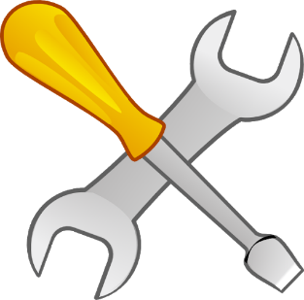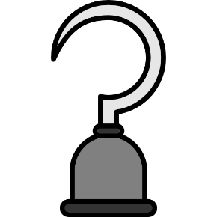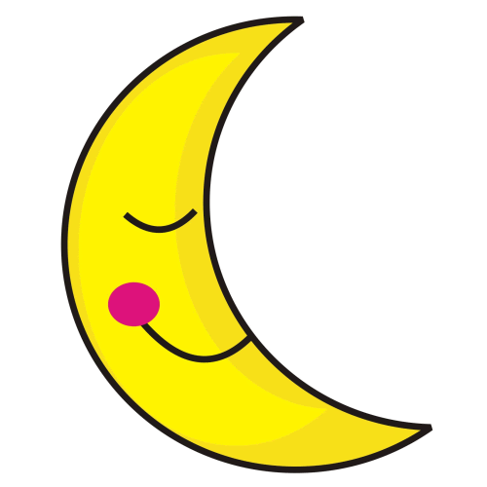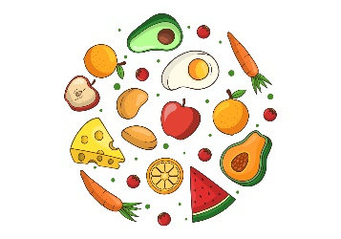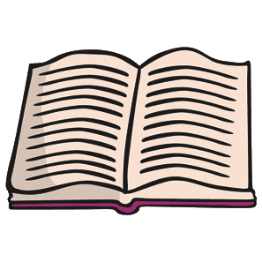

Bronze Phonics

food

tools

moon

hook

book

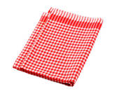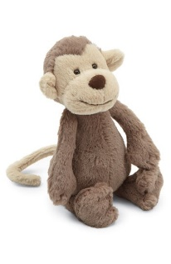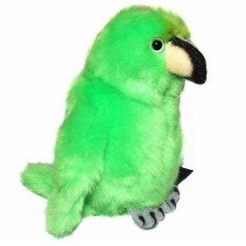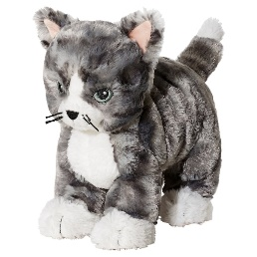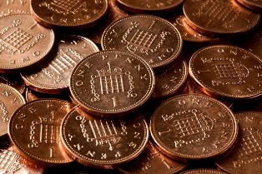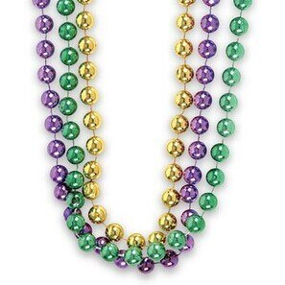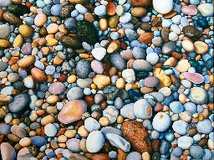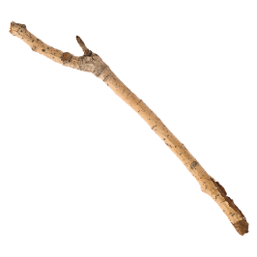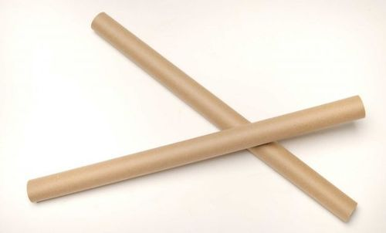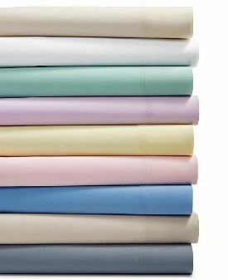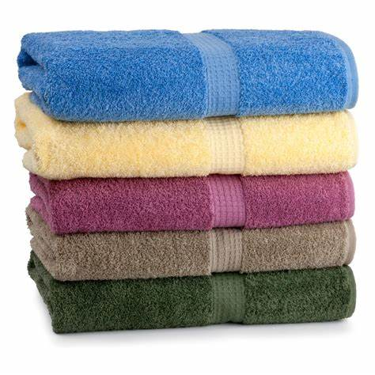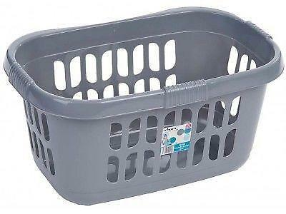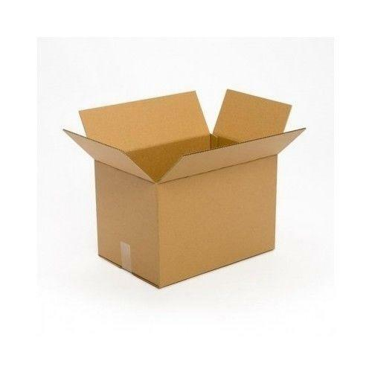

Items you could use for your pirate scavenger hunt

A pirate bandana (tea towel)

A pirate telescope (cup)

A pirate’s pet (soft toys)

Gold Doubloons (pennies)

Treasure (costume jewellery, stones)

A pirate's sword (stick, wrapping paper tube)

A ship’s sail (bed sheet, blanket, towel)

A pirate ship (The empty bath, washing basket, cardboard box)

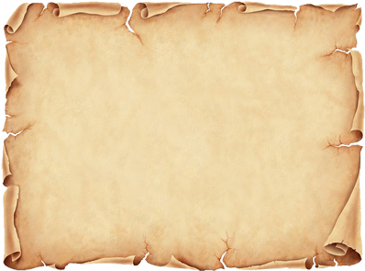

Pirate Scavenger Hunt