Year 2

Please find todays learning tasks below.

The table below explains the tasks and you will find the resources underneath. Your child will know which challenge they usually access in each subject and which task will be appropriate for them.

|  |  |  |  |
| --- | --- | --- | --- |
| **Year group: 2 Date: 15.05.20** | | | |
| **English** | Watch the story of Jack and the Beanstalk  See link below;  <https://www.youtube.com/watch?v=zurz-pL-uzw> | | |
|  | **Bronze** | **Silver** | **Gold** |
|  | Complete a book review of the story of Jack and the Beanstalk (see activity sheet below). | Complete the reading comprehension task below answering the questions in full sentences. | Complete the reading comprehension task below answering the questions in full sentences. |
| **Maths** | Warm Up – follow this link to complete your maths warm up.  <http://www.wldps.com/gordons/carroll__-_shape.swf>  Complete some of the shape activities sorting by 1 and then 2 criteria. | | |
|  | **Bronze** | **Silver** | **Gold** |
| **Find your log-in in the front cover of your red book!** | Complete the game on Education City called ‘Shape Escape’.  Log in – Subjects- Maths- Year 2- Geometry- Shape Escape- PLAY  [The Cedars Primary School - Education City@home](https://www.google.co.uk/url?sa=i&url=https://www.cedars.hounslow.sch.uk/learning/education-city-home&psig=AOvVaw2IWjuqnL-sTAJSWCzRK2vf&ust=1585663085281000&source=images&cd=vfe&ved=0CAIQjRxqFwoTCLiL77mtwugCFQAAAAAdAAAAABAD)  Complete the follow up activity below (all groups) see sheet below. | | |
| **Reading**  **Phonics** | Read a book from home today or your school reading book!  Complete the suffix task on Education City called ‘Little Hikes’. | | |
| **Other** | Today’s subject focus will be PSHRE  Draw a picture of your house and your family.  Complete the sentences below.  My family are special because…  When I am with my family I feel…  The people living with me in my house are…  My wider family are… | | |

Unless otherwise specified, please complete the tasks in either your home learning book or print out the document below.

**English Bronze**

**Complete a book review of the story.**

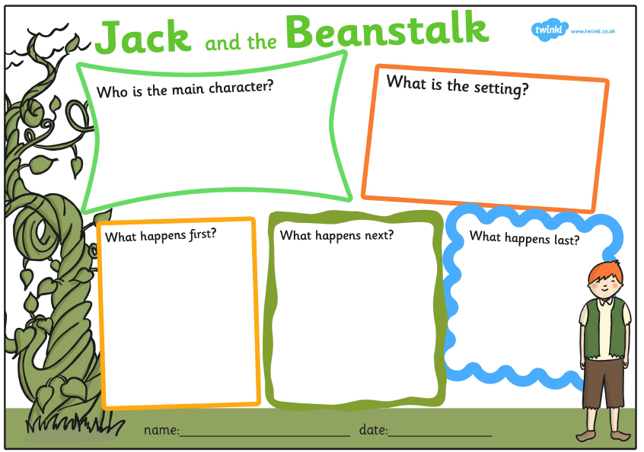

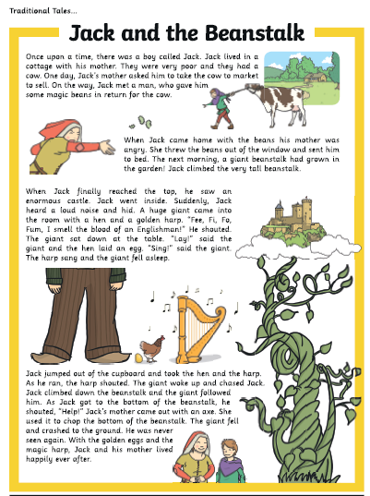**English Silver**

**Silver Questions**

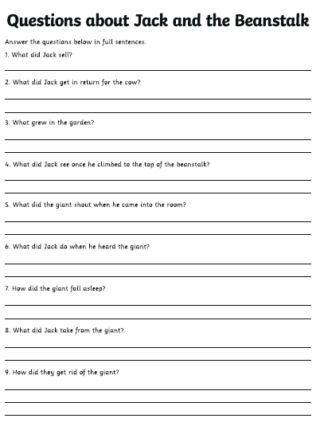

**English Gold**

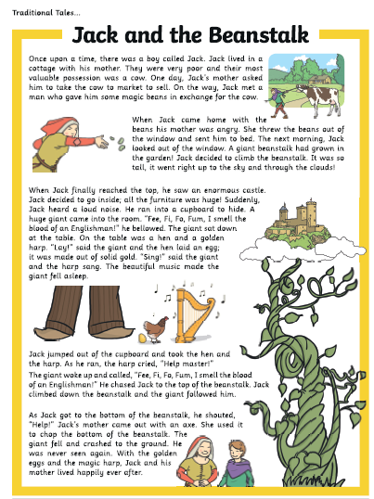

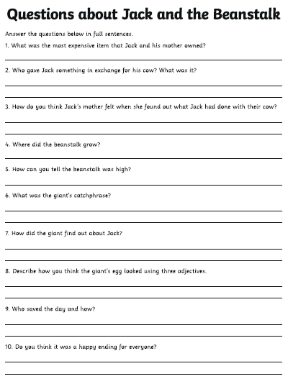

**Maths Follow up (all groups)**

