I liked…

A Picture of the Cover

Key Information

Title:

Author:

Illustrator:

Genre:

My Book Review

I was surprised when…

My Favourite Character

I recommend this book because…

I would give this book____stars

Book review completed by...

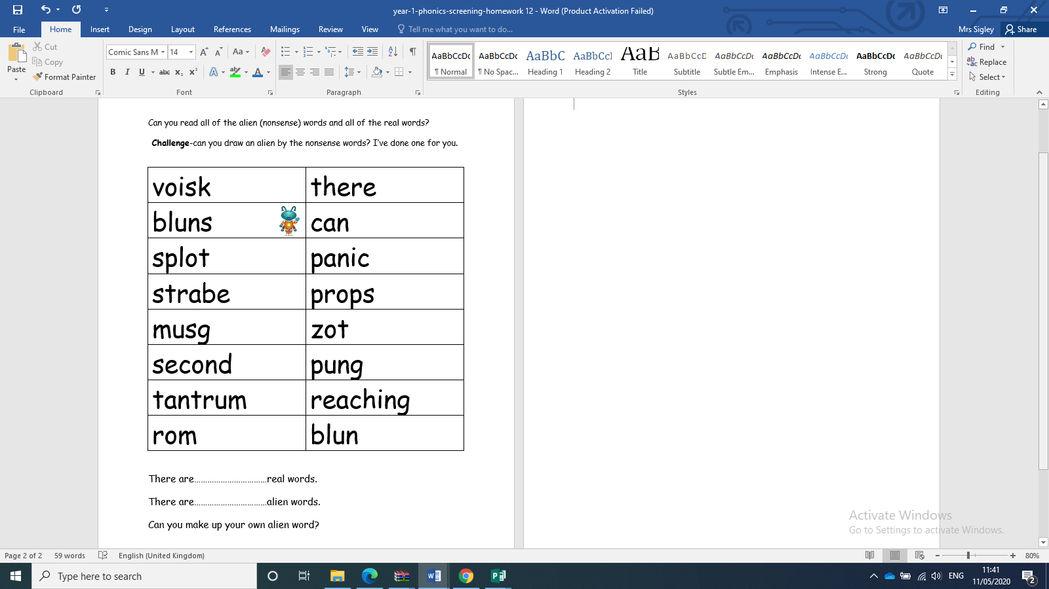

**PHONICS**

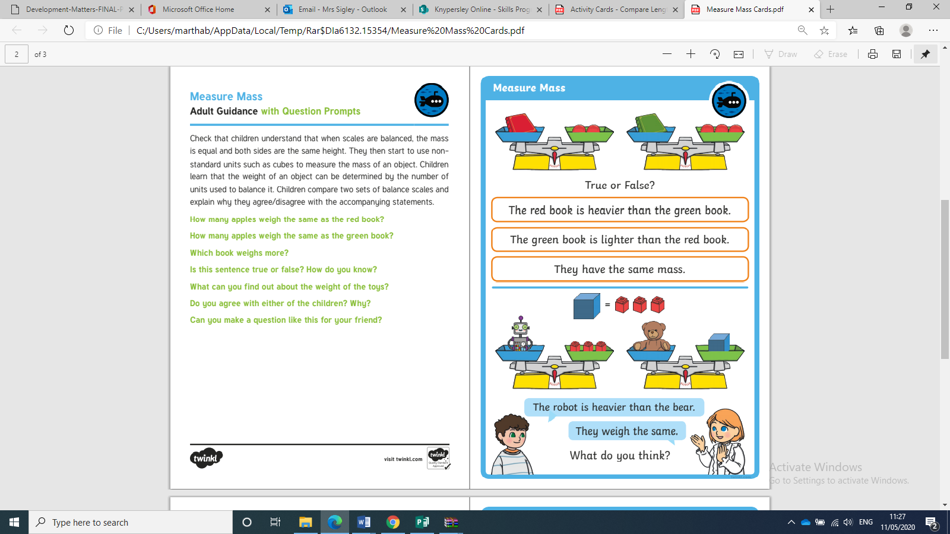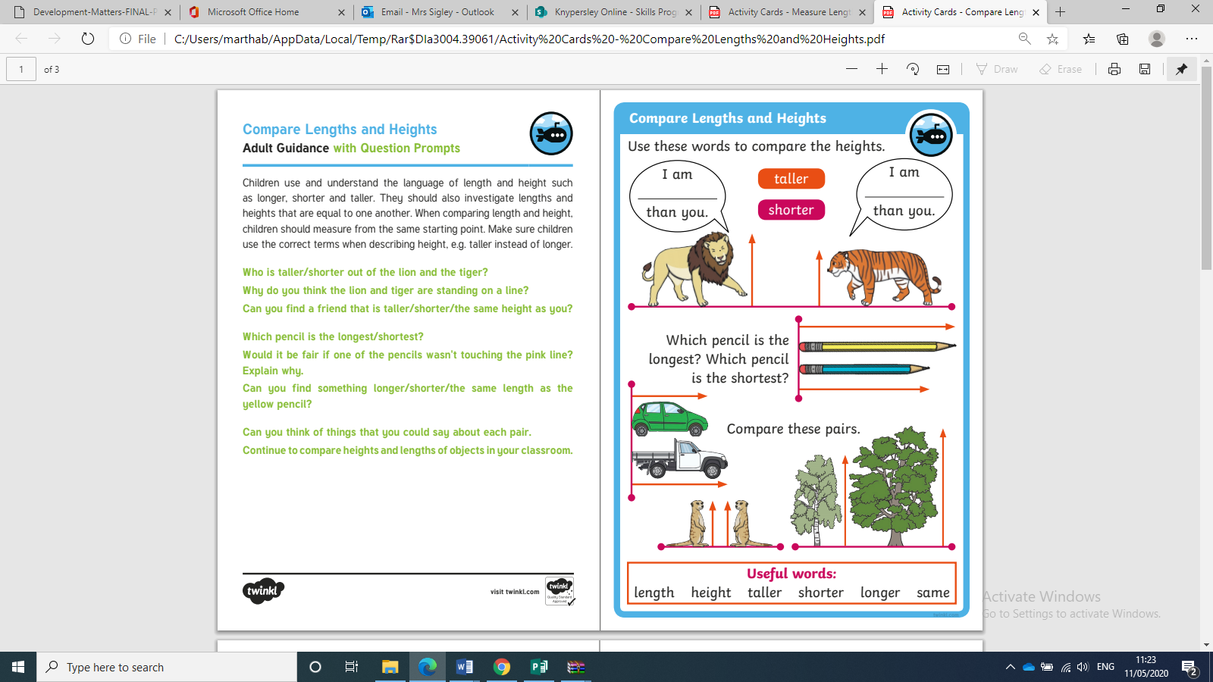

**Bronze Maths**

Tell a grown up…

I think…

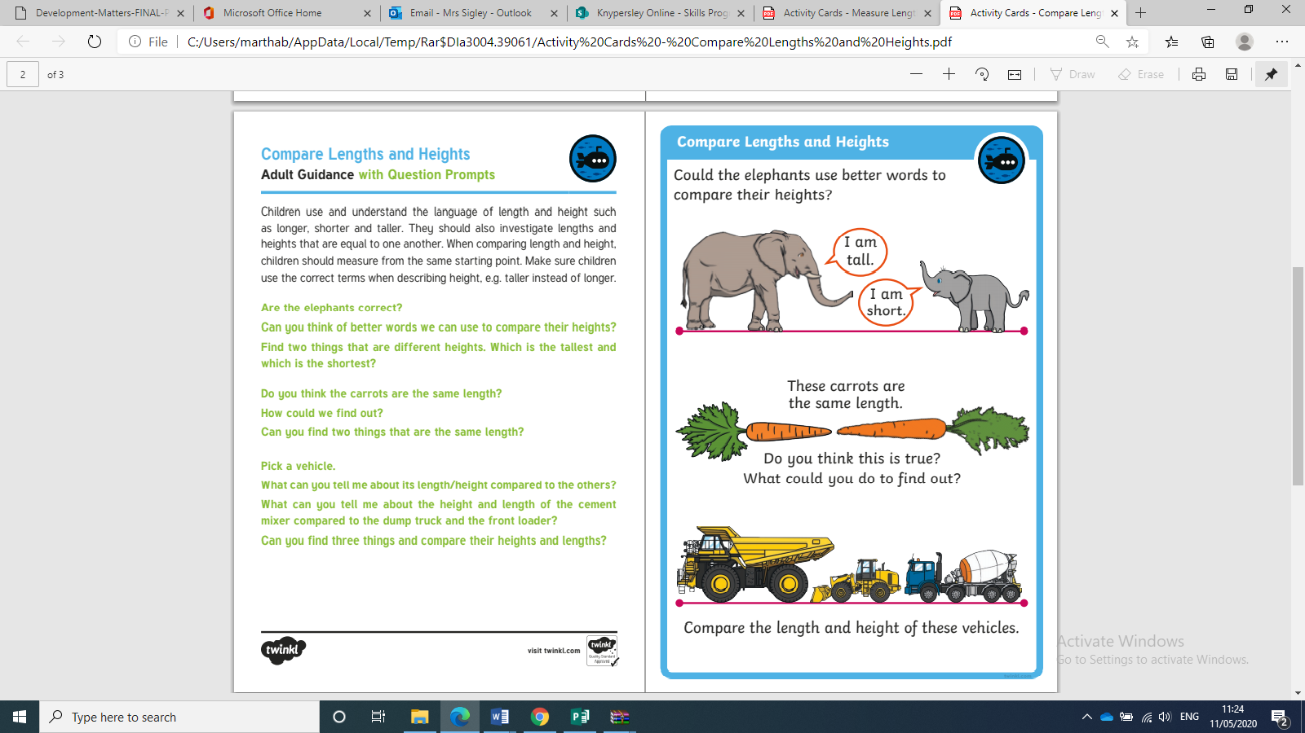

**Silver Maths**

I am

I am

I think…

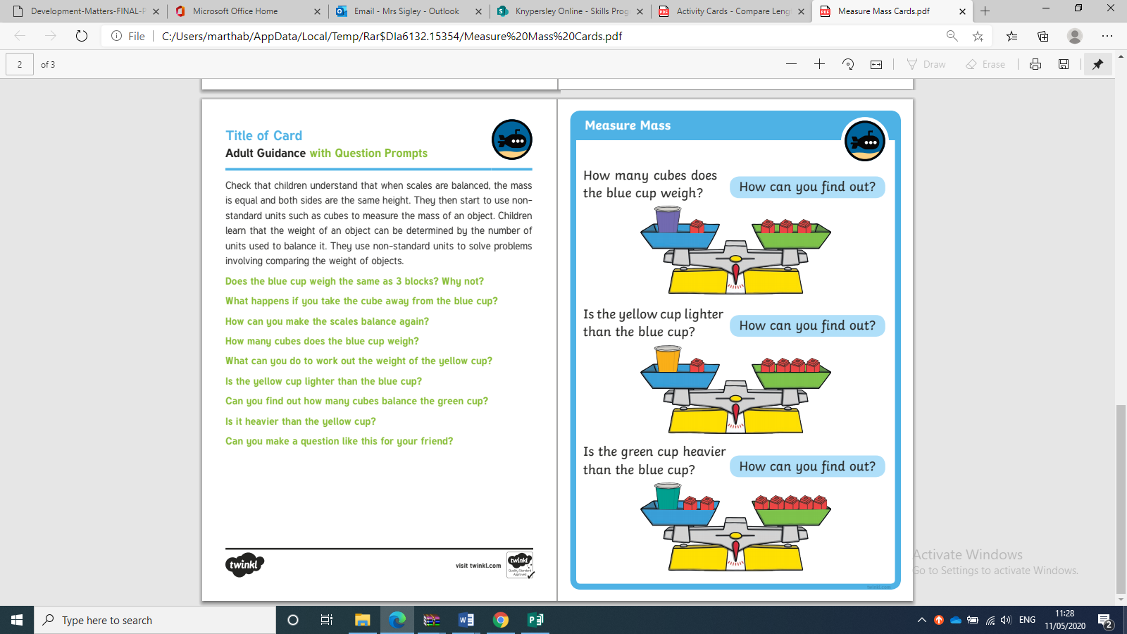

**Gold Maths**

