Year Group: Year 4 Date 22.05.2020
 | Bronze | Silver | Gold
English | Writing a persuasive piece of writing.  Use your planning proforma from yesterday to write your persuasive letter today. Try to include the following success criteria!
 | -Use the word mat  -Present tense.  -2A sentences.  -Consistent use of capital letters and full stops.  -Repetition.  -Time connectives. (Firstly, Secondly,)  -Facts. | As Bronze but also…  -Varied sentence length for effect.  -Persuasive language (obviously, I am sure that you’ll agree etc.) | As Silver but also…  -Emotive language.  -List of three to add emphasis to your arguments.  -Use of online thesaurus to up-level vocabulary.
Maths | Maths mystery- clue 5!  Find the value of the under lined digit. For example, 4678… the value of the 6 in this number is 600.  Unscramble the sentence to find out who stole plans from the locked safe! Who will it be?!
Phonics/Reading | Year 3 /4 statutory spellings.  Please read out loud the words in the list and then use the ‘look, cover, spell, check’ strategy to practise spelling the words.
Other | Art- continuous line drawings!  Watch the video by following this link, it will explain what a continuous line drawing is! https://www.accessart.org.uk/continuous-line-drawing-exercise/  Continuous line drawings require you to look very closely at an object in order to recognise the detail! Try using a handwriting pen, rather than a pencil. The handwriting pen has less friction against the paper and so the pen can “scoot” easily across the paper as the eye observes. Choose small objects as subject matter and have them close at hand so the children can easily observe detail. Keys, cutlery, tools, feathers, and coins all make excellent subject matter. We’d love to see your finished artwork!

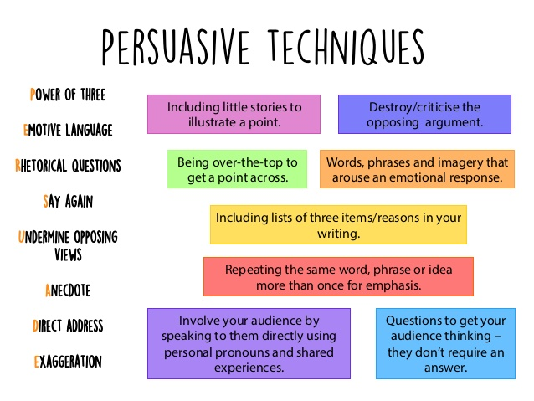
Bronze Silver Gold English—word banks.

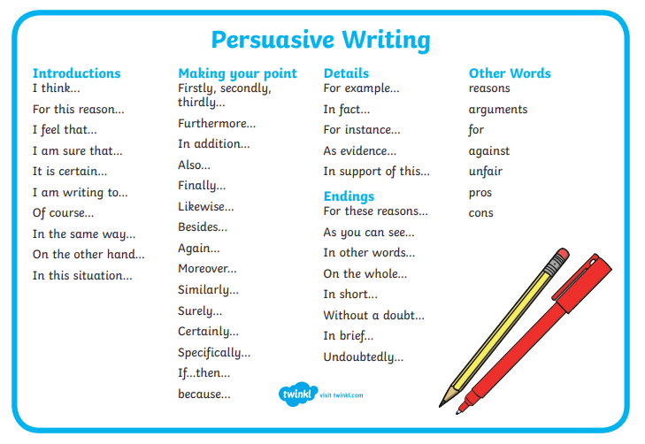

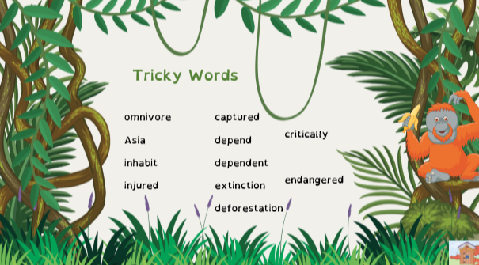

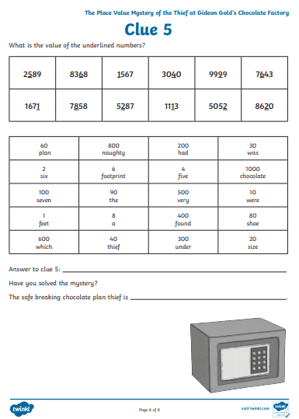
Bronze Silver Gold Maths

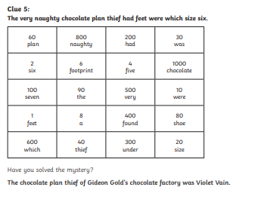
Maths Answers

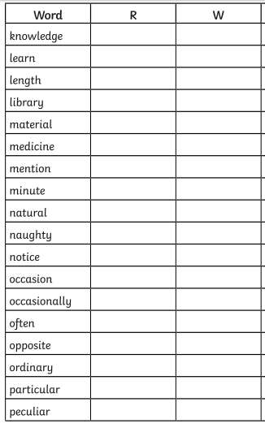
Reading/spelling.

