Year Group: Year 4 Date 21.05.2020
 | Bronze | Silver | Gold
English | Planning a persuasive piece of writing.  Tomorrow, you are going to write a persuasive letter to the Prime Minister, Boris Johnson to ask for his help with deforestation! You will have read about the effects of deforestation and understand that many animals including orangutans are deeply endangered! But first, you will need to plan your persuasive letter. Work with a grown up at home to complete the planning sheet below. If you look at the ‘help sheet’ you might want to include some of these persuasive devices within your plan to make your writing more effective and persuasive.
Maths | Maths mystery- clue 4!  Use the digit cards to make the biggest number possible. If that number is listed in the table at the top of the sheet, then you will need to use the word underneath within your answer. Today, you will find out which department of the chocolate factory the culprit worked in.
Phonics/Reading | Year 3 /4 statutory spellings.  Please read out loud the words in the list and then use the ‘look, cover, spell, check’ strategy to practise spelling the words.
Other | PE- Family fitness race game!  Use a dice to decide how many spaces your counter should move. Whichever square you land on, complete the fitness activity to the best of your ability! Whoever reaches the finish line first, wins! GOOD LUCK!

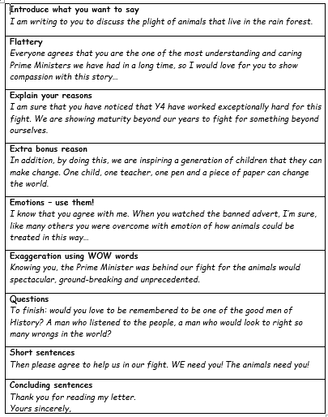
Bronze Silver Gold English—help sheet

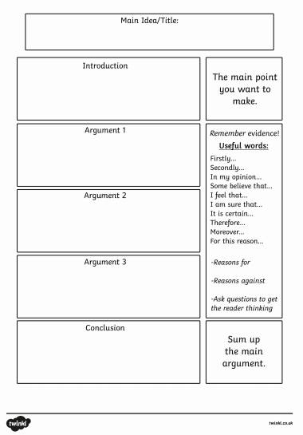
Bronze Silver Gold English—planning sheet

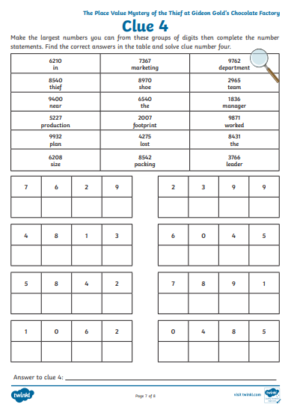
Bronze Silver Gold Maths

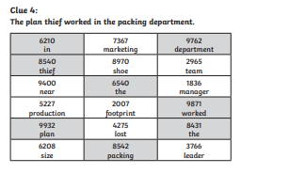
Maths Answers

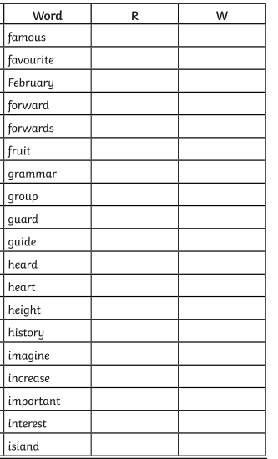
Reading/spelling.

PE

