Year Group: Year 4 Date 20.05.2020
 | Bronze | Silver | Gold
English | Identify the features of a persuasive text!  Please watch the video to understand what persuasive writing is, what it is used for and what it should contain.  https://www.youtube.com/watch?time_continue=101&v=Mlka2xBvV5Q&feature=emb_logo  We would then like you to read through the example of persuasive writing and use the checklist to identify the features. Can you spot all of the features within the text? You may choose to do this as we do at school… use a highlighter/coloured pencils to underline the features in the text and tick them of when you’ve found them!
Maths | Maths mystery- clue 3!  Read the numbers at the top of the sheet. Then look at the calculations. Work out the answer to the calculation and if the number matches one of the numbers from the top of the sheet then colour it in! When you’ve answered all of the questions, unjumble the words to find out whether the culprit is male or female!
Phonics/Reading | Year 3 /4 statutory spellings.  Please read out loud the words in the list and then use the ‘look, cover, spell, check’ strategy to practise spelling the words.
Other | Well-being Wednesday!  Take some time to really think about what makes you, you! Why you are so special and why people love you for the person you are! Complete the balloon activity below. (If you don’t have a printer, you could draw this into your workbook )

The deforestation of the Amazon rainforest NEEDS TO STOP!
Bronze Silver Gold English

The Amazon rainforest is the largest rainforest in the world. However, at the rate it is currently being cut down, this will not last much longer. Deforestation of the Amazon Rainforest affects all living things on Earth and unless it is stopped or limited, there will be serious consequences in the future.

Firstly, deforestation causes devastating loss to animal and plant life. Cutting down the enormous Amazon trees means that animal habitats are destroyed and plants are crushed. This is leading to many animals becoming endangered and extinct – each year, many animal and plant species are becoming extinct. Can you really imagine a world without certain species of animals?

Secondly, deforestation is causing climate change and global warming to worsen. The Amazon rainforest is described as the lungs of the Earth, but if we are cutting down these lungs, they won’t be able to breathe in many of the harmful gases that cause climate change and global warming. Surely someone as smart as you knows that if we carry on cutting down trees, that the Earth will become a place where no life will be able to survive!

Finally, deforestation is cutting the supply of oxygen to all living things. The Amazon rainforest is responsible for 20% of all oxygen produced on Earth. We are carelessly killing the Amazon and at the same time, killing ourselves! Deforestation means there are fewer trees available to absorb carbon dioxide and release vital oxygen needed for all living things to stay alive. It is like we are slowly suffocating ourselves and nobody cares!

You must do something to prevent the changes that have already started because of deforestation. Animals are becoming endangered and extinct, climate change and global warming is getting worse and the amount of oxygen on Earth is decreasing. If these aren’t reasons to act now, then the future of mankind and all living things is in great danger.
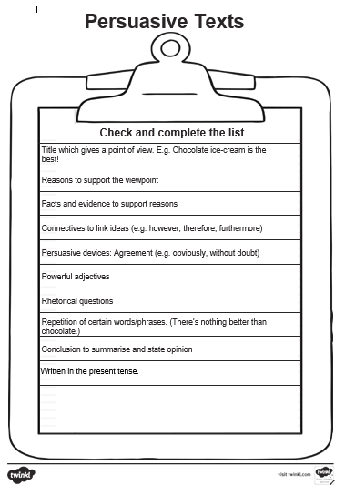

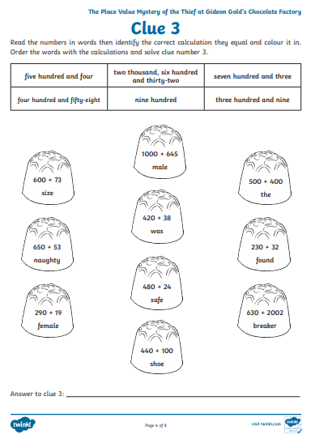
Bronze Silver Gold Maths

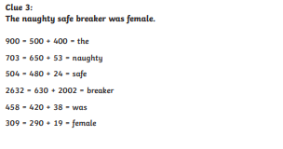
Maths Answers

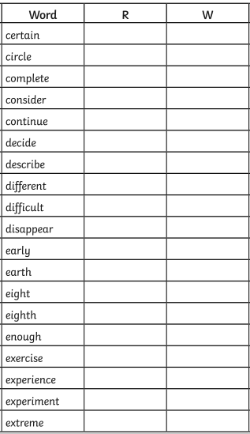
Reading/spelling.

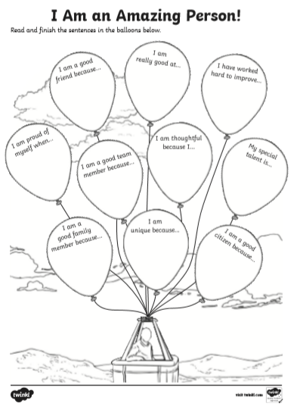
Well-being Wednesday!

