|  |  |  |  |
| --- | --- | --- | --- |
| **Year Group: Year 4 Date 19.05.2020** | | | |
|  | **Bronze** | **Silver** | **Gold** |
| **English** | Fact file!  Today, we would like you to create a fact file about orangutans! We would like you to research orangutans to find out as much information as you can about them. We have given you a word bank, a WAGOLL and a template for your fact file. You don’t have to use this though, you could design and create your own wonderful, colourful and informative fact file in you work books or even using a computer! | | |
| **Maths** | Maths mystery- clue 2!  Compare the numbers by using your understanding of greater than >, less than < and equal too =.  Today, you will find out whether or not the culprit was wearing a hat! | | |
| **Phonics/Reading** | Please use the Get Epic website. (Class login code = uam9686)  Search for books about orangutans and use the information that you find within your English fact file!  Discuss whether the book that you are reading is fiction or non-fiction. | | |
| **Other** | Computing- sequences!  <https://www.bbc.co.uk/bitesize/articles/z4gsy9q>  Watch the videos on the website above to understand how computers use sequences and programming in order to work. When you’ve read through the information with a grown up, we would like you to have a look at the ‘traffic light sequencing’ sheet below. | | |

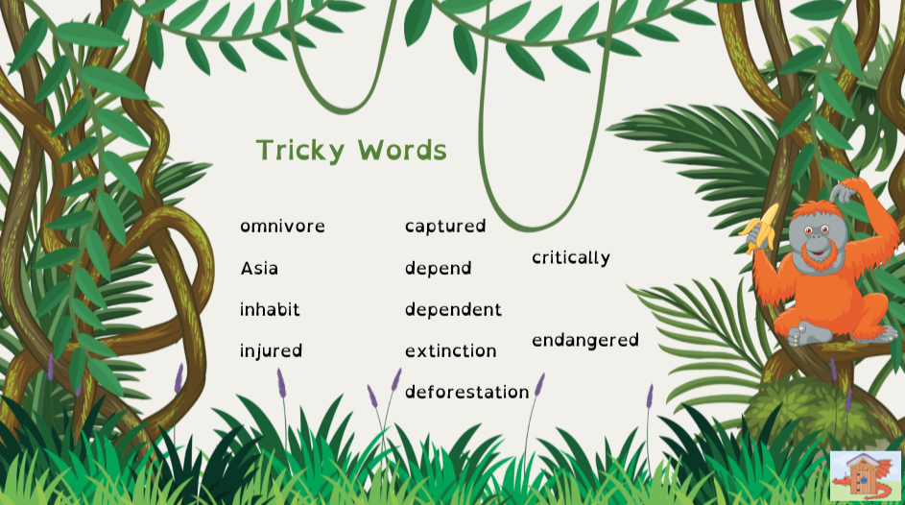

Bronze Silver Gold English

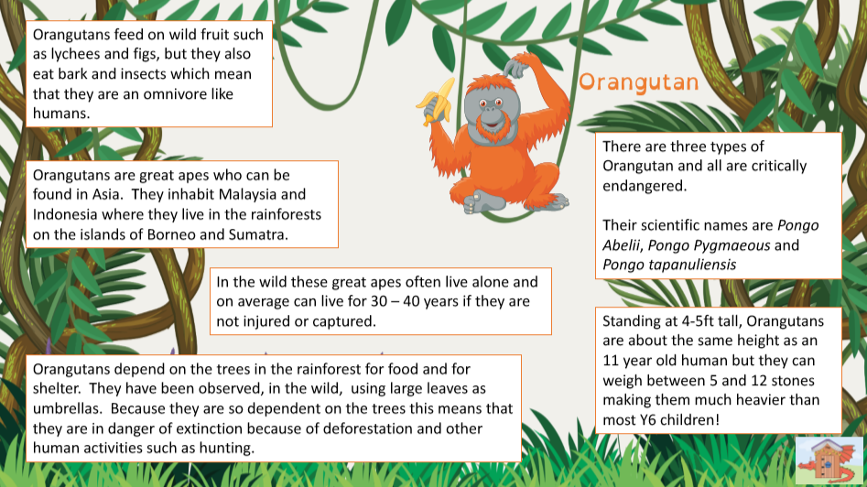

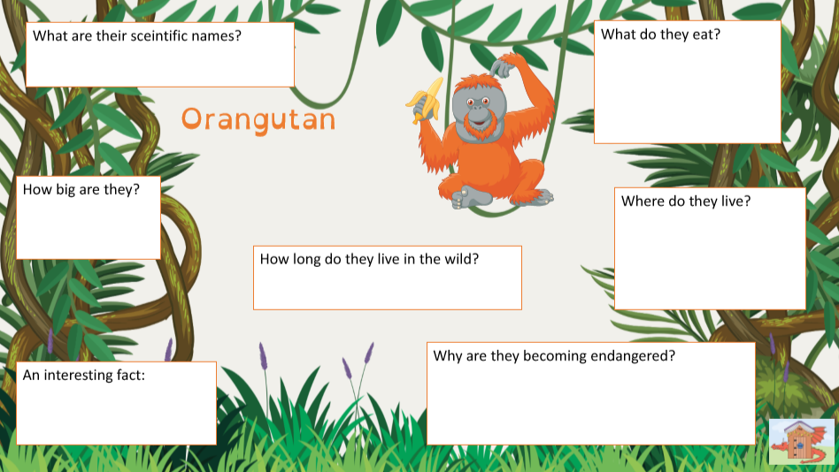

being destroyed and lives lost.

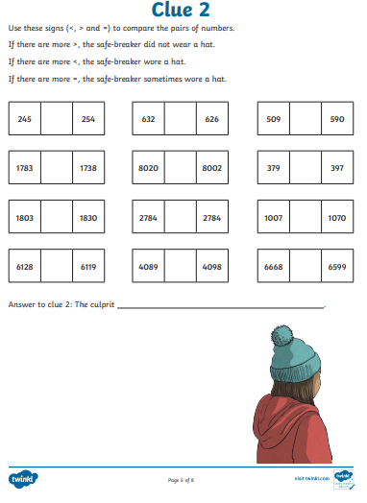

Bronze Silver Gold Maths

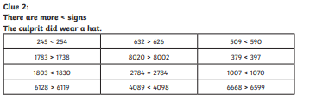

Maths Answers

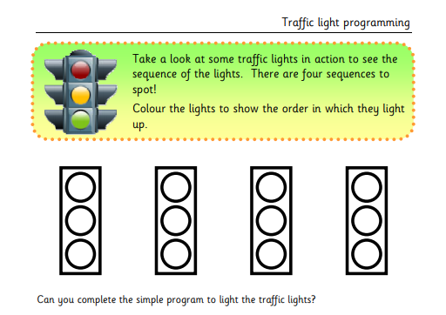

Computing

